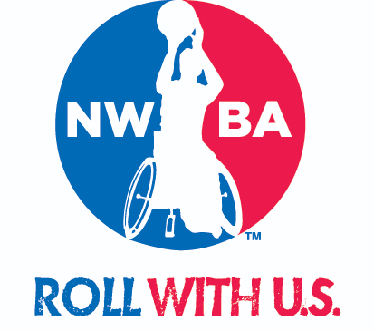

National Wheelchair Basketball Association
Toyota National Championships Series

2020
Request for Proposal

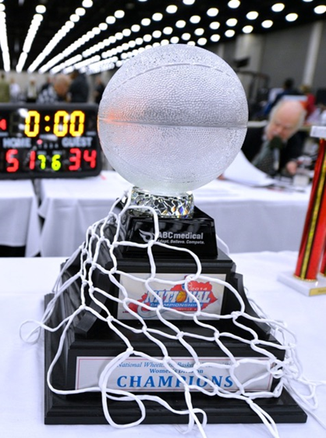

Dear Prospective Event Host,

Thank you for considering a partnership with the National Wheelchair Basketball Association (NWBA). By partnering with the NWBA, you are providing opportunities for people with physical disabilities to significantly change their lives. Transforming lives through sport is our business.

The NWBA is offering seven event properties available for host for wheelchair basketball competition in the United States. These events are part of the NWBA National Tournament Series, the organization’s premier annual competitions. The following national tournament events are available for bid for 2020:
  - Adult Division I National Championships
  - Adult Division II National Championships
  - Adult Division III National Championships
  - National Junior Wheelchair Basketball Tournament
  - National Junior National Invitational Tournament
  - National Prep Wheelchair Basketball Tournament
  - National Women’s Wheelchair Basketball Tournament

We are providing a unique opportunity to your community in expanding the further development of wheelchair basketball and create a mutually beneficial relationship.

Feel free to be creative in your bid proposal and contact the NWBA with any additional questions you may have. Please submit final bid proposals by 12 p.m. Mountain Standard Time on Friday, May 31, 2019. Formal bids will be awarded to host by July 1, 2019.

Submissions must be sent to brandonmcbeain@nwba.org or received by mail at:
NWBA
1130 Elkton Street, Suite A
Colorado Springs, CO 80904

Thank you for your interest in hosting our great sport and amazing athletes in your community!

Sincerely,
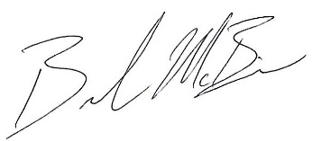

Brandon McBeain

Director of Membership Services and Programs

W 719.266.4082 x 108
brandonmcbeain@nwba.org

Letter of Interest and/or Proposal Statement
- Organization/s (supporting organization, team or individual) hosting the tournament
- The name of the tournament/s to be hosted
- Stated interest in hosting the tournament/s
- The aims and objectives behind the bid to host the tournament/s

Local Organizing Committee (LOC)
- Tournament Director – contact info, qualifications and experience
- Management Staff – contact info, job descriptions, qualifications and experience (including Venue Manager, Accommodations Director, Medical Director, Director of Basketball Operations, Communications Manager, Business Manager, etc.)
- Tournament Volunteers - Include a plan for recruitment, training and management

Tournament/s Details & Logistics
- Proposed dates of the tournament
  - March and April 2019
  - Events & Dates to Consider
    - Easter – Sunday, April 12
    - US Hockey Disabled Hockey Festival - TBD
    - Overlap of NWBA events at different host cities/locations
      - College Division – March 18-21
- Venue/s address and information
  - Website
  - Video
  - Pictures
- List amenities and facilities in venue/s
- Parking information
- Description of past or similar events hosted
- Distance from airports to tournament venue/s
- Contingency plan should main venue/s become unavailable

Courts
- Number of courts and location (include map) / Suggested # of courts Needed
- Description of quality, floor type and surrounding areas
- Suitability for spectators
- Availability of water
- Lining of courts
- Scoreboards
- Shot clocks

Accommodation and Food Services
- Identify Host Hotel/s
- Include a range of accommodation options. (Including player costs if a player chooses not to take up your choice of accommodation options.)
  - Stay to Play Model – fee/fine if applicable
- Concessions and/or food options available near venue

Medical Services and Facilities
- Medical services, facilities, and equipment available to players at the tournament site, including doctors, nurses, physiotherapists, para-medics, masseurs etc.
- Hospitals, medical facilities, and ambulance service – proximity to venue, accommodation, or surrounding areas
- Emergency response plan
- Insurance

Marketing & Communications Plan
- Identify and Profile Audiences
- Develop messages and Identify Messengers
- Develop Strategies
- Selection Communication Channels
- Implementation & Execution

Ticket Sales Plan
- Support to be provided by NWBA
- Pre-Event Management
- On-Site execution and management

Sponsors/Key Stakeholders
- List of potential sponsors
- Level of potential involvement

Host City / Host Organization Information
- Demographics
- Previous events hosted
- Attractions/Amenities

Budget
- The budget should reflect all financial aspects of your bid. Should be divided into revenue and expenditure (please example and attach sample budget).
- Please attach a sample budget proposal for your event

Additional information you would like to include for consideration of your Request for Proposal.

