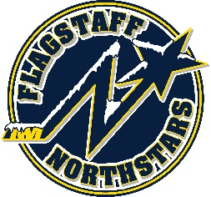
Flagstaff Youth Hockey Association
BOARD OF DIRECTOR’S MONTHLY MEETING AGENDA
October 20, 2021

Topic: FYHA General Board Meeting
Time: October 20, 2021 @ 6:00PM
Location: 215 E Birch Ave or via teams: https://teams.microsoft.com/dl/launcher/launcher.html?url=%2F_%23%2Fl%2Fmeetup-join%2F19%3Ameeting_N2Y5ZDg5OTYtZTczZC00ZjE4LWJkNzAtNGUzNDUzMzdiYjAw%40thread.v2%2F0%3Fcontext%3D%257b%2522Tid%2522%253a%2522e6f978e1-75d4-4db0-904e-5b79fb778570%2522%252c%2522

GENERAL BOARD MEETING
Topic: FYHA General Board Meeting
Time: 6:00pm

Approval of Minutes:
Reports
- President’s Report- Travis Joralmon:
- AAHA Hockey Director- Travis Joralmon:
- ADM Coordinator: Kris Walsh:
- Coaching Coordinator- Travis Johanson:
- Equipment Manager- Greg McLaughlin:
- Fundraising Coordinator-Kyle Palmer:
- Ice Scheduler-Brad Mihalik: re
- COVID Updates and Protocols- Brad Mihalik:
- Registrar-Judy Smith:
- Treasurer-Lauryn Sandoval:
- Webmaster-Courtney Matthews:
- Managers-Courtney Matthews:

UPCOMING EVENTS:

OLD BUSINESS:
- Travel Pictures

NEW BUSINESS:
- Bylaw review
- NAO sponsorship
- 8UFLGJAM
- Selling Ice to coaches

