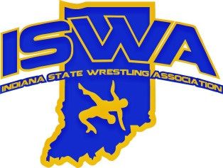
2025 ISWA Section 3 Annual Report

Section 3 had 58 sanctioned clubs including three new clubs in the 2024 -2025 season. We encourage clubs to continue working together to coordinate their events so that we can support each other’s tournaments and achieve the best events and participation possible. If your club needs assistance setting up or running a tournament, please contact us and we can assist with the proper resources.

Section 3 hosted the following ISWA State events. Thank you to the host clubs for your hard work and efforts in making these successful events.

-+Freestyle/Greco State (May 2-4) – Hosted at Avon High School

Congratulations to the following Section 3 clubs for their outstanding effort at the following ISWA events:

Middle School State Duals: Noblesville Wrestling Club – 3rd Place

Folkstyle State:
- Academy Division – Contenders – 1st place
- Large Team – Perry Meridian- 3rd place
- Medium Team – Avon - 3rd place

Freestyle State:
- Academy Division – Contenders – 1st place
- Large Team – Perry Meridian – 3rd place
- Small Team – Warren Wrestling Academy – 1st place
- Small Team – Southport – 3rd place

Greco-Roman State:
- Large Team – Perry Meridian _ 3rd place
- Medium Team – Avon 2nd place

Don't forget the Annual Meeting with election of ISWA officers, tournament bidding, rules and policy updates, breakout educational sessions etc. is coming up on the second Sunday in September.
At the end of August, make sure that you jump in and get your SAFE SPORT renewal or certification, background check, Wrestling Leader card and maybe upgrade your certification to Bronze or Silver checked off your To Do list. You'll have less time, the closer it gets to wrestling season.
So much to do and so little time to get it done. Don't wait too long, the closer it gets to deadlines, the longer it takes to get your necessary items certified. You will need the above-mentioned items for the ISWA State Tournaments coaches' wristbands at mat side and EVERY CLUB HOSTING A TOURNAMENT MUST HAVE BOARD MEMBERS THAT ARE CERTIFIED.
Let's make sure that you plan to communicate your club's tournament date(s) prior to the Annual Meeting so that every weekend, we can support the local tourneys. Make sure that you check the availability of your facility. Be sure to become familiar with the USAW registration and bracketing systems as most clubs and tournaments are updating to them and relying less on Track Wrestling.

Thank you to all the clubs, parents, and wrestlers for a great season! We appreciate all the effort and time spent giving our wrestlers the opportunity to compete and grow through the sport of wrestling.

Section 3 Director

