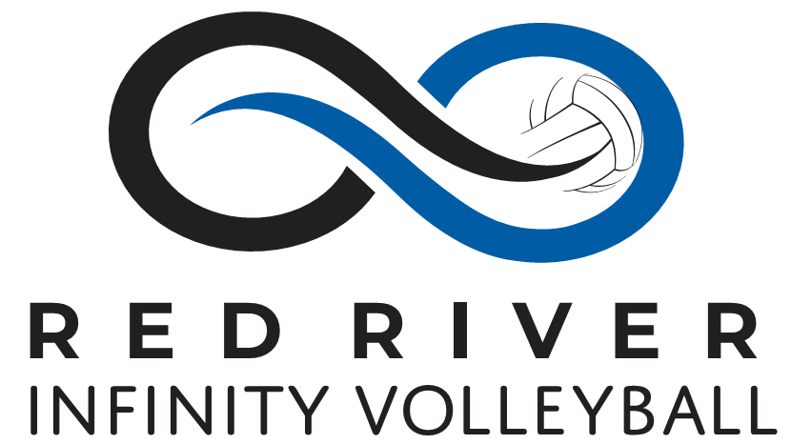

Dear Community Members,
The Red River Infinity 18 Select Volleyball Team will be competing at the 2019 Asics National Jr. Volleyball Championships in Chicago in June. This team consists of girls from the Fargo Moorhead area, including Fargo, West Fargo and surrounding communities. You may even have an employee or co-worker who has a daughter in this program.
The purpose of the Red River Infinity Volleyball Program is to provide a competitive team atmosphere and allow girls from the Fargo / Moorhead area to compete in a higher level of Volleyball, develop leadership skills and build friendships with athletes from other community schools.
As a valued member of our community we would like to request your support for helping sponsor the Red River Infinity 18 Select Volleyball Team. Sponsorship levels are listed below and thank you for your support and help.
To make a donation to RRIV at this time, please complete and mail this form to:
Red River Infinity Volleyball
PO Box 6561
Fargo, ND 58109
Sponsorship Levels:
- $500 and up will receive their Company logo on Web Page and Team Sponsor warm up jersey to be worn at the National Tournament.
- $250 and up will receive their Company Name on Web Page and Team Sponsor warm up jersey to be worn at the National Tournament.
- $249 and down will receive recognition as a national sponsor on the web page.
Any Donation amount is greatly appreciated. Please note in Check Memo: National Team.
Amount of Donation: ________________
Name of Company: __________________________________________________
Contact Person at the Company: __________________________________________________
Contact Number: _________________________________________
Address: __________________________________________________
Email: __________________________________________________

Question on Corporate Sponsorship please contact:
David Henry Email: davesupra@gmail.com Phone: 701-730-6313

Important Instructions:
Sponsors will need to have their company logo to the club by: May 25th, 2019.

