2022 Saber Jam Game Rules

Game Time
Teams are requested to be ready 10 minutes prior to game time at their court. Each team will be provided a minimum of 5 minutes for warm-ups.
Scoring/Fouls
Scoring and fouls will not be tracked. Play hard, keep it clean, and have fun!
Length of Games
- 20-minute running-time halves (no stop time in either half)
- No overtime will be played
- Teams listed on the top in the pool will be responsible for providing a volunteer to manage the clock
- Halftime will be 2 minutes
Timeouts
Each team will be provided two timeouts per game, clock stops.
Free throws and Ball Sizes - We will follow the MYBA rules.
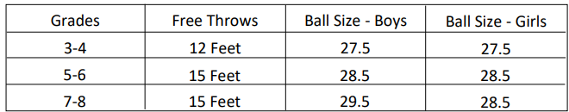
Defenses – We will follow the MYBA rules.
