COVID-19
Procedures
K.B. Willett Ice Arena

Kate Gullickson: Facilities Supervisor
Stevens Point Parks Recreation and Forestry Department

Please know all procedures in this document are subject to change due to the rapidly changing nature of COVID-19. Any changes will be communicated to employees and our guests.

GENERAL INFO & PROCEDURES FOR COVID-19
Signs & Symptoms of COVID-19
People with COVID-19 can have mild to severe symptoms. Symptoms may appear 2-14 days after exposure to the virus. According to the CDC, people with these symptoms may have COVID-19:

- Fever
- Cough
- Shortness of breath
- Difficulty breathing
- Fatigue
- Muscle or Body Aches
- Headache
- New loss of taste
- New loss of smell
- Sore Throat
- Congestion
- Runny nose
- Nausea or vomiting
- Diarrhea

Staff and Rink guests are asked not to send their children or visit the arena if they or a member of their household have symptoms or if any family members or close contacts have tested positive for COVID-19 in the last 14 days.
Parents/Guardians
1 Parent/ guardians per child to be able to assist a younger skater with skates and restroom needs. We are not allowing any extra family or friends in the rink as spectators so that we can limit the number of guests in the rink at all times.
Entrances and Exits
Entrance to the Willett Ice Arena is 1000 Minnesota Ave Exit is on the West end of the building and a walkway can be accessed to get to the Minnesota Ave Parking lot or skater can be picked up in the parking lot of 2442 sims Ave, in-between the Municipal pool and the Practice football field. Skaters are required to arrive no more than 15 minutes before their scheduled skating times and they must leave within 15 minutes of their scheduled ending times. Skaters are asked to come to the rink with only having to put on their skates before entering the ice.
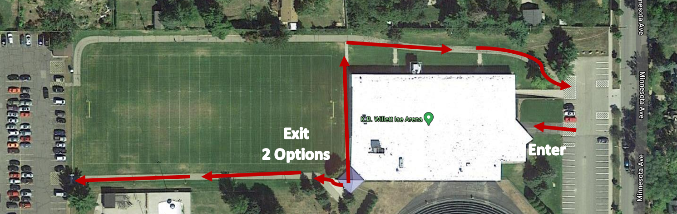

Patron Check In
Entrance into the K.B. Willett will be off the Minnesota Ave Parking lot. Participants of any program and skaters of every team must check in at office window. The office staff member will check that person in off the provided roster that the user group has given the rink staff. This will aid any contact tracing if needed.
Facility Capacity and Pods
Ice Arena capacity is currently limited to 100 people. This is a pod system that we are adapting. Since the area of an Ice rink is quite large. We are separating the on ice pod from the off ice pod. Allowing 50 people to be in each area, including staff.
The number of people in the building will be monitored by the office attendant and enforced by all rink staff.
Normal Building Capacity is 1872 people.
Facility Signage
Facility Signage will be up reminding of the signs and symptoms of COVID-19 and other precautions such as social distancing, and required mask usage.
Social Distancing
The CDC recommends social distancing of 6 feet. Please remain 6 feet apart from others and encourage patrons to do the same. Social distancing markers are located throughout the Arena in areas where there may be lines formed.
Facecoverings
Facemasks will be worn by staff at all times at the Ice Arena. Additionally, all patrons (over age 5) must have a facemask on while entering and exiting and all other times. While on the ice, a mask is recommended.
Handwashing and Hand Sanitizer
Hand sanitizer will be available at many locations in the arena. Please use the sanitizer frequently when handwashing is not an option. Soap for handwashing will be in each restroom within the arena as well.
Cleaning & Sanitization Increased cleaning and sanitization measures will take place. Staff will be sanitizing the Ice Arena after each user group according to the pre-determined schedule and checklist. This includes the high touch areas of bench areas, chairs, bathrooms, changing areas, and all door handles, and all areas occupied by that user group.

Locker Rooms
The teams with permanent home locker rooms (UWSP & SPASH) can use those rooms; they need to be sanitized daily after use by each team. The Arena will sanitize the common spaces after each group. The other nonspecific Locker rooms will be used on an as needed basis and will need facilities supervisors’ approval to use. There needs to be ample time to properly sanitize between each group in order to warrant usage.
Bleachers
The bleacher area will be used for parents/guardians that accompany their skaters while they skate, if skaters need assistance. We require social distancing and if other children need to accompany the one parent or guardian, they need to stay with that parent or guardian and are not allowed to be roaming the arena unattended.
Drinking Fountain
Drinking fountains will be off. Participants should bring their own labeled water bottle.
Reported Positive COVID-19 Employee or Arena Guest
In the event someone tests positive for COVID-19, contact tracing is coordinated via the County Health Department in which the positive result occurred. The City is unable to provide names of individuals whom the City learns tested positive but will make every attempt to notify employees and guests who may be known “close contacts” to the positive test employee or guest. Close contacts are defined as answering “yes” to at least one of the following questions:
- Did you have direct physical contact with the person (shook hands, hug, etc.)
- Were you within six (6) feet for more than fifteen (15) minutes
- Did you stay overnight for at least one (1) night with the person
- Could you have had contact with any of the persons respiratory secretions (cough, sneeze)
If you answer yes to one of those questions, you will be asked to leave the arena and consult with your medical provider. You may be subject to local isolation and/or quarantine orders per your medical provider and may be required to provide documentation in order to be able to return to the K.B. Willett Arena for activities.

I, _______________ have read and acknowledge the City of Stevens Point Willett Ice Arena COVID-19 Procedures.

Signature:_______________________________________________ Date:_______________

Any questions or Concerns please contact:
Kate Gullickson
Facility Supervisor
Stevens Point Parks Recreation and Forestry
715-346-1578 kgullickson@stevenspoint.com

