First Annual Women’s Flag Football,
May Long Weekend in Vancouver Presents:

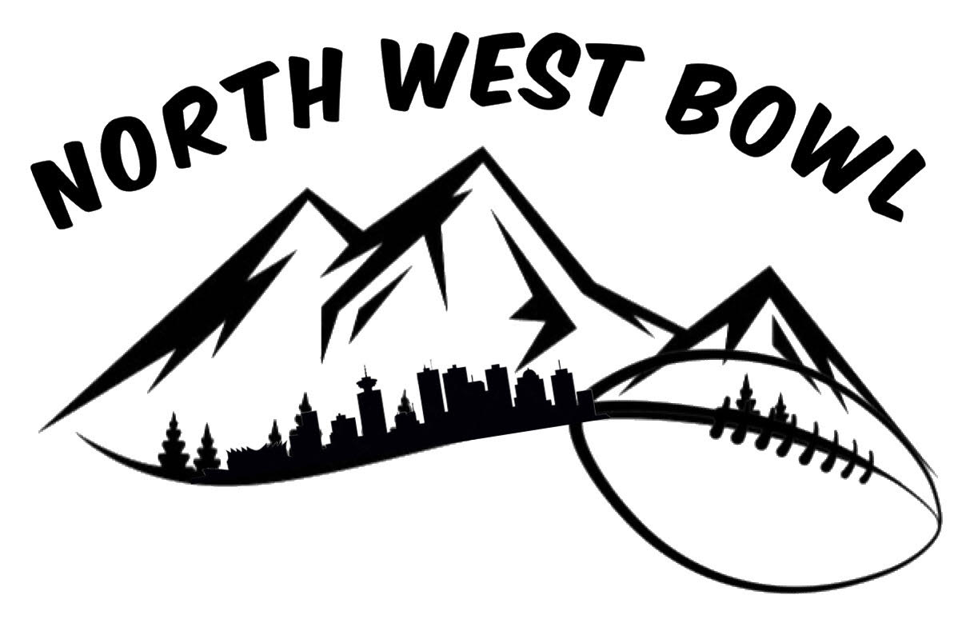

Sat & Sun: May 20-21, 2023
- Argentinian BBQ food
- Beer Garden
- Burnaby Lake Rugby Fields

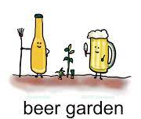
10 Team Spots Avail:
Registration Opens March 20th
Team Fees: $700.

-email Alyssa for questions
Transfer fees to:
lyssdalman@gmail.com

