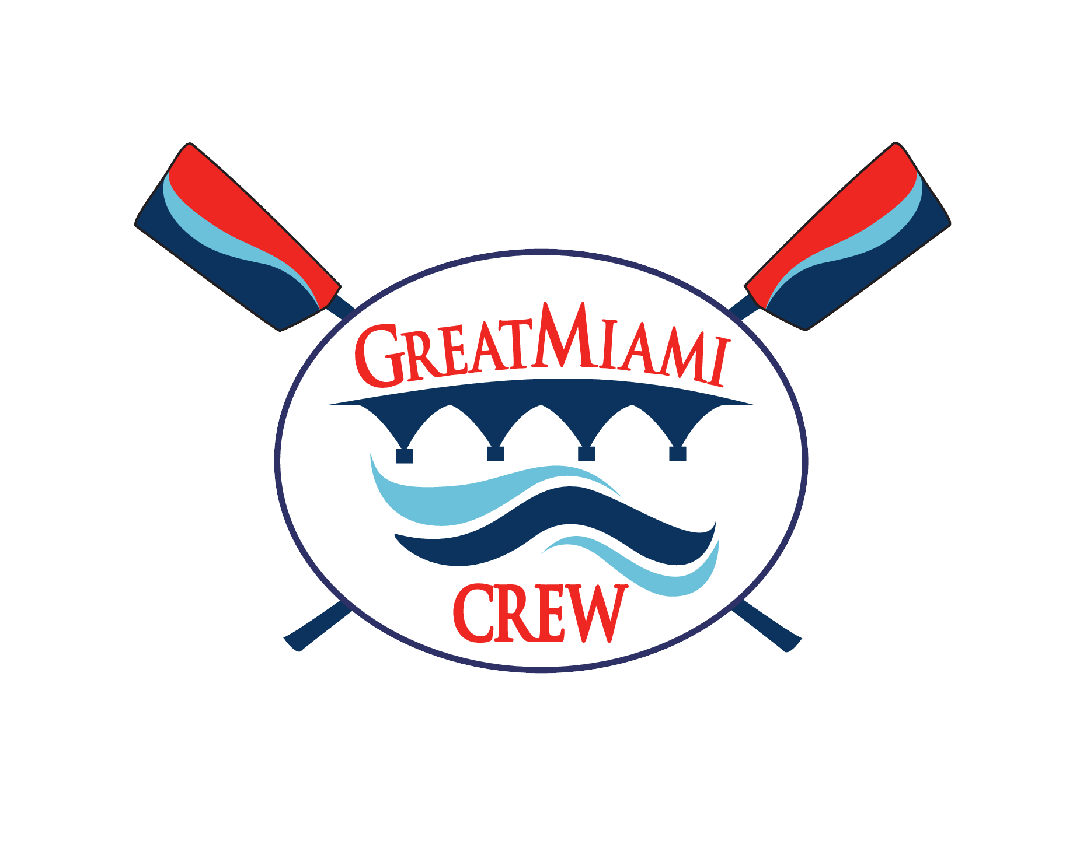

Great Miami Rowing Center WAIVER/RELEASE FOR COMMUNICABLE DISEASES INCLUDING COVID-19

ASSUMPTION OF RISK / WAIVER OF LIABILITY / INDEMNIFICATION AGREEMENT
In consideration of being allowed to participate on behalf of Great Miami Rowing Center (GMRC) and related events and activities, the undersigned acknowledges, appreciates, and agrees that:
- Participation includes possible exposure to and illness from infectious diseases including but not limited to MRSA, influenza, and COVID-19. While particular rules and personal discipline may reduce this risk, the risk of serious illness and death does exist; and,
- I KNOWINGLY AND FREELY ASSUME ALL SUCH RISKS, both known and unknown, EVEN IF ARISING FROM THE NEGLIGENCE OF THE RELEASEES or others, and assume full responsibility for my participation; and,
- I willingly agree to comply with the stated and customary terms and conditions for participation as regards protection against infectious diseases. If, however, I observe and any unusual or significant hazard during my presence or participation, I will remove myself from participation and bring such to the attention of the nearest official immediately; and,
- I, for myself and on behalf of my heirs, assigns, personal representatives and next of kin, HEREBY RELEASE AND HOLD HARMLESS GMRC their officers, officials, agents, and/or employees, other participants, sponsoring agencies, sponsors, advertisers, and if applicable, owners and lessors of premises used to conduct the event (“RELEASEES”), WITH RESPECT TO ANY AND ALL ILLNESS, DISABILITY, DEATH, or loss or damage to person or property, WHETHER ARISING FROM THE NEGLIGENCE OF RELEASEES OR OTHERWISE, to the fullest extent permitted by law.

FOR PARTICIPANTS OF MINORITY AGE (UNDER AGE 18 AT THE TIME OF REGISTRATION)
This is to certify that I, as parent/guardian, with legal responsibility for this participant, have read and explained the provisions in this waiver/release to my child/ward including the risks of presence and participation and his/her personal responsibilities for adhering to the rules and regulations for protection against communicable diseases. Furthermore, my child/ward understands and accepts these risks and responsibilities. I for myself, my spouse, and child/ward do consent and agree to his/her release provided above for all the Releasees and myself, my spouse, and child/ward do release and agree to indemnify and hold harmless the Releasees for any and all liabilities incident to my minor child’s/ward’s presence or participation in these activities as provided above, EVEN IF ARISING FROM THEIR NEGLIGENCE, to the fullest extent provided by law.

I accept the terms and conditions outlined in GMRC’s Waiver/Release for Communicable Diseases including COVID 19 and Liability.: *

I Accept the Terms and Conditions

Print Rower’s Name:​
___________________________________________________
Signature:​
___________________________________________________
Print Parent/Guardian Name:​
___________________________________________________
Parent / Guardian Signature:​
______________________________________________________

Date:​ __________________________________

