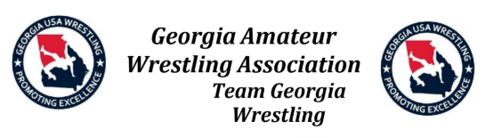

Dear Youth Supporter,

The bearer of this letter has earned the opportunity to represent their school, community, and State at the 2025 USA Wrestling National Greco-Roman/Freestyle Championships or National Duals. This honor is earned by only a select few wrestlers in each state.

The USA Wrestling Greco-Roman/Freestyle Nationals is one of the largest and most prestigious wrestling tournaments held in the United States. Many college coaches will be at this event looking for recruits. This year, the 2025 National Duals will be held in June 2025 in various locations in Indian, Pennsylvania, Utah, and Wisconsin. The 2025 US Marine Corps/USAW Cadet/Junior Nationals will be held in Fargo, North Dakota, in July 2025.

Unfortunately, there are many expenses associated with an opportunity such as this. The expenses include travel, lodging, meals, tournament entry fees, equipment, and several other miscellaneous costs.

By donating, you will be helping a young athlete reach his/her goals as well as showing your support for the youth in your community and state.

Team Georgia Wrestling is a not-for-profit organization exempt from Federal income tax under section 501(c)(3) of the Internal Revenue Code. Donors may deduct contributions as provided in section 170 of the Code using our Federal Tax ID: 58-2026096

If you would like to donate to a specific athlete, you can email our treasurer at [treasurer@teamgawrestling.org](mailto:treasurer@teamgawrestling.org).

Simply include the wrestler’s name you would like to sponsor. Once received, our treasurer will respond with instructions on how to make your donation.

Thanks again for your continued support of our athletes!

Sincerely yours,

Jason L. Griner

State Chairman

Team Georgia Wrestling