
GameSheets “Game Day” Cheat Sheets

- Open the GameSheet app on your iPad by tapping its icon on the home screen
- If the app is requesting a "League iPad Access Key", enter the key provided to you by your league / event organizer and tap "Sign-In"
League iPad Access Key: ipad-mg8garbsf
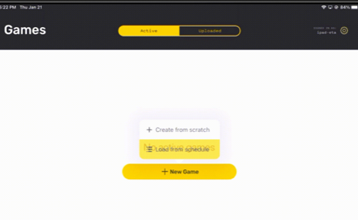
- Tap "+ New Game" and then "Load from Schedule"

- Locate your game and tap the "Load Game" button

- Confirm Lineups
  - Tap either "Visitor Roster" or "Home Roster" on the left side to load the team's roster
  - Team rosters are downloaded when the game is loaded, so coaches should only need to make updates specific to the game's lineup
  - Players can be set to Starting, Playing, Sitting Out, Injured, or Suspended by tapping on their status
  - Editing of players and coaches can be done by tapping the content you'd like to edit and following the prompts

- When the lineup is correct, the coaches must sign before returning the iPad.
- Verify that there are no errors displayed beside the Home and Visitor Roster page titles.
If the orange Error button is displayed, tap on it to review the errors

- Start the Game
- Tap "Game Details" on the left side
- Fill in any missing details and confirm the period lengths are correct
- Enter the "Start Time", e.g., 7:01PM (When the puck is dropped)

- Score the Game
  - Tap "Scoring" on the left side to enter the game scoring page
  - Record the game's events

7a. Editing the GameSheet - Deleting a Goal or Penalty in the Scoring App
- Swipe from right to left over the goal / penalty.
- Tap the "Delete" button.
- Tap "Delete" again to confirm.

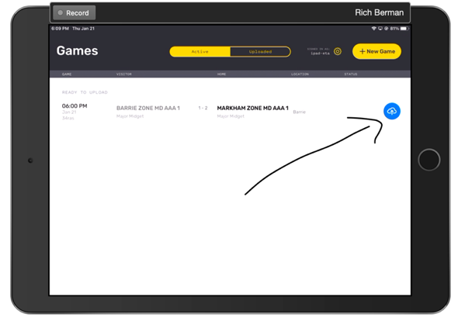
Warnings and Errors in the iPad Scoring App
As you proceed through the various screens in the iPad Scoring app, you'll begin to see icons appearing which indicate the number of errors and/or Warnings present on each screen.
- Errors must be corrected before a game can be locked and uploaded
- Tap an error/warning icon to view the list of errors and warnings
- Tap a specific error to view and correct it

- Post-Game – Verify there are no errors on the scoring page (shown in the top right)
- If the orange error icon is displayed, tap the icon, and then tap on the error to make the necessary adjustments.
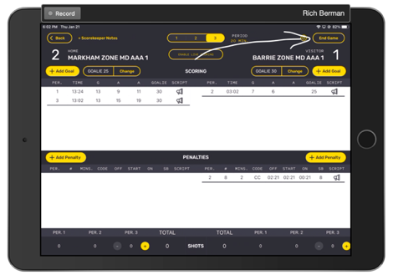
Warnings should be reviewed!

- Tap " End Game" in the top right corner. This will load the Officials / Post Game page.

- Give the iPad to the referees to complete the Officials / Post Game page and sign
- Referees are expected to:
  - Add themselves to the game by tapping "+ Add Referee"
  - Review the penalties and confirm the codes and lengths have been correctly recorded. If any penalties are incorrectly recorded, the referee may edit them directly by tapping the "Edit" button above the penalties table
  - Add notes to major and misconduct penalties (as instructed to do so by the league)
  - Sign
  - Lock the game by tapping "Lock Game" button
- After the referee has locked the game, the app will return to the Games page and a blue icon will appear to the right of the game. Tap the blue icon to upload the game. Once uploaded the game will disappear from the Active games list, the league will have a copy of the game, the website will be updated, and the managers and coaches of both teams will have been sent a copy of the scoresheet via email.
Do not forget to make sure that your game has been uploaded!! If you are unsure – you can check the home page on the app and if you see your game under “Active Games” – You have NOT uploaded your game.
The games will remain on the iPad that was used until uploaded.

