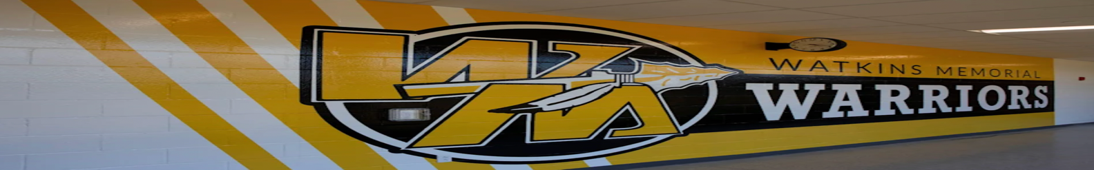

League Rules of Conduct

League Mission Statement

The Watkins Youth Basketball League is devoted to providing an opportunity for students at the Southwest Licking School District to play basketball in an organized and supervised atmosphere. It is our expectation that all participants will uphold that ideal with their conduct during all Associated functions. All coaches, athletes, and spectators shall:

- Model sportsmanship at all times. Treat our volunteers, opponents, and officials with equal respect.

- Be supportive.

- Keep your comments positive. Parents and coaches must communicate with mutual respect. Coaches have the right to postpone conversations for 24 hours that are getting out of hand. Heated discussions have no place in front of the players and no communication with a parent will involve any other child on the team, only their own. These conversations will be had with the coach, parents, and members of the board of directors of the youth program, either virtually, or in person at a public location.

- Communicate with your coach. Keep them informed about problems that may be going on with your child. If the child has been sick, taking medication, or going through some emotional trauma please make sure the coaches are made aware of the problem as soon as possible.

- Only players, coaches and system volunteers are allowed on the practice and playing fields, no exceptions.

- Leave the coaching to the coaches. Regardless of your background or experience, please refrain from coaching your kids. These kids are being taught to play as a team, each player performing a set function that his teammates can rely on. A player who abandons his teammates to do something his parents coached him to do is letting down his team, his coaches, and himself. At best he may open up the door for the opponent to win the game. At worst he may cause himself or a teammate to be injured. Please talk with a board member if you are interested in volunteering or coaching.

- Leave the officiating to the officials. Spectators are not allowed to make comments, suggestions or communicate in any way with officials. No exceptions.

- Disrespectful behavior towards players, opponents, officials, coaches, or volunteers will not be tolerated. Nor will abusive or foul language.

- Behavior that is disruptive to the program or takes away from the experience of other players and parents is not acceptable. Creating unnecessary drama or stirring controversy will not be tolerated.

- Players must be at practice on time, properly equipped and with adequate water. Unexcused absences will result in loss of playing time. Multiple unexcused absences are grounds for dismissal from the program.

- If playing on multiple teams, this will be the primary team that the child will play on. It is not fair for the team if a player that is relied on is not available during games due to other team commitments.

- This is a team first coached league. While we understand some children do have exceptional skills, the coaches will work with all children equally and bring them along as a team.

Board of Directors:
· Each board position is responsible for tasks related to the operation of the league

Board Member Authority:
- Board members have the authority to intervene when observing unsportsmanlike or unsafe conduct
o In these cases, the board will meet within 7 days to review the conduct observed
- Board members have the authority to suspend or replace any coach which they believe is under the influence of drugs or alcohol during a team event or violating any said content within these by-laws
o The board will meet within 7 days to determine the length of suspension or replacement of the coach
- Board members may order a fan/parent/spectator to leave the gym if they are interrupting a league event, whether practice or a game.

General Conduct

A coach shall not display any behavior which will discredit himself or bring dishonor to the Watkins Basketball Program. Such actions shall include, but are not limited to unruly behavior, exhibiting disrespect to players, referees, officials, school representatives or employees, fans or other coaches; disregarding rules and regulations of the Southwest Licking Local School District, or the league in which his team plays; and displaying behavior which is offensive to the community (use of profanity, discriminatory, derogatory or harassing language; spitting; fighting; etc.) The above guidelines shall be observed at all Association-sponsored events. Such events shall include, but are not limited to, practices, games, meetings and social events of the Association. Any coach, player, parent or spectator who fails to maintain and adhere to these rules is subject to disciplinary action by the Watkins Basketball Board and, if serious enough, the entire Association. After an investigation, the Board may impose any of the following as punishment:

1.) Official Warning
2.) Game(s) Suspension
3.) League Expulsion

