SPORTS INTERNSHIP OPPORTUNITY
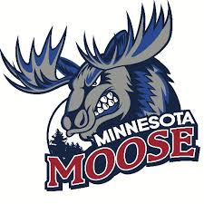
Minnesota Moose, United States Premier Hockey League
Part Time
Half Season (Sept-Dec, Jan-Apr) & Full Season (Sept-Apr)
The Minnesota Moose Hockey Club, are moving in to the fourth year of operation and are looking for motivated, passionate interns to assist with operations during the 2020-2021 season. Moose internships are full-time or part-time and allow students the opportunity to gain valuable work experience within a sports organization through hands-on experience. A successful applicant will demonstrate strong organizational skills along with initiative, resourcefulness, and an ability to collaborate with team members for the achievement of team goals. In past years, interns working with Jr. A hockey teams have been successful in securing full time positions across a wide field of industries post-internship. Career mentoring is a central aspect to the Moose internship program.
Game Operations Internship
Fan Experience, Game Presentation, Live Entertainment
- Responsibilities
  - Prepare and operate our merchandise store
  - Conduct sound check/run through with live entertainment (anthem singer, choirs, color guards, flag boy or girl, etc.)
  - Assist with live promotional giveaways
  - Enthusiastically interact with fans during live promotional giveaways
  - Act as ushers for groups finding reserved seating
  - Assist with taking tickets at gate
  - Review game script and prepare game day materials
  - Work alongside our game presentation team to ensure proper timing for promotions and presentations
  - Assist with post-game cleanup and organization
  - Option to work other team events (Local Parades, School Events, Community Service Events, etc.)
- Qualifications
  - Enrolled in high school or technical or undergraduate program, school credit available in accordance with school and program qualifications
  - Strong communication and organization skills
  - Able to multi-task in a fast-paced environment

- To apply, please send cover letter and resume to mnmoosecoach@gmail.com

Jon Jonasson
Head Coach/ General Manager
952-457-0525
mnmoosecoach@gmail.com

