- Log in to or sign up for a SafeSport Account: https://www.usahockey.com/safesporttraining

2. Click on "Catalog" to view the available courses.
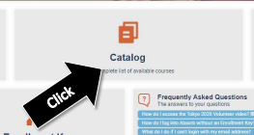
3. Enroll in and complete the required courses:
- First-Time Users: Complete "SafeSport Trained Core."
- Returning Users: Complete the appropriate Refresher Course
  - Year/Season 2 complete: Refresher 1- Recognizing and Reporting Misconduct
  - Year/Season 3 complete: Refresher 2- Preventing Misconduct
  - Year/Season 4 complete: Refresher 3- Creating a Positive Sport
  - Year/Season 5 complete: SafeSport Trained Core again and Re-start the series
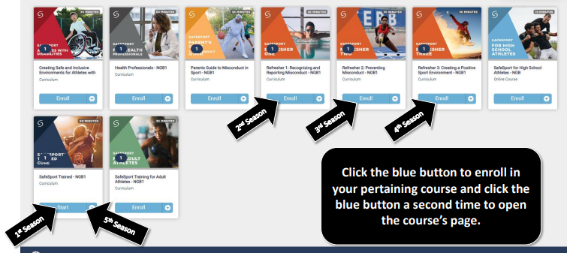
How Download Your SafeSport Certificate
- Select the Menu icon (3 horizontal lines) at the top right of the webpage.
- From the list of options select “Transcript.”
- The Transcript page displays. Locate the most current completion for the curriculum under the Certificates section.
- Download the certificate by selecting the Download button at the right of the completed curriculum
4. Send your certificate to the Team Manager: michelle.raths26@gmail.com and mark off your completion date and most-recently completed module HERE.

