
Boys Hockey Booster Club
June 26th, 2024, 7:15 PM
FHS Conf Room

Board Members:
Keith Bridgeman, President  PRESENT | Allison Fuller Vice-President PRESENT | Brian Soucy Treasurer PRESENT | Jason Conway At-Large PRESENT
Shavon Anderson, Secretary PRESENT | Jennifer Miller At-Large PRESENT | Brad Farrell At-Large PRESENT | Dave Bennett At-Large PRESENT
Dave Rodgers At-Large PRESENT | Ed Risch At-Large PRESENT | David Marsh At-Large PRESENT | Ryan Bjorkstrand At-Large
Mike Budde At-Large | Dave May Head Coach PRESENT | Stacey Farrell At-Large

CALLED TO ORDER: 718PM

Coach’s Updates: Dapper, Buell, Oslund, Martinsen (VAR) (JV) Weinburger, + 2 volunteer coaches: Shirley and Walton, possibly Willis and Rulough
FINAL QUOTE this week for jerseys
(Dave May)
- New Jersey’s
  - Waiting for final mock-up of jersey
  - Need to decide on orange breezer or orange shell which would be owned by booster.
  - Orange breezer intended for Varsity or JV and Breezer? Recommend getting the same for Varsity and JV
  - $117 - $127 for matching gloves – CCM
    - Option could be for players to buy them unless the raffle could cover.
- Bags
  - Get jersey bag zipper fixed – Stacy will get it fixed.
  - Gear bags – donate to Junior Gold. Alison will get them to Coach.
- United heroes league – 11/23/24
  - $1000 cost
- Set up a Scrimmage bus trip up north for the first Fri-Sat after tryouts.
- Hang old jerseys in the rink – Holmes is working on it.
- Helmet numbers/Logo decision.
  - Coach will work with the owner/designer.
- STP Summer tournament 7/19 – 7/21 in Eagan.
  - Other scrimmages to be set up.
  - 54 signed up for STP.
- Schedule for 2024 is set.
Treasurer Update: $200 difference approximately, not much update
(Brian Soucy, Jason Conway)
- Jason, Brian update.
- Budget Overview and wish list.
Tiger Fan Club liaison / 501-C3:
(Keith Bridgeman)
(Brad Farrell, Allison Fuller)
- Recommend staying separate entity from FYHA. We will continue to partner with FYHA as we do today for development, etc.
- $1800 - $2000 to set up our own 501-C3 VOTE – APPROVED FOR $260/HR (ANNUAL AUDIT + SET UP)
- Next steps:
  - Vote to approve all board members documented (need to clarify Budde, who will be the board member).
  - Vote to approve the Bylaws and Articles of Incorporation APPROVED
  - Vote to approve the use of the Al Quist / Bennett and Associates letter of engagement, which will be shared. MEMBERS WILL SIGN ELECTRONICALLY
- Captains practice insurance needs a separate policy, this was flagged as a concern last year.
  - Idea to add extra $ to the cost of sign-up. The club voted unanimously.

Apparel Coordinator: WILL TOUCH BASE WITH COACHES REGARDING THEIR GEAR, WILL LOOK INTO JACKETS, KIDS OPTIONAL ITEMS: BACKPACK, HAT
(David Bennett, Brian Soucy)
- Charlie will work with captains to determine apparel.
- Brian/Dave reach out to Vinar to get the ball rolling.
- Helpers for trying on apparel – Ed, Allison, Stacey - Complete
  - Motion put a price point of $200 for team apparel.
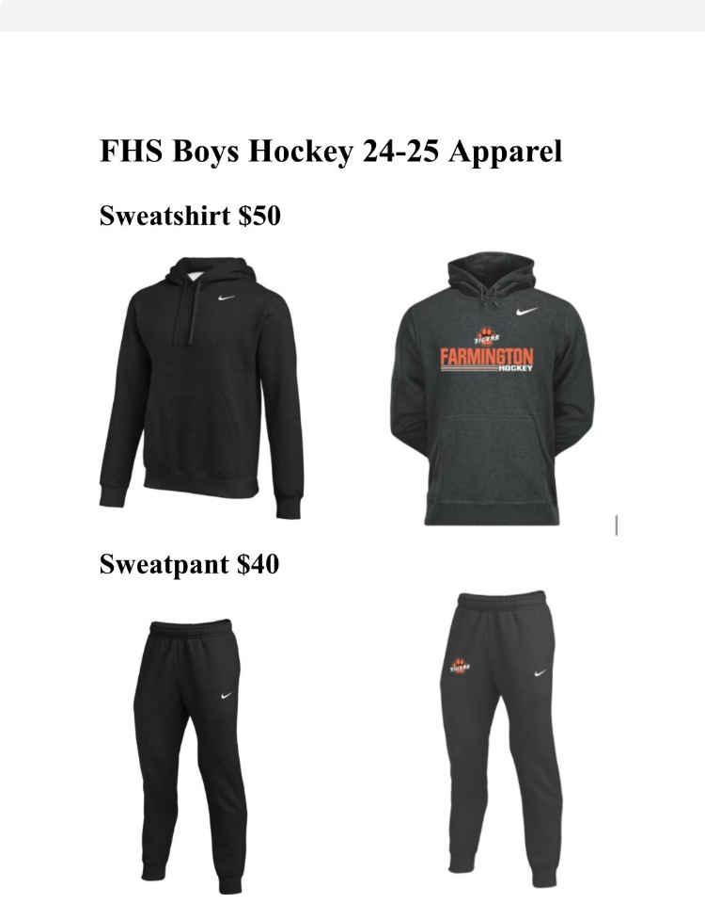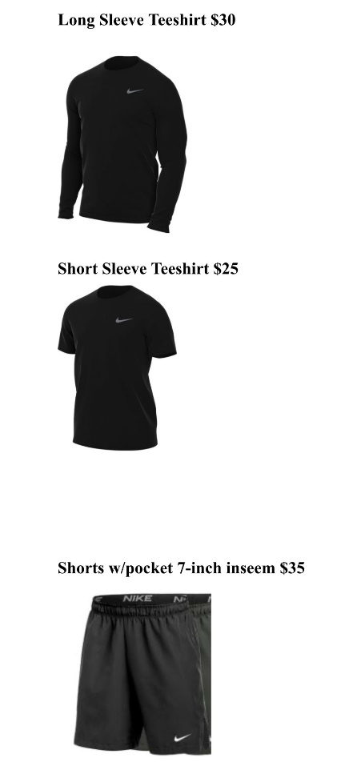

FHS Girls’ Program Liaison:
(Allison Fuller)
- Nothing New

Team Building/Community Outreach Coordinator/FYHA Liaison: 1/30 1/31 BACK TO BACK GAMES
(Shavon, Allison, Jen)
UHL/SHANE FOR UHL – COURSE FOR FALL – SHAVON WILL REACH OUT TO SCHEDULE 11/23 SCHEDULED
- MN Hockey Fights Cancer Night JEN MILLER JOLEEN B
- Flag Bearer (Mites) SHAVON
  - signup genius sent to FYHA
- Signup Genius made to coordinate shooters for FYHA Goalie training.
- MENTORSHIP (APPROX 23-26 TEAMS BOYS, 10 TEAMS GIRLS)

Fundraising Coordinators
- (David Rodgers / Mike Budde)
- Gun Raffle
  - $20 Per ticket, selling 2000 tickets. Handed out to all players at STP.
  - Dew Days – Sold 272 Tickets
  - FYHA golf event, etc
  - Gun Raffle was added to Facebook, Instagram, and X. Emailed players info.
- Steak Fry
  - August 17th
  - Return around $2500
  - Ticket $17 – price increase BRIAN WILL ORDER TICKETS (250 FOR $35)
Sponsorship Drive / Jersey Sponsorships
(Dave Marsh / Ed Risch)
- Keith put up Social Media post on June 24th. “Get Noticed, Become a Sponsor”
- Update Sponsor Letter that outlines giving levels.
  - Dairy Queen(new), Grant Heating, Omega(new), Culvers, and Insurance Producers Network are on board.
- Aim for 25-30 sponsors. (16 Sponsors in 23-24, 12 Jersey sponsors)
  - Sponsorship/Ad raised in 23-24 season = $12,450.
- Will order Sponsorship warm-up Jersey with the Girls team this season to lessen cost.

Game Day Production / Rink
(Ryan Bjorkstrand)
- Rink not interested in any extras.
- Look into using the contract which the school has with the city – Oct approval.
- Signs – have the wrong logos – Ryan B will take care of them
Game Day Programs Coordinator DAVE WILL LOOK INTO PRINTER/DESIGNER, WILL NEED TO DETERMINE HOW MANY SPONSORS TO DETERMINE IF WE ARE DOING OUR OWN PROGRAMS OR COMBINING AGAIN WITH THE GIRLS
(Stacy Farrell)
- Who are we going to use next season?
- Rachel Acari put them together for Boys/Girls ($500 split with girls)
- ISD #192 printed 100 copies for free.
- Jeff Lewis @ Total Source Printing printed 75 nice copies.
  - $5.45/per copy (408.00)

Photography Coordinator
(Stacy Farrell)
- 24/25 Badger chose 1 photographer (under contract) to take all team photos, so they are uniform.
  - Confirm our financial responsibility.
- Action shots, you can use who you want. Use Benny Lego again?

Senior Night Coordinators THURSDAY 2/6 VS MANKATO
(Your Name Here)
- Prefer to have it later in the year. Pick the home game.

Social Media/Communications Coordinator: WILL POSTERIZE THE GAME SCHEDULE FOR THE RINK – PERHAPS 3x5 AND SEE IF THE GIRLS WILL DO ONE TOO
(Keith Bridgeman)
- 24-25 Schedule was put up on all social sites.
  - Will finalize all game-times and then print posters for business and rink.

Team Meal/Snack Coordinator:
(Jason / Allison)
- Team meals at peoples’ houses
- Breakfast provided after pictures.
- Subway, Noodles, Culver’s, Chick Fil-A have been used for out-of-town games.
- Snacks and Drinks purchased at Sams for home/away games.
- Kwik trip gift card donation
  - Allison received $125.

Webmaster:
(Keith Bridgeman
- Keith updating the new TFC site. All website info will reside here now,
Hockey, Boys (tigerfanclub.org)
- Redirect the old site to the new one.
- Add an appreciation night – First responder, military, police, teacher, etc. in addition to cancer night. Keith will ask Badger about this.

Alumni Liaison/Legacy Fund:
(Jen Miller)
- College Photo Wall

End of Season Banquet Coordinator:
RESERVE DATE/SET UP COMMITTEE LATER
- Keith Confirmed date for 2025. MARCH 10, 2025. Have reached out to Andrea but have not heard back yet.
  - 23/24 ($4400 + COST OF DESSERT)
  - Bracketts Crossing, Andrea Pelletier apelletier@brackettscrossingcc.com

Open forum for new/existing issues/things to keep in mind:
- Managers KALLIE BRUBAKER POSSIBLE, WORKING ON FINDING OTHERS
  - Coach – can you put together what the roles and responsibilities are?
  - Up to four managers (2 each JV, Varsity)
  - Up t0 $200 each for apparel voted Unanimously.
- Sparks wheels
  - Coach is putting together a list of things needed.
  - Tape
- Coaching staff
  - Six paid and 2 volunteer.
  - Coach wp.
  - $300 for coaching apparel spend.
- Captain practice Registration sent out to all current and incoming players. Jason is our contact. 52 TOTAL RESPONDED SO FAR
Approval of Minutes
Next Board Meeting: July 24th, 7:15PM, LOCATION: Farmington Lanes
MEETING ADJOURNED:

Future Meetings
- July 24th, Farmington Lanes
- August 21st FHS Conf Room 1201
- Sept 18th FHS Conf Room 1201
- Oct 23rd FHS Conf Room 1201
- Nov 20th FHS Conf Room 1201
- Dec 18th FHS Conf Room 1201

Briansoucy01@gmail.com NEEDS to UPDATED in the distribution list!

ADJOURNED: 904PM

