LITTLE LEAGUE BASEBALL, INCORPORATED
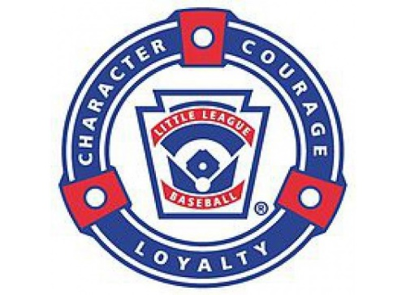
WILLIAMSPORT PENNSYLVANIA
Red Bluff Little League PO Box 284
California District 1 Red Bluff, CA 96080

Red Bluff Local Farm 1 Rules
___________________________________________________________________

FARM 1:
- Games are 90 minutes or 6 innings (whichever comes first).
- Outs count but no strikeouts.
- 3 outs made or batting through the lineup completes a half-inning.
- Runners stop when the ball is controlled in the infield.
- Bat entire roster and each player shall play half the game defensively.
- 10 defensive players on the field (4 outfielders).
- On defense, only rostered managers/coaches allowed on the field.
- On offense, only rostered manager/coaches allowed as first and third base coaches.
- No stealing. No running until the ball is put into play by a batted ball.
- Coach pitches to their batting team and will also serve as the umpire.
- Each player gets five hittable pitches only.
- Safety balls will be used.
- No player shall play a single position more than two innings in a game.

