Centennial High School Boy’s Hockey Legacy Plaque
This is a unique opportunity to become a lifetime sponsor of the High School Boy’s Hockey Program and have a legacy plaque in your honor adorn a locker in a newly constructed boy’s locker room. To become a lifetime sponsor we ask for a minimum donation of $500. Each 10” x 10” legacy plaque will have a space for you to customize a personal message. The plaques will be permanently attached to an individual locker or placed in the perimeter of the locker room. All money raised by this fundraiser will be applied to the Centennial High School Boys Hockey program.
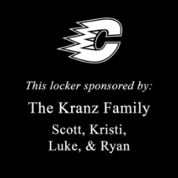

Sample Legacy Plaque
To reserve your legacy plaque. Return this completed form along with a check for your donation written out to Centennial Boys Hockey Blue Line Club.
Name: _________________________________
Email: __________________________________
Phone number: __________________________
Wording on the plaque:
_____________________________________________________________________________________
_____________________________________________________________________________________
_____________________________________________________________________________________

Submit form and donation to: Centennial Boys Hockey Blue Line Club, PO Box 332, 300 Civic Heights Drive, Circle Pines, MN 55014
If you have any questions, please contact a Blue Line Club Member.

The Centennial Boys Hockey Blue Line Club is a tax exempt Section 501(c)(3) organization. Your gift may qualify as a charitable deduction for federal income tax purposes. Please consult your tax advisor or the IRS to determine whether your contribution is deductible. No goods or services of any value were provided in exchange for this contribution.

