How to Enter your game information after the completion of the game.

Sign into website, if you have not done that yet.



Next, go to “SYB Leagues” on the top toolbar and click on your league

Scroll down and click on “Game Schedule”


If not on the day of your game, change the date. Then once you find your game, Click on the Item in the Status Column of your game.

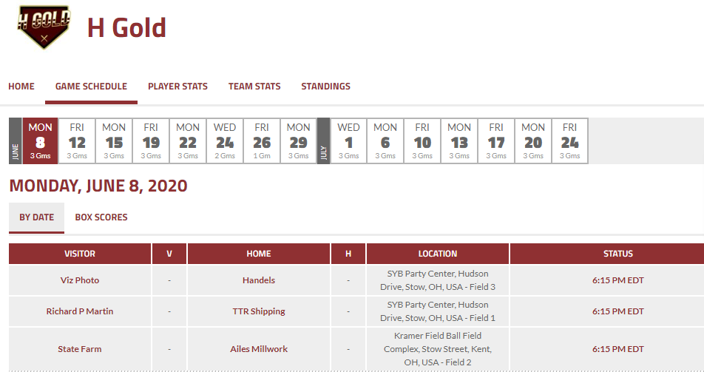

Click on ‘Edit Stats’
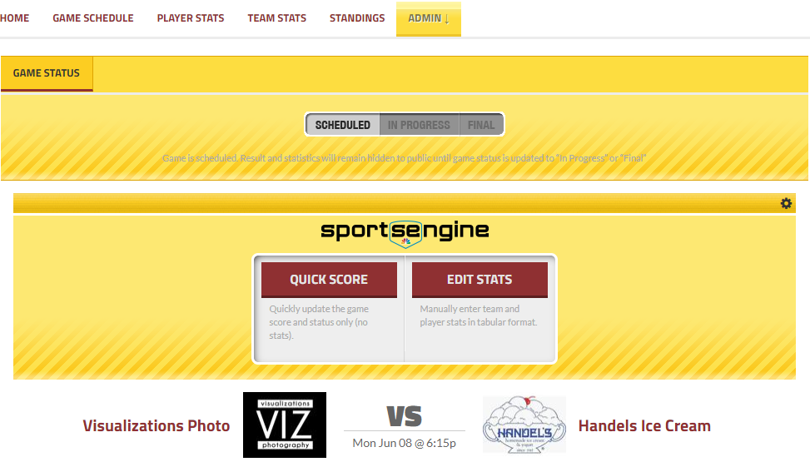

If you do not see this option, Make sure your ‘Edit Mode’ is on. It will be located on the left side of the screen.


Enter the Score
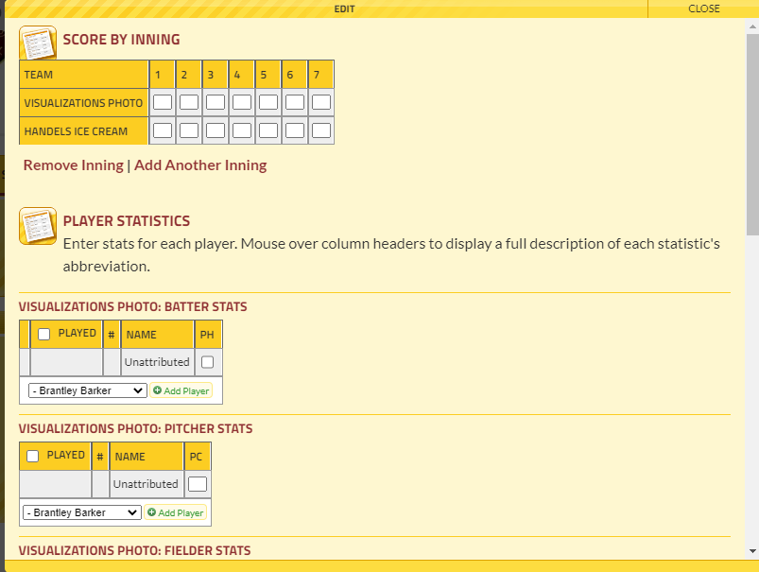

Under Pitcher Stats, pick a player from the drop down and hit the + to Add Player
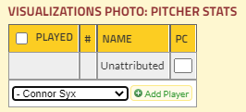

Do this for every pitcher used in the game and enter their pitch counts.
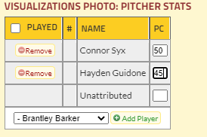

Once done, select ‘Save Stats’ at the bottom of the screen (will have to scroll down). If this button is not pushed, you will have to start over as the stats will not be saved.

