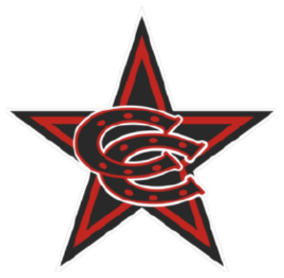

**Fall 2025 12U Select Team Roster**

|  |
| --- |
| **Coppell Cowboys**  Coach O’Brien |
| 1. Luke Burgin 2. Maximus Campos 3. Jude Cato 4. Diego Espejo 5. Eli Lozano 6. Mikah May 7. Ahaan Narkar 8. Corbin O’Brien 9. Trace Parson 10. Easton Richards 11. Luke Walsh 12. Ben Wilcox |
|  |