Video: | - To Be Added
JO Club Experience | - Coastal 16 Gold (2018); Coach Kevin Charles  - Coastal 16 Riley (2019); Coach Chris Riley  - Coastal 17 Stein (2020) Coach Will Stein
Education: | - Member of International Baccalaureate Program at Granby High School  - Member of National Society of High School Scholars  - GPA: 4.2  - (2019-2020) Class Schedule: IB Math SL, IB Psych, IB English III, IB Hist AM, IB Bio, IB Spanish IV  IB The Know I/II
High School Experience: | - 2018 Varsity Starter  - 2019 Varsity Starter
Camp Experience | - 2017 Mary Washington Nike Camp  - 2017 Virginia Wesleyan Camp  - 2018 Sports Performance Setting Camp  - 2019 Michigan Volleyball Camp
Extracurricular Activities: | - Former Girl Scout  - Volunteer at Food Bank of Southeastern Virginia and the Eastern Shore  - Volunteer at ForKids Emergency Shelter
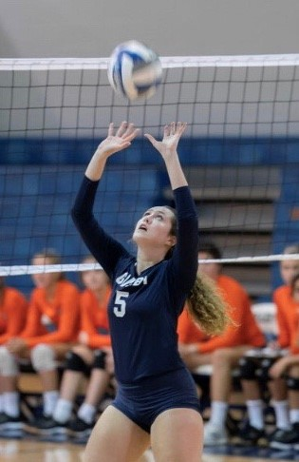
Contact Information:
Maggie’s email: maggie.pitman@icloud.com Club Coach: Will Stein
Maggie’s Phone: (757) 793-6985 Club Coach Email: will.stein@coastalva.org
Father’s Phone: (757)803-3235 Club Coach Phone: (757) 744-9336
Father’s email: pitmangreg@cox.net Club Recruiting Coordinator: Will Stein
Mother’s email: pitmanmary@cox.net will.stein@coastalva.org
Club Recruiting Coordinator: Phone No.
(757) 744-9336

First Name: Margaret
Nickname: Maggie
Last Name: Pitman
Height: 5’8”
Weight: 140 lbs.
Age: 17
Date of Birth: 11/23/2002
Dominant Hand: Right
Position: Setter
2nd Position: Defensive Specialist

Margaret (Maggie) Pitman #23
Setter Coastal VA Volleyball Club, Team 17 Stein (Open) c/o 2021

High School: Granby (Norfolk VA)
Class of: 2021
Grade: 11
H.S. Coach: Kristina Villanueva
Club: Coastal VA (CVVC)
Club Team: Coastal 17 Will
(Open)

Club Head Coach: Will Stein

NCAA Clearinghouse # 180332695

