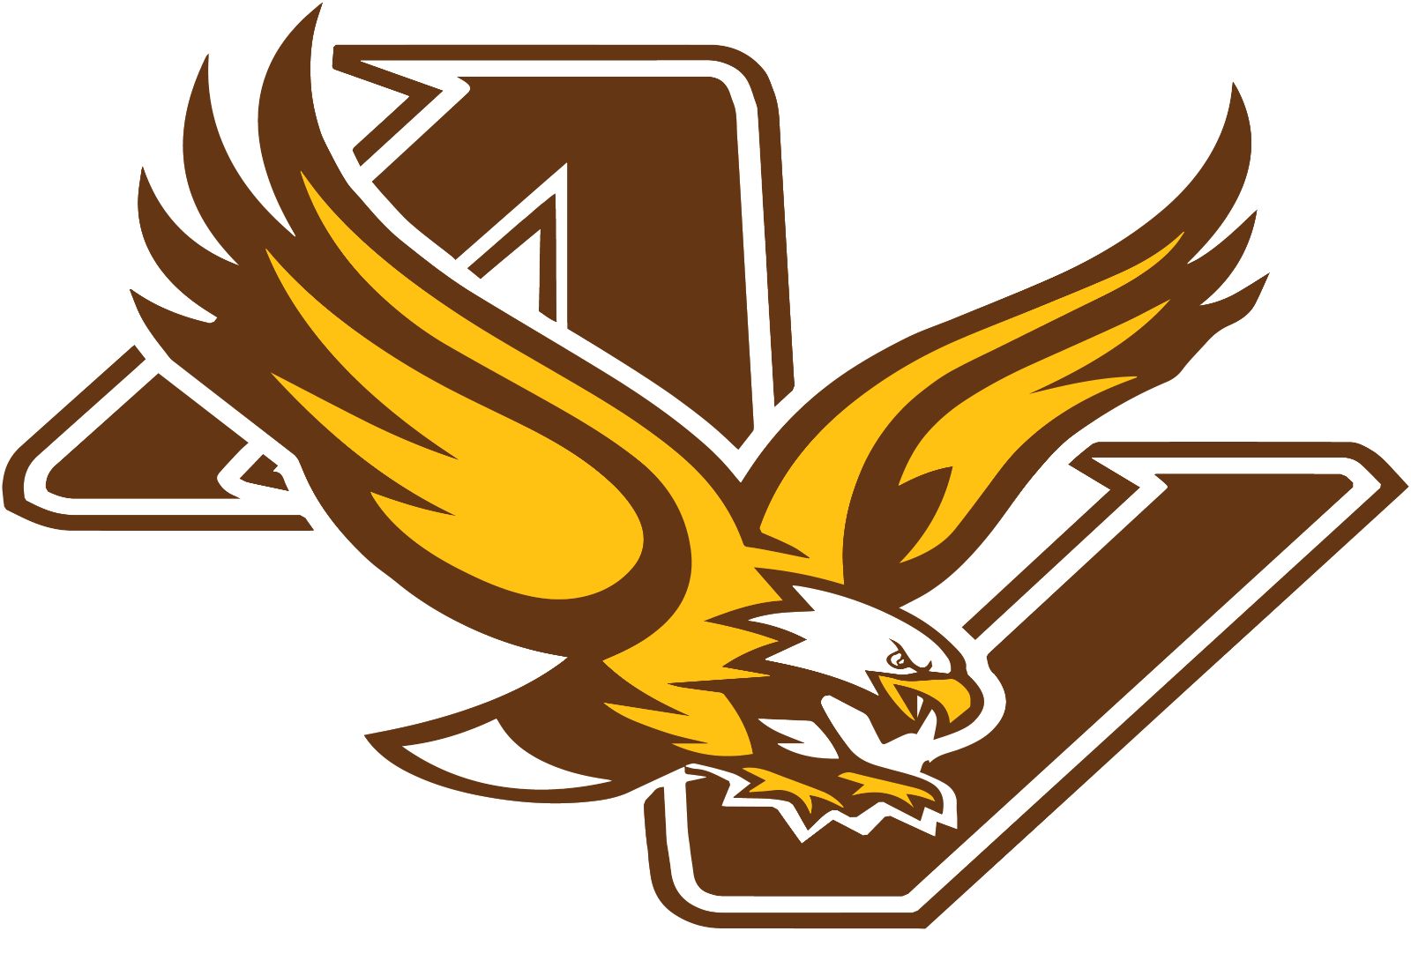
Apple Valley Baseball
Cooperstown 2021 Sponsorship Opportunities
Apple Valley’s 12AA Traveling Baseball team will proudly represent their hometown at Cooperstown Dream Park in Cooperstown, New York in the summer of 2021. Participation in the Cooperstown tournament includes a week of 7 or more tournament games with teams from all over the country and events such as a tour of the National Baseball Hall of Fame and induction into the American Youth Baseball Hall of Fame. Described as a dream-like setting for playing baseball, we are asking you to help us make this dream come true for our team by becoming a sponsor.
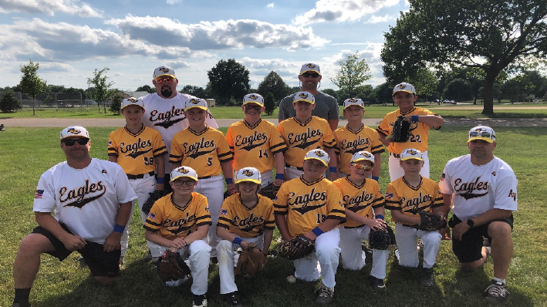
Roster:
Paxton Ames #7
Kellen Britt #22
Ben Chamberlain #5
Kole Fricke #49
Sam Gilbertson #3
Wade Gilbertson #14
Collin Hill #1
Marshall Link #19
Jonah Provencher #99
TJ Robb #18
Noah Weaver #44
Coaches: Brian Ames, Eric Robb, Dave Chamberlain, Lonnie Provencher

Sponsor Options and Recognition:

MVP Sponsor: $1,000 +
Listed as a MVP Sponsor on both sides of our 2021 team banner (displayed at all 2021 events and games), on our Cooperstown t-shirts, and on our website.

Grand Slam Sponsor: $500
Listed as a Grand Slam Sponsor on both sides of our 2021 team banner (displayed at all 2021 events and games), on our 2021 Cooperstown t-shirts, and on our website.

Home Run Sponsor: $250
Listed as a Home Run Sponsor on one side of our display banner (displayed at all 2021 events and games), and on our website.

Team Sponsor: $100
Recognition as a Team Sponsor on our website.

What Your Sponsorship Pays For:
- $1,295 -- Fees for 1 Player/Coach
- $600 -- Tournament Umpire Fees
- $250 -- Team Trading Pins

Other Expenses: Team photos, team banner, team lunches, t-shirts

Apple Valley Baseball Sponsorship Sign-Up Form
Donation Amount: $
Level of Sponsor: MVP $1,000+ Grand Slam $500 Home Run $250 Team $100
Contact Name: Contact Phone Number:
Email Address:
Business/Individual Donor Name (to be displayed):
Business/Individual Donor Address:
- Make checks payable to VAA Cooperstown Baseball
- Do you want your Business Logo/Name displayed: Yes No
If yes, please submit logo in .jpg format with translucent background to AV Baseball Sponsorship Contact (below)
- Do you need a receipt noting your donation? Yes No

- Please email or mail Sponsorship Form to AV Baseball Sponsorship Contact (below)
AV Baseball Sponsorship Contact: Lori Hill, Cooperstown Treasurer; 812 Springhill Drive
Burnsville, MN 55306; intuitivesouls@hotmail.com
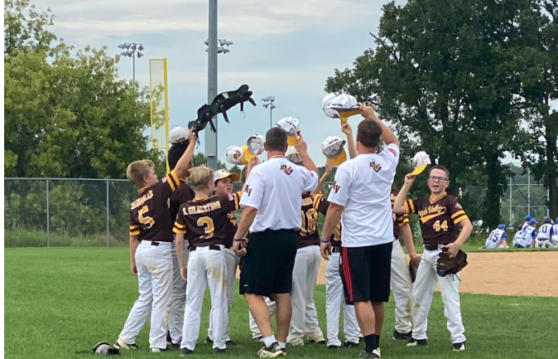

For questions, please contact Lori Hill at 651.245.8941.
VAA is a 501(C)(3) non-profit organization.
Thank you for your support and generosity!
2021 Apple Valley 12AA Traveling Baseball and Valley Athletic Association

