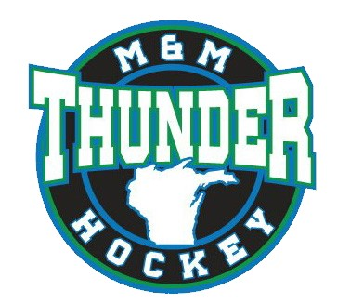

Marinette Menominee Area Youth Hockey Association
Board Meeting Agenda:
REC Center 2/1/2023 5:30PM
- Call Meeting to Order
- Approval of last meeting minutes
- Public Comment
- Officer Reports
President
Vice President Rules & Regs
Secretary Facility Director
Treasurer IP Director
Athletic Director
- Chairperson/Representative Reports
Registration Chair Concession Chair
WAHA Representative Fundraising Chair
Sponsorship Chair Hours/Dibs Chair
- Team Rep Reports
18U – HS 10U Squirt B
14U – Bantams 10U Squirt C
12U – Pee Wee Mites/Cross Ice/IP
12U - Pee Wee
- Old Business
  - Outdoor Show
  - MMA/Squirt Tourney
  - MMA Locker Rooms
- New Business
  - End of Season Banquet
  - WAHA Region 3 Playdown
- Public Comment
- Agenda Items for Next Meeting
- Closed Session
- Adjournment
Next regular meeting is set for 3/1/2023 at 5:30pm.

