TOMAHAWK CHOP
Open Tournament
Sunday Dec 14, 2025
________________________________________________________________________________________________________________________________________________
Location:

Indian Creek HS Field House
802 S Indian Creek Dr. Trafalgar, IN 46181
Door 27E (back of the school)
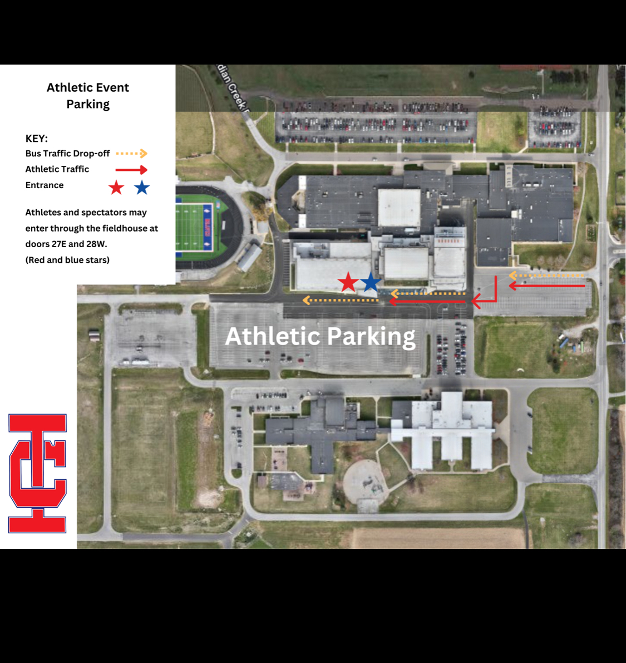
*PLEASE BRING LAWN CHAIRS! There is limited
bleacher seating available.

Session 1:
6u, 8u, 10u
Doors Open: 8:00 am (NO EARLY ENTRANCE)
Wrestling Start: 9 am

Session 2:
12u, 14u
Wrestling Starts: 1 pm

ENTRY FEE : $25

SATELLITE WEIGH INS
Sanctioned club representative must send satellite weigh in by NOON Saturday 12/13/24. Email indiancreekwc@gmail.com A challenge fee of $10 will be paid to the tournament director, if a wrestler is 3lbs out of their weight class the wrestler is disqualified without a refund.

Awards
Medals 1st-4th

Spectator fee: CASH ONLY
$5 person
$10 family
Coaches free with card
No USWA cards on site, purchase at www.usawmembership.com

Contact email: indiancreekwc@gmail.com

