Team: 16U Cadet National Duals
Team Leader: Cory Graham
Coaches: Gralan Early, Dylan Lydy, Isaac Ray, Mike Morgan, Ethan Bunce, Dezmen Goddard
Volunteers You'd Like to Thank: Frank Ingalls for table work.

Team Results:
Greco Gold- All-American, Gold/Silver Pool, Sixth Place Overall, 4-4 Record
Freestyle Gold- All-American, Gold/Silver Pool, Eighth Place Overall, 4-5 Record
Greco Blue- Red Pool, Third Place, 2-6 Record
Freestyle Blue- Bronze/Copper Pool, Eighth Place, 2-6 Record

Roster:
88- Revin Dickman F:9-0, G: 5-3, All Freestyle Team; Nathan Rioux F:7-1, G: 5-0, Ayden Bollinger F: 4-4, G: 2-0
94- Brady Byrd F: 1-8 G 2-6; Tristan Smith G: 4-3, Tyler Tun G: 1-2
100- Gavin Jendreas F: 7-2 G: 2-0; Luke Rioux F: 8-0 G: 3-4, All Freestyle Team
106- Tanner Tishner F: 5-4, G: 4-3; Isaiah Schaefer F: 4-4 G: 4-3
113- Seth Syra F: 3-6, G 1:7, Jalen May F: 2-6, G: 1-6; Terry Easley G: 0-7
120- Griffin Ingalls F: 4-4 G: 1-7; Parker Reynolds F: 4-5
126- Kyrel Leavell F: 6-3 G: 7-1; Joey Buttler F: 4-4, G: 4-3
132- Justice Thornton F: 3-6 G: 2-6; Dillon Graham G: 0-3, Jason Shuey F: 0-7 G: 0-4
138- Rider Searcy F: 6-3 G: 4-3; Jackson Todd G: 4-4; Cameron Clark F: 1-8
145- Anthony Rinehart F: 2-6 G 2-6; Aidan Torres F: 4-5 G 4-1; Waylan Cressell G:3-3
152- Luke Robards F: 1-8 G 4-3; Hunter May G: 2-2; Brenton Russell G:1-3
160- Anthony Cashman F: 3-6 G: 5-2; Logan Farnell F:2-7 G: 0-1; Clay Guenin F: 2-6
170- Michael Durham F: 3-5 G: 4-4
182- D’Alcapone Veazy F: 6-3 G: 7-1; Jaquan East F: 4-4 G: 3-4
195- William Clark F: 5-3 G: 3-3, Gunnar Henry F: 5-4 G: 3-5
220- Paul Clark F: 2-7, G: 6-2; Kyvan Bandy F: 3-5, G: 3-4
285- Dominic Burgett G: 3-5; Hosia Smith F: 5-4 G: 4-3

Narrative: Team Indiana Gold made history this year by becoming the first 16U National Duals team to ever All-American in both Freestyle and Greco in Indiana history. This accomplishment was achieved through hard-work, determination, and great team comradery! These boys were relentless and fought for every single point. They finished 2nd in their first pool in both Freestyle and Greco in order to make the Gold/Silver Pool. The team finished in 6th place in Greco-Roman and 8th place in Freestyle. Team Indiana Blue also had a good showing at the duals. The team finished 5th in the Red Pool in Greco against some stout competition. They had a great Freestyle showing, making the Bronze/Copper Pool and finishing 16th in the country overall. Revin Dickman and Luke Rioux both went undefeated, making the Freestyle All-Tournament Team. All of these young men did a tremendous job representing themselves and the state of Indiana.

Photo(s) & Captions:
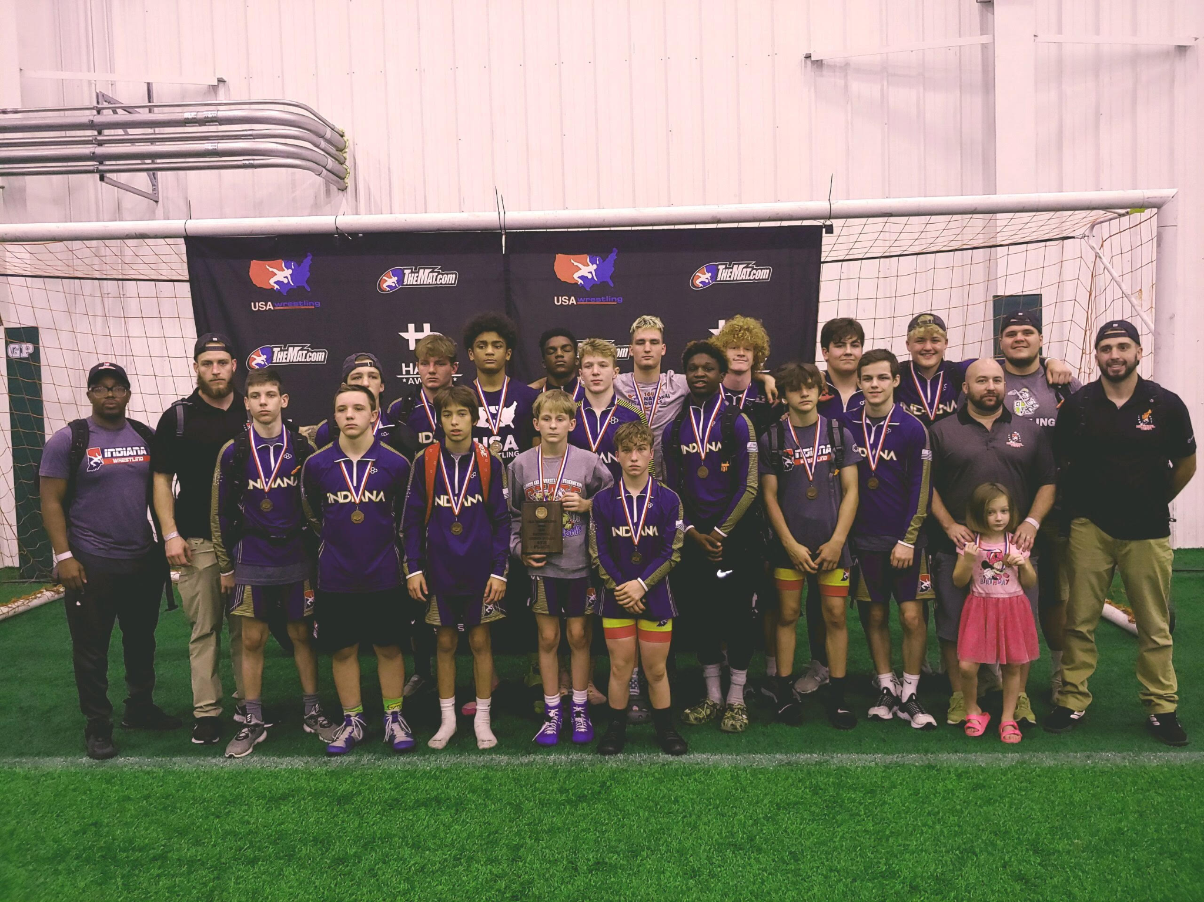
Back Row: (Coach Gralan Early, Coach Dezmin Goddard, Jackson Todd, Gunnar Henry, Brenton Russell, Michael Durham, Anthony Cashman, Logan Farnell, Dominic Burgett, Paul Clark, Coach Ethan Bunce)
Front Row: (Tanner Tishner, Justice Thornton, Tyler Tunn, Revin Dickman, Brady Byrd, Kyrel Leavell, Seth Syra, Griffin Ingalls, Coach Mike Morgan, Coach Cory Graham)

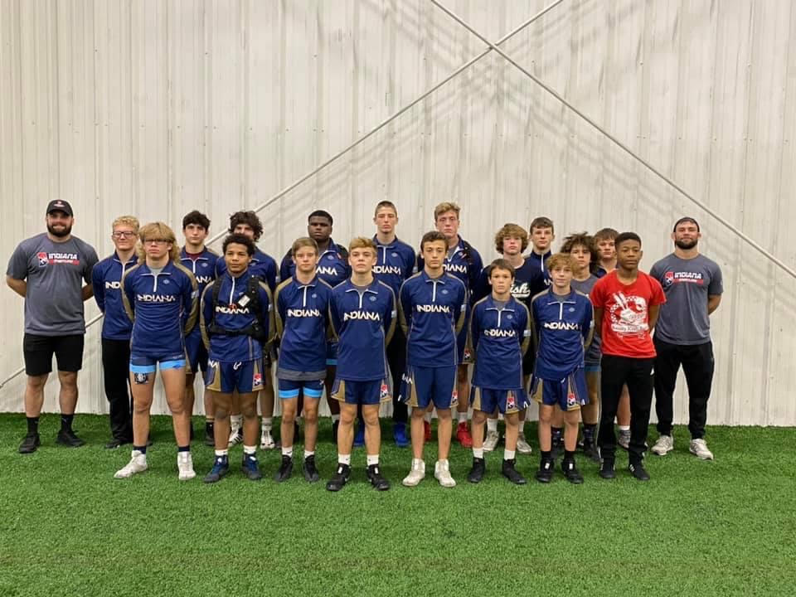

Back Row: (Coach Isaac Ray, Rider Searcy, Aidan Torres, Luke Robards, Hosia Smith, Clay Guenin, William Clark, Dillon Graham, Waylon Cressell, Joey Buttler, Kyven Bandy, Coach Dylan Lydy)
Front Row: (Jason Shuey, Jalen May, Tristan Smith, Isaiah Schaefer, Luke Rioux, Nathan Rioux, Ayden Bolllinger, Terry Easley)

Thank you!

