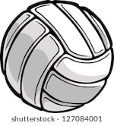

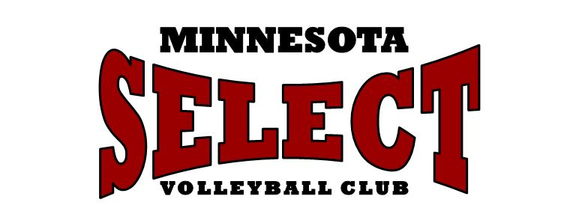

MN Select Spring Break Camps – 2020
March 16-18, March 30-April 1 and April 6-8

Minnesota Select will offer Spring Break Camps the weeks of March 16-18, March 30-April 1 and April 6-8. Camps will be held for Elementary girls (grades 3-5) Middle School (grades 6-8) and High School (grades 9-12). Three sessions will be offered on Monday, Tuesday and Wednesday of each week with sessions running from 9:00-11:00am (for Elementary) and 9:00am-12:00p.m for Middle School and High School girls.

The Spring Break Camps are a great opportunity for those who wish to stay sharp during the off season, improve their skill base, or continue working during their JO season. These camps will also provide the opportunity for you to work with some of the coaches at MN Select.

The 2020 Spring Break Camps are listed below. We have split the camps by age group.
- The Elementary Camps are 2 hours and cover skills training, while also including some competitive game-like drills each session so that participants can use what they have learned.
- The Middle School and High School aged Camps will be 3 hours in length and include skill training, competitive game-like drills, and work on improving overall volleyball IQ.

Camp Weeks | Time | Age Level | Cost
March 16-18, March 30-April 1, April 6-8 | 9-11am | Grades 3-5 | $110 or $40/day
March 16-18, March 30-April 1, April 6-8 | 9am-12pm | Grades 6-8 | $160 or $60/day
March 16-18, March 30-April 1, April 6-8 | 9am-12pm | Grades 9-12 | $160 or $60/day
Email info@mnselect.com prior to a walk up to check for availability.

