Volunteering Instruction Guide

Table of Contents
Field Setup & Takedown Volunteers 3
What will I be doing? 3
How much do I need to know about lacrosse to volunteer in this role? 3
When and Where to Report? 3
Ball Shagger (Home and Away Side Volunteers) 4
What will I be doing? 4
How much do I need to know about lacrosse to volunteer in this role? 4
When and Where to Report? 4
Scorer’s Table – Clock/Scoreboard Operator 5
What will I be doing? 5
Equipment Details 5
How much do I need to know about lacrosse to volunteer in this role? 5
When and Where to Report? 5
Scorer’s Table – Scoresheet 6
What will I be doing? 6
How much do I need to know about lacrosse to volunteer in this role? 6
When and Where to Report? 6
Hudl Video Camera Operator 7
What will I be doing? 7
When and Where to Report? 7

Field Setup & Takedown Volunteers

What will I be doing?
The field setup volunteer will be responsible for the setup and preparation for both JV and Varsity games that take place on the home field that day.
This will include the following:
- Placement of home and away goals
- Placement of field 4 corner posts
- Setup of Scorer’s Table & Clock/Scoreboard Unit
- Placement of practice ball bucket on the field
Note: Once you’re done a quick touch base with both the scorekeeping and ball shagging volunteers is nice to let them know they can start the setup for their volunteer roles.
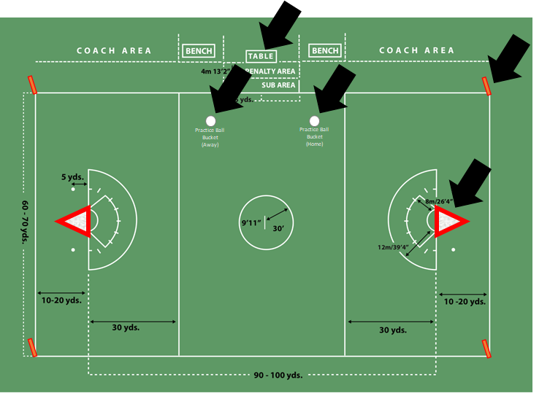

How much do I need to know about lacrosse to volunteer in this role?
Nothing. The nets are heavy and require a strong adult to move them across the field. Everything else is a walk in the park.

When and Where to Report?
Report to the field 30 minutes before game start.
The field setup volunteer will leave a ‘ball bucket’ from which practice balls will be used by teams.

Ball Shagger (Home and Away Side Volunteers)

What will I be doing?
The ball shagger is positioned at the field end lines and replaces the end line balls (see black arrows in diagram) with balls that leave the field from missed passes or shots that leave the field.
- Grab 12-15 balls from the practice ball bucket (to have some extra) and position them prior to game start
- 10 balls per side and are kept in rotation
  - 6 end line balls at end lines
  - 2 balls on either sideline of each end for sharp angle shots
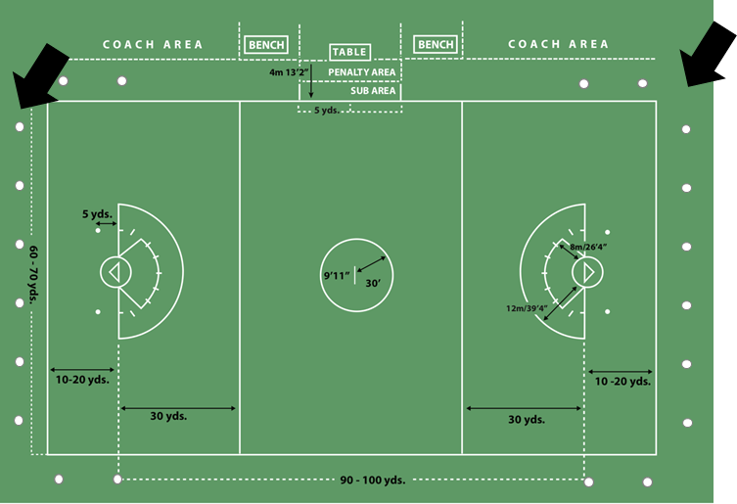

How much do I need to know about lacrosse to volunteer in this role?
Nothing. See ball fly by, replace ball with ball you have in hand. That is all.

When and Where to Report?
Report to the field 15 minutes before game start.
The field setup volunteer will leave a ‘ball bucket’ from which practice balls will be used by teams.

Scorer’s Table – Clock/Scoreboard Operator

What will I be doing?
The clock/scoreboard operator manages the times and scores for the game. This activity will absolutely require the volunteer’s full and undivided attention during the entire game. You will be called upon to interact with the game’s officials and possibly also some of the team’s coaching staff.

Equipment Details
Daktronics Clock/Scoreboard Dashboard: The clock/scoreboard operating unit will be placed on the scorers tables by the field setup volunteer prior to the start of team warm-ups.
ADD CLOCK INSTRUCTIONS

How much do I need to know about lacrosse to volunteer in this role?
This is a volunteer where some lacrosse knowledge is beneficial as there is some interaction with game officials.

When and Where to Report?
Report to the field 10 minutes before game start.
The clock unit will be placed on the scorer’s table by the
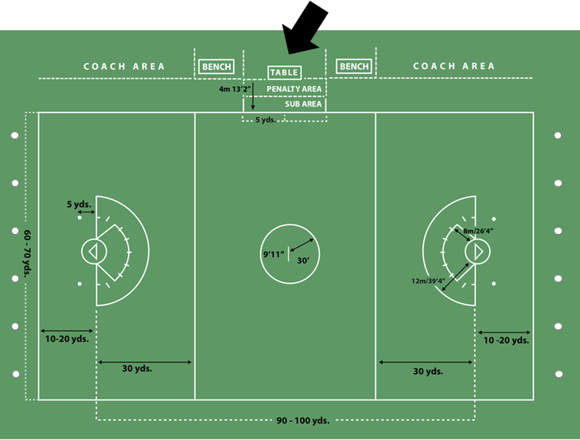

Scorer’s Table – Scoresheet

What will I be doing?
The scoresheet volunteer manages recording the game details on the official game scoresheet.
This activity will require the volunteer’s full and undivided attention during the entire game. You will be called upon to interact with the game’s officials and possibly also some of the team’s coaching staff.
You will be recording the game’s scoring and penalties including clock times as well as infractions (penalties) so this is a role of detail and keeping up is important.
ADD SCORESHEET INSTRUCTIONS

How much do I need to know about lacrosse to volunteer in this role?
Nothing. Paying attention will be required, but this is a great volunteer role to help you learn more about lacrosse since you’ll be near a lot of the action without needing to know a lot .

When and Where to Report?
Report to the field 10 minutes before game start.
The scoresheet will be left will be placed on the scorer’s table by the home team manager(?)

Hudl Video Camera Operator

What will I be doing?

When and Where to Report?

