Beginner Pitching Mechanics

After another successful pitching clinic this past weekend, I have received questions about what was taught and what pointers need to be reminded to players over the season. The pitching mechanics taught to 9 and 10 year-olds are the building blocks to be both successful pitchers and successful fielders. As the kids get older, more “advanced” pitching mechanics will be added in. During the first year or two of pitching, accuracy over speed should be emphasized. Below are the methods used to introduce proper throwing and pitching mechanics during the pitching clinic hosted by HBA.

The most important part of throwing mechanics for accuracy is the proper grip which will allow for more accurate and strong throws. The 4 seam grip allows for the fingers to pull down on the seams and get maximum backward rotation on the baseball. This allows the ball to spin true and straight. The 4 seam grip should be used every time a position player throws a baseball, and by pitchers who are learning to pitch for greater accuracy. Below are two different ways to throw a 4 seam grip. During the pitching clinic the grip in Figure 1. 4 seam grip option 1 was taught.
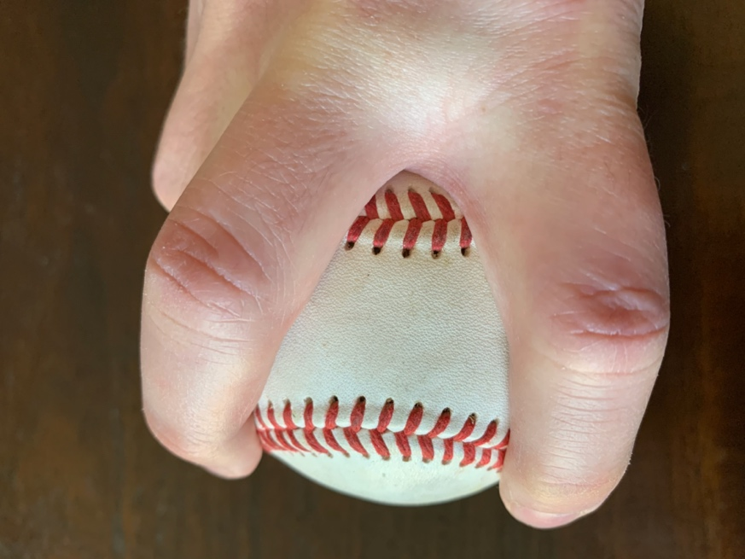
Figure 1. 4 seam grip option 1
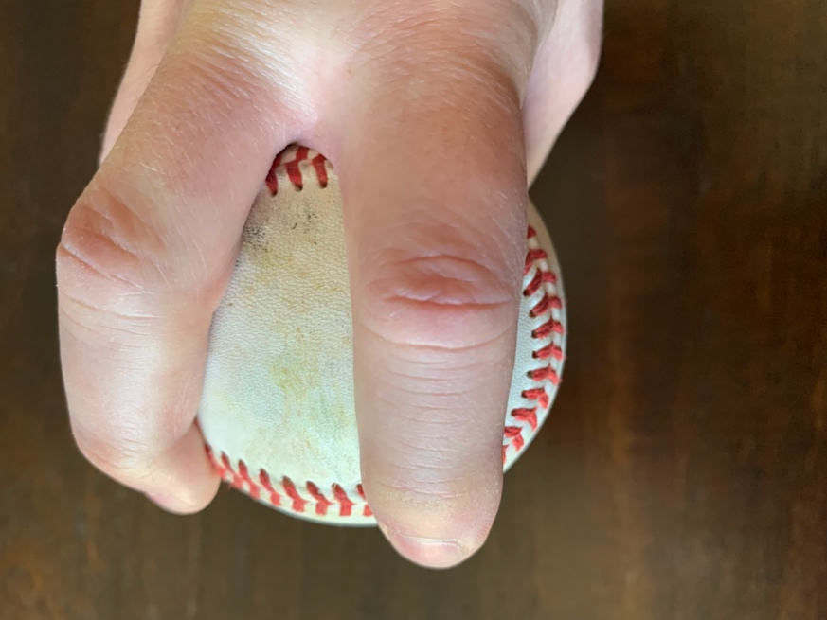
Figure 2. 4 seam grip option 2

During the pitching clinic, players participated in a simple drill to pull the baseball from their glove and find their 4 seam grip. The goal of the drill was to get the players to feel for the proper grip without looking at the baseball. This drill is more important for fielders, who need to get the proper grip quickly.

The next thing the players were taught is how to stand on the pitching rubber in the stretch. This stance is used by a pitcher when runners are on base and allows for the pitcher to throw over to a base in a pick-off attempt in older ages. The reason that pitchers are taught to pitch from the stretch at the beginning, is it allows for proper alignment to home and reduces the chances of getting off balance from high leg kicks from the windup. The first part of the stretch is to start with the glove and ball separated, against opposite legs, feet are usually wider than shoulder width apart. Then the pitchers will come “set”, where the ball and glove meet in front of the chest of the pitcher and feet are brought to shoulder width apart. Pitchers shall pause for at least 1 second when coming “set” before delivering the pitch.

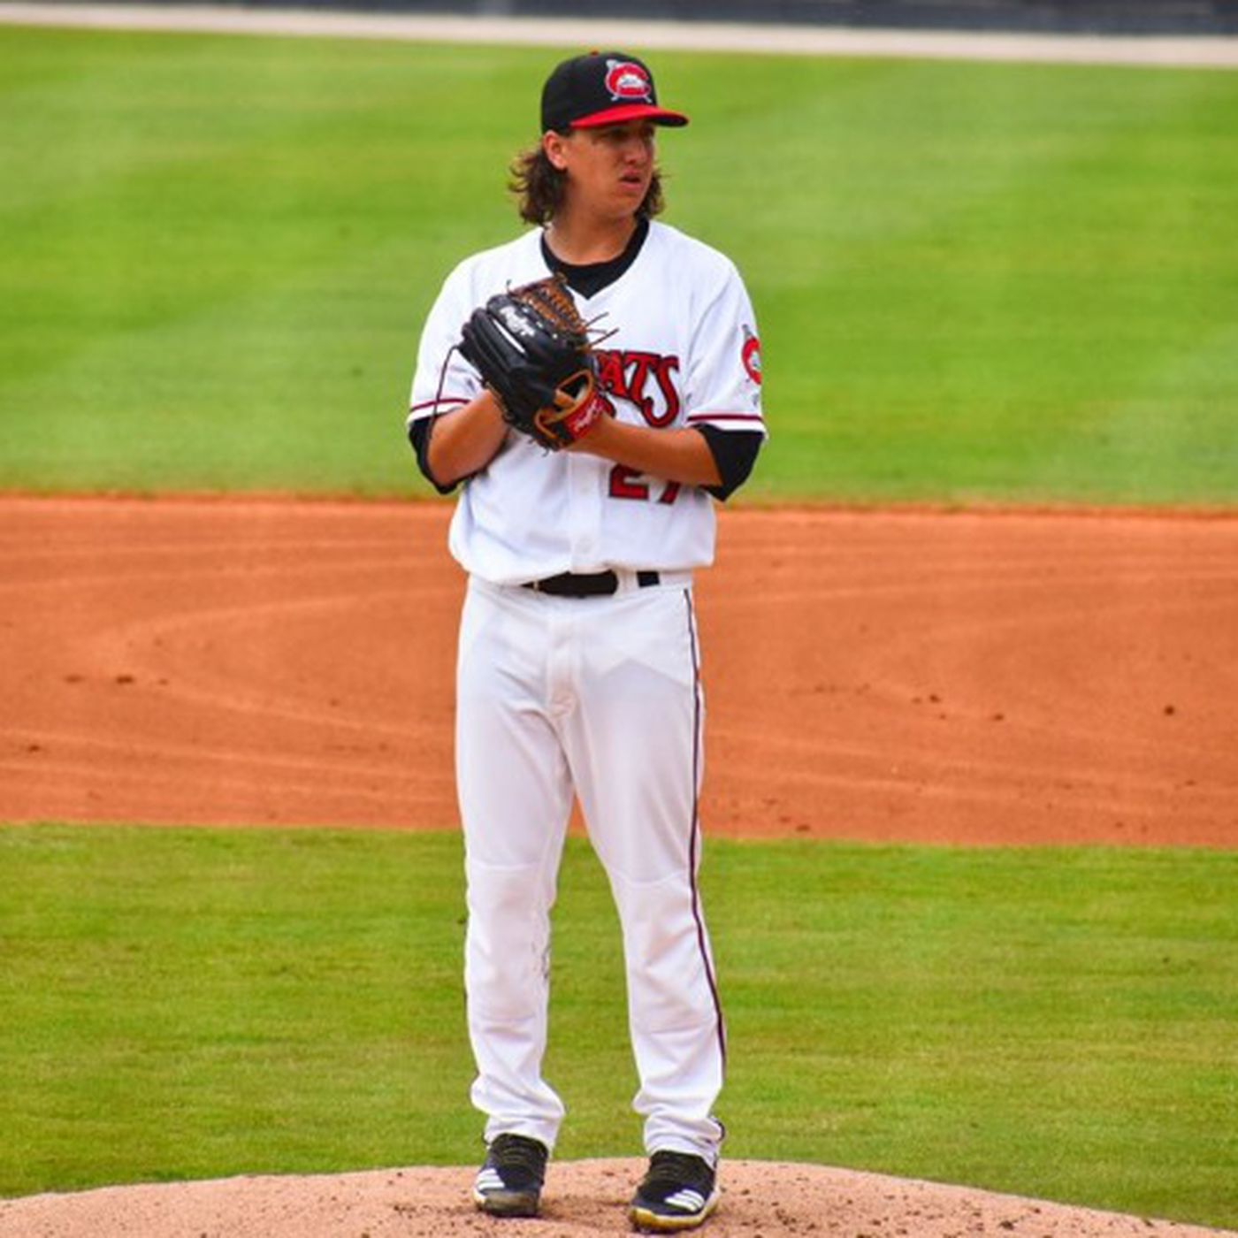
Figure 3. Pitcher Comes "Set" Delivering from the Stretch

The first lower body movement which was taught was the slide step. The front foot should have a minimal lift off the mound, and plant in an imaginary line from the back foot to home plate. The players were taught to not “point the toe” to the catcher because it isn’t a natural feel, and instead were taught to have the font foot at a slight angle instead of straight to home because it feels more natural. Teaching the slide step first, while it does reduce velocity, allows for better balance and easier transition from the stretch to delivery towards home plate. As pitchers get more comfortable with the slide step, they can transition to a leg “kick” and turn to generate a little more velocity from the lower body.

The second most important part of throwing, pitching or in the field, is the take away. The throwing arm should be behind the player with a slight bend in the elbow (not a truly straight arm). The baseball should be facing away from the target, pitchers will face the baseball towards second base. During the pitching clinic this was called long arm. With the long arm on takeaway all the way through release and follow through creates the most efficient way of throwing with maximum velocity. Lots of younger players will struggle with this and throw with a 90 degree elbow bend and ball over their shoulder, or with a less than 90 degree bend which the ball is closer to their ear. The step and take away will happen together so that the foot is moving toward home while the ball is moving away from home. The glove arm should lead the pitcher towards home plate. The pitcher can either point their glove, wrist, or elbow towards the batter. In the photo below, the pitcher has a bent elbow, glove tucked, and is using his wrist to lead his body towards home plate.

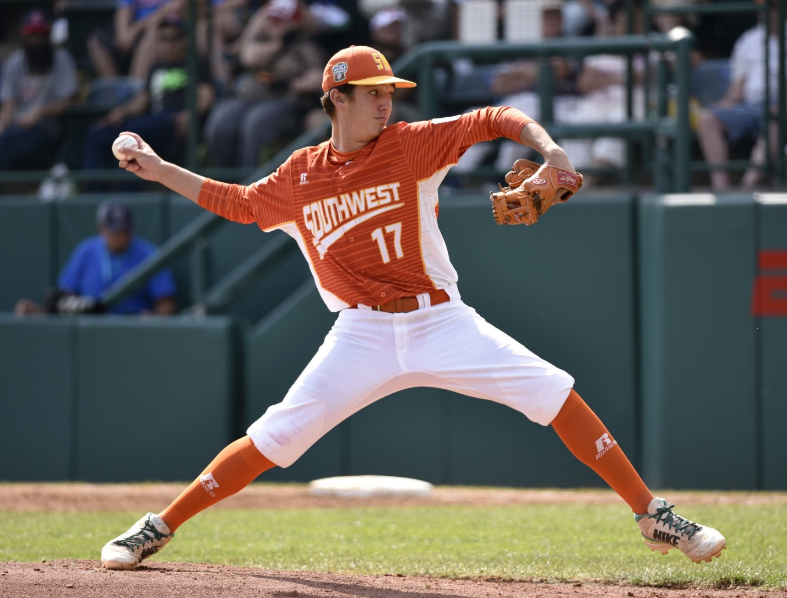
Figure 4. Pitcher With Full Arm Extension While Striding Towards Home Plate.

The last part of the pitching mechanics taught was the follow through. The follow through should place the pitching hand on the outside of the front knee opposite their throwing hand (right hand throwers will finish with their right hand next to their left knee). The transition from long-arm to follow through should be a natural motion to throw the baseball. As the pitcher gets better with practice, they will naturally find the proper release point.

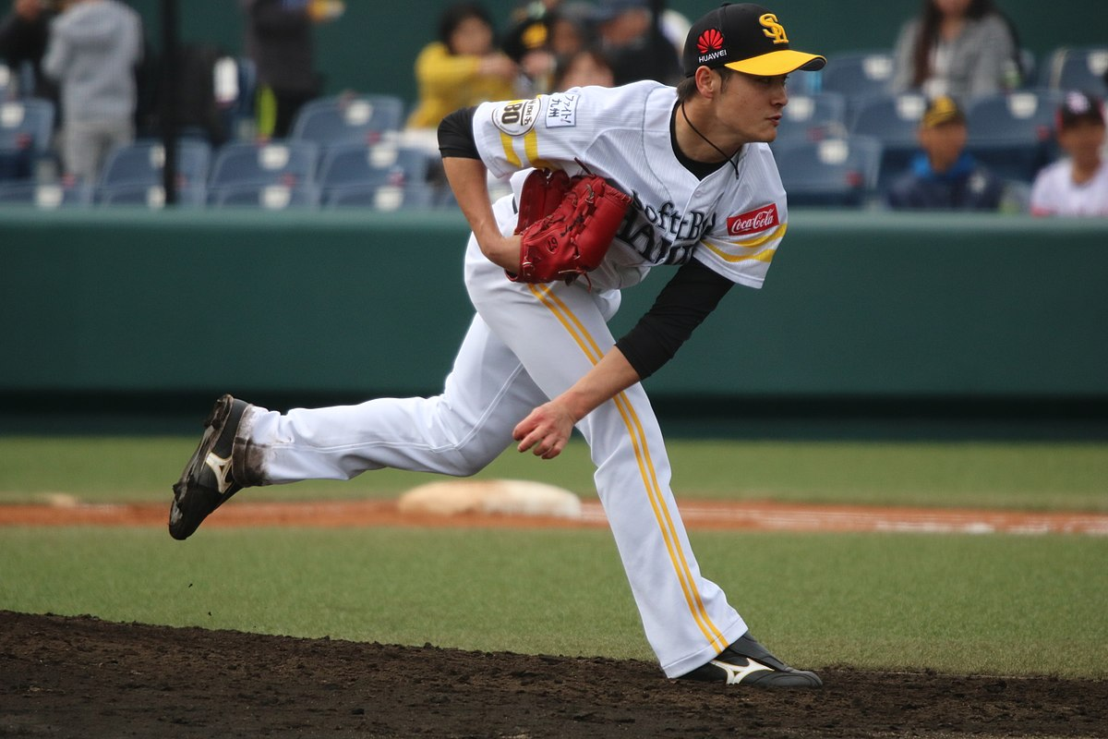
Figure 5. Proper Follow Through with Throwing Hand Outside of Front Knee.

After practicing with the 4 seam grip, long arm, slide step, and follow through, the kids were taught how to lift their leg, twist (slightly), and push from their back leg to generate power while throwing. The front leg will raise and knee will cross the back knee and stop when the front knee is slightly past the back foot. This creates load on the back leg. Then the pitcher pushes off the back foot and plants the front foot and continues with the long arm and follow through from the previous instruction with the slide step.

As the pitcher progresses, more advanced things can be added like: longer stride, lead with front hip, higher leg kick (just a little over parallel), and slightly more twist with a squat and weight on inside of back foot.

Right now with the 9 and 10 year old age group for better pitching the main thing to focus on is the four seam grip and long arm take away along with focus on the target. When warming up or throwing in the back yard the player does not need to “pitch” to practice these good throwing mechanics. As they say, practice makes perfect, and the more the player practices the basic mechanics the better thrower and pitcher they will become.

