Instructions for accessing DIBS and signing up for a Volunteer Activity
The DIBS system is only accessibly by the Full Website. Unfortunately, Sports Engine has not added this as an option within the Mobile App, so you must access via the website to see the volunteer opportunities and sign up.
In addition, the access being through the website, the ISD Girls Lacrosse “Teams” are set to Private because otherwise this would publish their names (first and last) on a publicly accessible website. Sorry for the extra complexity, but if you have difficulties accessing the DIBS portion of the website or signing up for a volunteer opportunity, please reach out to Cori Holmes (cori.isdgirlslax@gmail.com).
- Sign in to the Sports Engine account used to register your player  Example is using my personal Account used to register both my daughters | 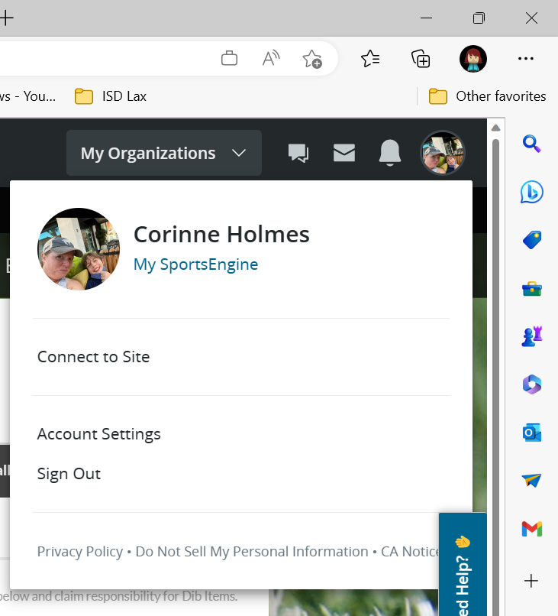
- Click on DIBS in the top RIGHT corner to view the Dibs sessions that your account has access to. | 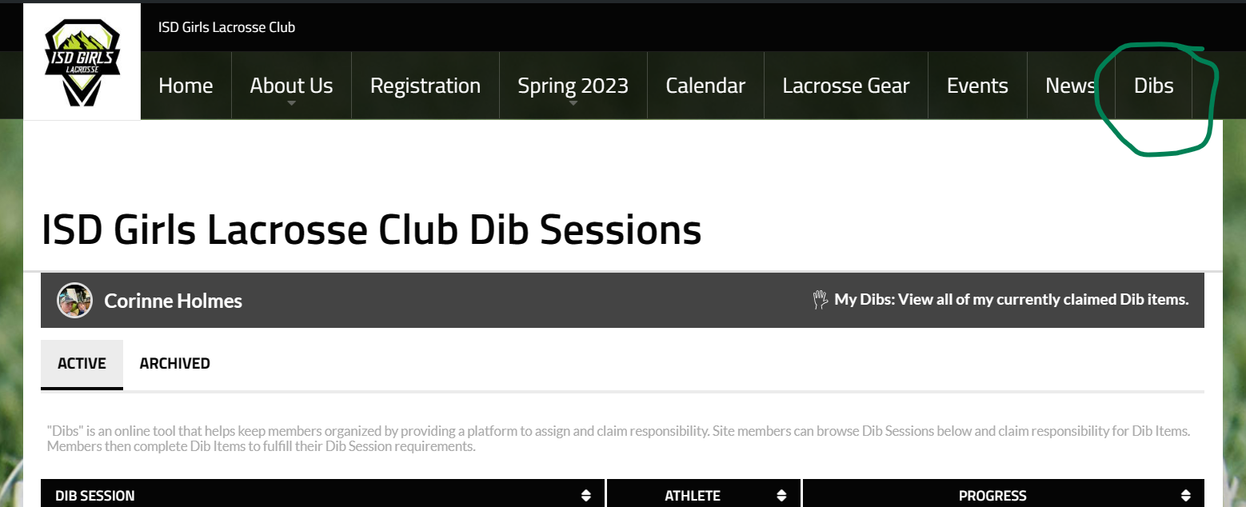
- Notice the DIBS sessions you have access to. This may include those from previous seasons.  NOTE: The Sessions and you progress toward the completion target (3 hours per player, per team) | 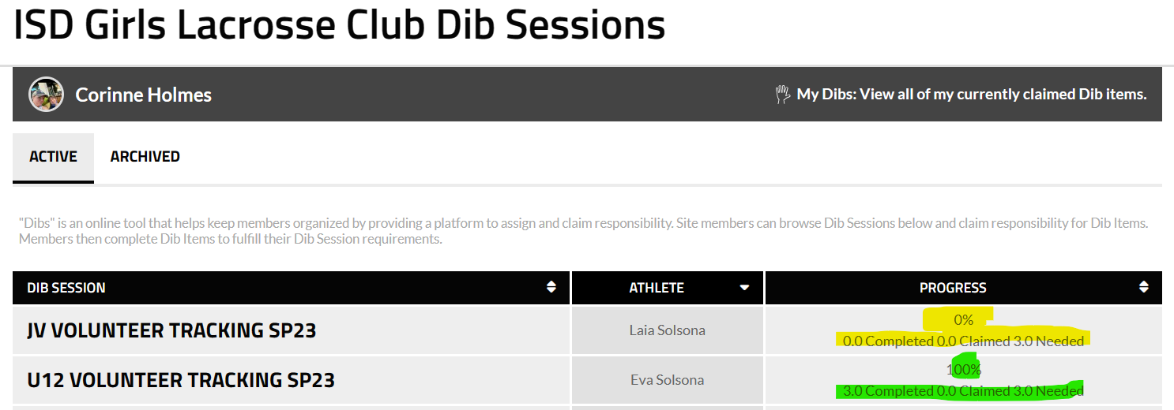
- Find the DIBS session that you want to access to sign up for a Volunteer opportunity and your player’s name should be in the Athlete column

- Once you select the session you will see all the opportunities available for the season, and can follow the steps below to CLAIM a volunteer task.  Notice the items that are “Unclaimed” as those are the open Volunteer items which are waiting for someone to Claim.  For this example, we will use the “JV Field Setup vs. Seattle Prep (2)” item. | 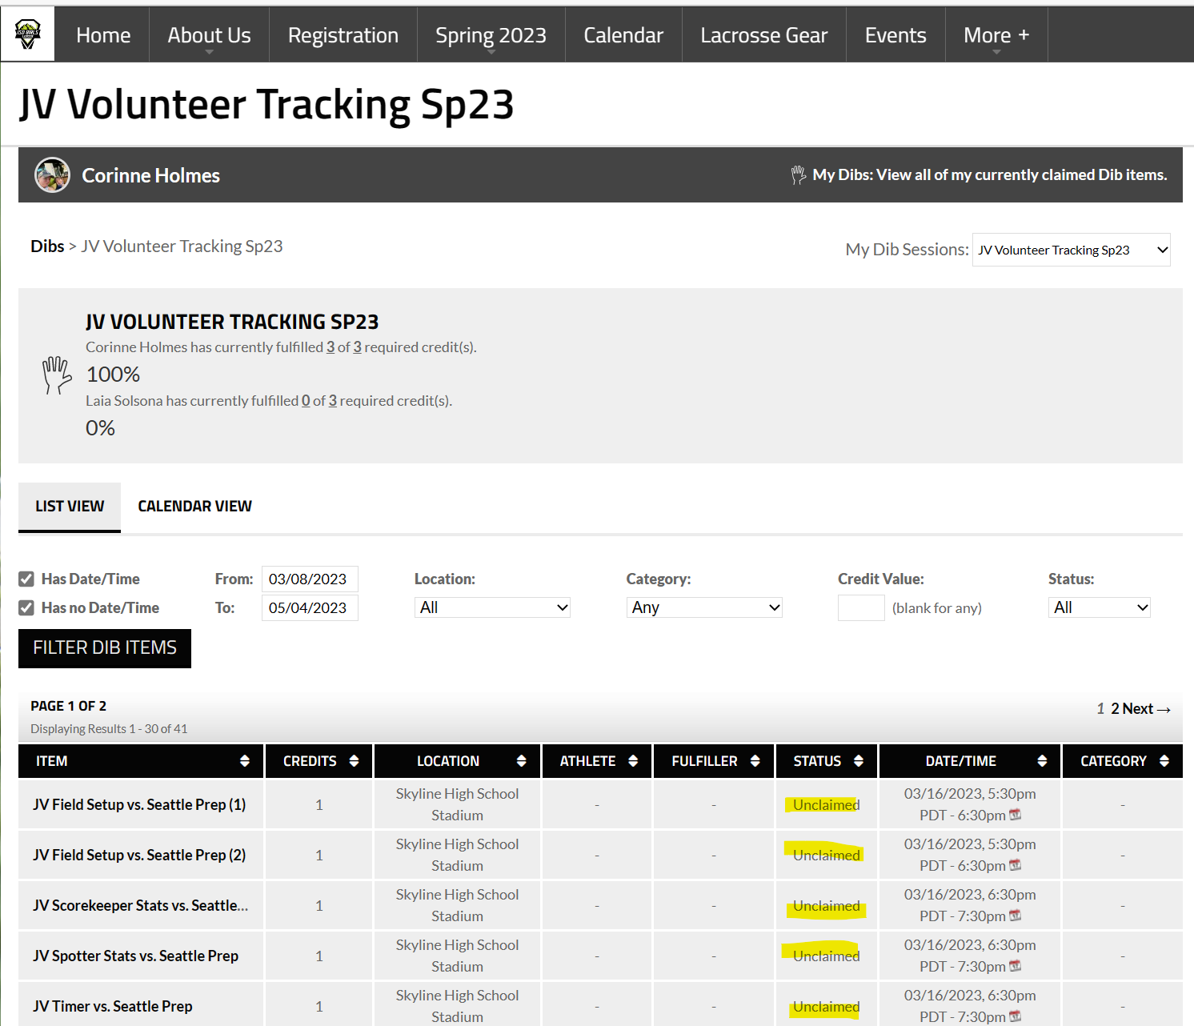
- Click on the title of the Item you want to Claim  For this example, we will use the “JV Field Setup vs. Seattle Prep (2)” item. | 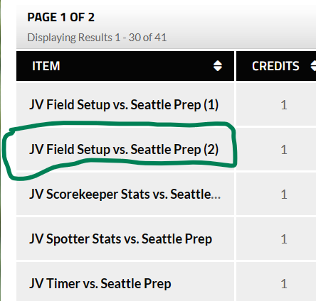
- Click on “Claim this Dib item” to start the Claim process | 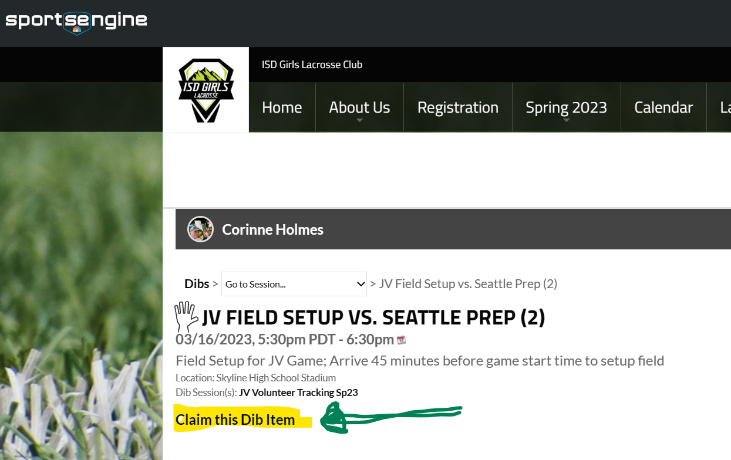
- Complete the form to Claim the Dib item; Select the Athlete you are claiming the volunteer task on behalf of.  Note: items with the red asterisk are required | 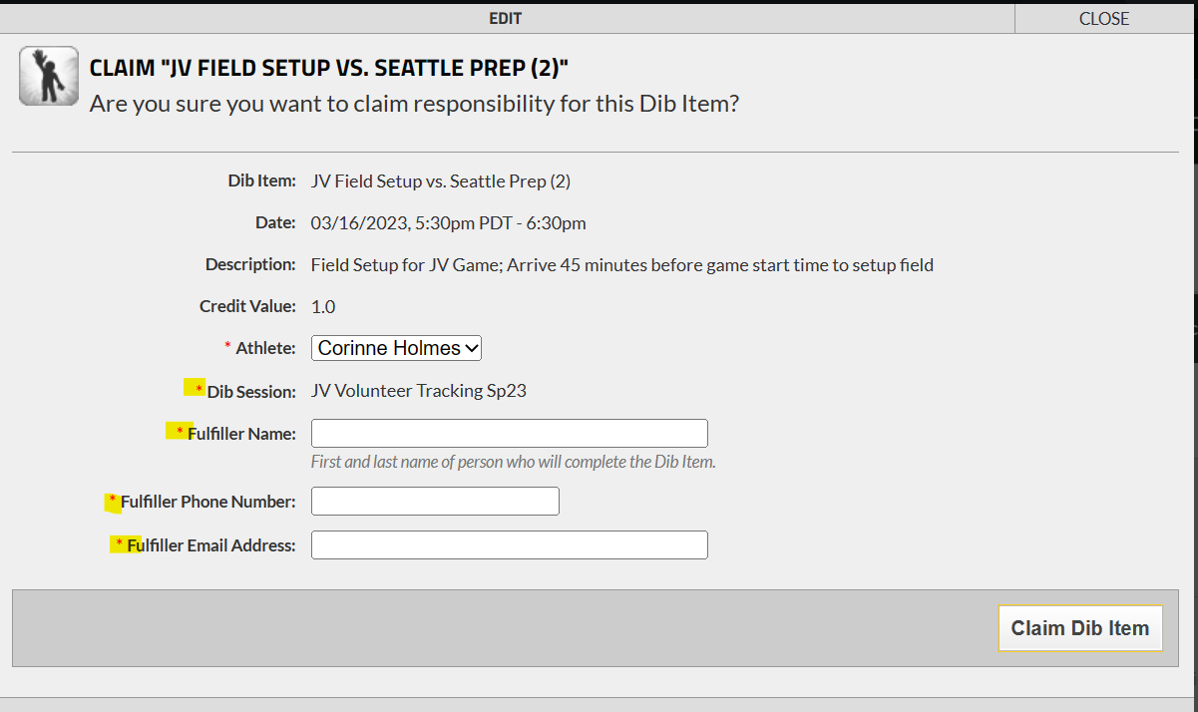
- Once the form is submitted the Task will have the Athlete’s name and Fulfiller’s information and marked as “Claimed” | 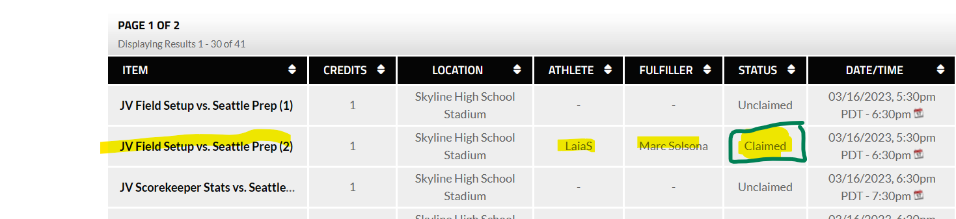
- Once the activity is completed the Admin will “Mark Completed” and the volunteer credit will be issued to the Athlete.  Admins can track and post to Sports Engine the balances | 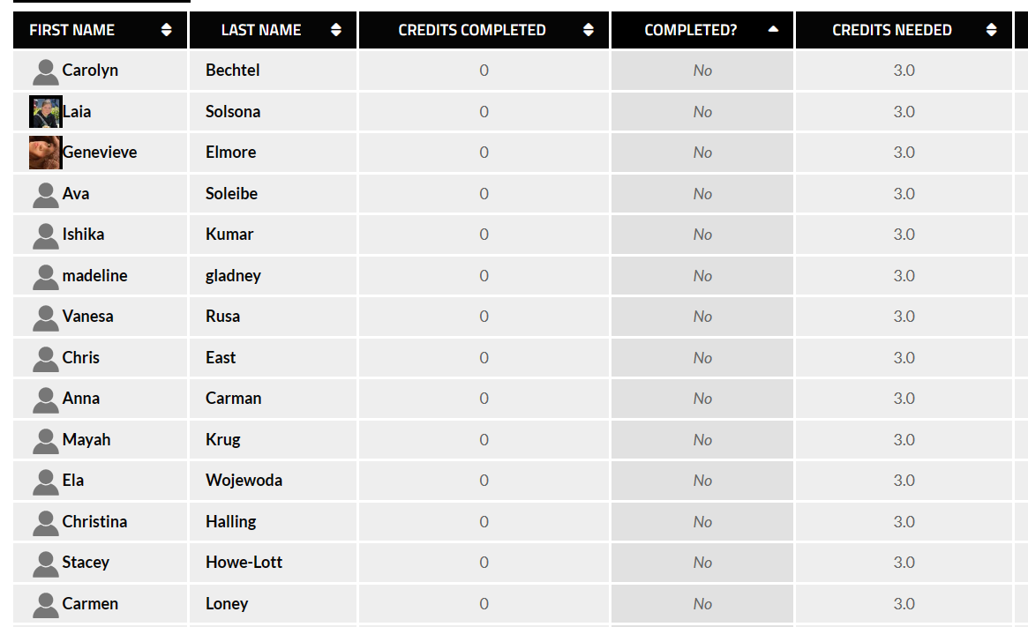
You can se your status toward completion of the 3 volunteer hours through the Shortcut to your Dibs sessions by Clicking on the “My Dibs: View all of my currently claimed Dib items.”

The link takes you here: