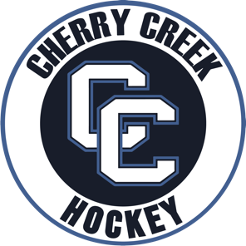

CHERRY CREEK NAPHL/AHF/CPHL 16U/18U SEASON REGISTRATION FEES 2022-2023

Cherry Creek Season Fees for V-Prep T1 / V-Prep T1 Makar and CC Prospects.
Season Fees include CPHL Game and Practice Ice. Limited local tournament expenses.
Game jerseys, practice jerseys, game socks, practice socks, dryland tees, dryland shorts. Limited local tournament fees. CPHL league fees.
** Team required apparel and equipment are in addition. Team off ice training is in addition.
** Team Travel and Tournament / Showcase expenses are in addition which include coaches travel and expense. Player team travel is responsibility of player family. All players are expected to travel.
** V-Prep/CC Prospect teams will have 3-5 ice sessions per week which include league, showcase, tournaments excluding limited holiday dates.

** CC Prospect team is full season USA Hockey. Prep teams will continue showcase/tournament games during the CHSAA season. CHSAA season fees are not included in Prep registrations.

** Season fees installment plan is listed below. Pay in Full Option and Payment Plan Option.

Season Fee Season Fee. 5-Sept. 5-Oct. 5-Nov. 5 Dec
Pay Plan

NAPHL 18U $2600.00 $2800.00 $575.00 $575.00 $575.00 $575.00
CPHL 18U

NAPHL 16U $2600.00 $2800.00 $575.00 $575.00 $575.00 $575.00
CPHL 18U

CC Prospects $3200.00 $3400.00 $725.00 $725.00 $725.00 $725.00
Full Season USA
CPHL T2

