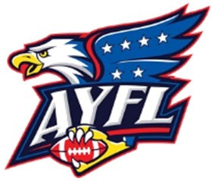
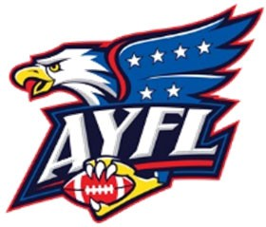
American Youth Football League 2026 Season Official Player Release Form

This form must be filled out completely by the League Member and Parent/Guardian wishing to obtain permission for release from their existing League Member. The Parent/Guardian should review and initial the relevant bylaws below prior to signing the release form.

Section 5.I.1: Once a player registers with a League Member, the player has until on or before March 31st to move to another league member. On or After April 1st that player must remain with the registering League Member for the duration of that season, unless that player is involuntarily released (i.e. cut). Initial
Section 5.I.3: ‘Two Move’ Rule: Players can only change League Members twice during their lifetime, other than as specified in Section 5:I.4, Section Five:I.5, and Section Five:I.6. This provision is not waivable as a hardship. Sitting out one or more seasons does not ‘reset’ ‘the move’ count.
Initial
Section 5.I.4: A Player will be permitted a third move back to either one of their two previous parks without a hardship waiver. This move must adhere to Section Five: I.2. This will be the final move allowed for this player. Initial
Section 5.I.5: If a player is cut by a club and as a result elects to play for another club that season, that shall not be considered a move for the purposes of the ‘Two Move’ Rule. If the same player returns in a subsequent season to the club who originally cut them, that shall not be considered a move for the purposes of the ‘Two Move’ rule. A move to any club other than the club that originally cut the player shall be considered a move. Initial
Section 5.I.6: A ‘cut’ is defined as the involuntary removal of a player from a team, either for disciplinary or performance reasons. No league member may claim to have cut a player in order to circumvent rule 5.I.3. Misrepresentation to the AYFL Board shall be punished in accordance with the disciplinary matrix. Initial
Section 5.I.7: Third moves will not be allowed under any circumstances other than as specified in Section Five: I.4. Initial

Player Name:
Address:
Phone:
League Member Joining: □ Boca □ Boynton □ Delray □ Central Pines □Coral Springs □ Hallandale □ Hollywood □ Kendall □ Lauderhill B. □ Lauderhill L. □ Miami PAL □ Miramar□ North Miami □ Plantation □ Pomp E □ Pomp C □ PPO □ Tamarac | Weight Division: □ 6U □ 7U □ 8U □ 9U □ 10U  □ 11U □ 12U □ 13U
League Member Leaving: □ Boca □ Boynton □ Delray □ Central Pines □Coral Springs □ Hallandale □ Hollywood □ Kendall □ Lauderhill B. □ Lauderhill L. □ Miami PAL □ Miramar□ North Miami □ Plantation □ Pomp E □ Pomp C □ PPO □ *Sunrise* □ Tamarac | Weight Division: □ 6U □ 7U □ 8U □ 9U □ 10U  □ 11U □ 12U □ 13U
Is this the player’s first or second move? □ Yes □ No | Is this move back to the □ Yes □ No player’s original park?
Was this player cut by another program? □ Yes □ No | League Member that cut player: □ Boca □ Boynton □ Delray □ Central Pines □Coral Springs □ Hallandale □ Hollywood □ Kendall □ Lauderhill B. □ Lauderhill L. □ Miami PAL □ Miramar□ North Miami □ Plantation □ Pomp E □ Pomp C □ PPO □ Tamarac
PARENT OR GUARDIAN:
I have read and understand this entire form, including the “One-Move Rule”, and agree to abide by the above referenced AYFL bylaws. If this is a second move, I agree to provide any and all requested supporting documentation to the league. I understand that the signature of the releasing League Representative only indicates that I do not owe the releasing team equipment, and that I am not part of the new team until the AYFL approves this release. I understand that supplying false information to the league may result in the suspension of my child for the balance of the season and game forfeits for his team.

Name Signature Date
NEW LEAGUE REPRESENTATIVE: I have fully explained the above referenced AYFL Bylaws to this player’s parent or guardian.

Name Signature Date
RELEASING LEAGUE REPRESENTATIVE: □ Release Approved □ Denied – Equipment owed

Name Signature Date
AYFL Approval (Exec Board Member): □ Release Approved □ Release Denied

Name Signature Date
COMMENTS (League use Only)

