INDUCTEE
Kenneth W. McComb, Sr. ’58
Ken McComb was born in Brooklyn and raised in Ardsley, NY where he attended Ardsley High School from 1954 to 1958. Although, he was a member of the baseball team, Ken excelled in basketball. Ken started his basketball career in 1954 playing under Coach Frank | 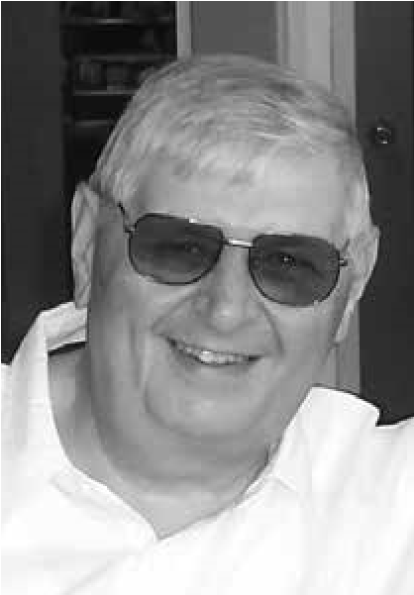
Kluge on the Junior Varsity Squad where he was a JV standout. As
a Sophomore, Ken played on the Varsity team under Head Coach Mike Jackman and eventually, became Captain of the squad. Coach Jackman referred to Ken as the “best sophomore he has ever seen” and a “very talented center.”
By his Junior year, Ken had earned enough laurels in his first two years of playing Varsity that he was selected to the All County Basketball Squad for the 1956-1957 season. As a senior, Ken was recognized again as the only repeat member to this elite All County Squad for the 1957-1958 season. At 6 feet 6 inches weighing 225 lbs., Ken was scoring over 20 points per game at this point in his career.
The Ardsley Panthers Team under Coach Jackman tied for the Western Westchester League
Championship (W.W.L.) in 1956-1957 and were the undisputed W.W.L. champions for the 19571958 season. From 1956 to 1958, this Varsity basketball team won fifty games and lost only eight. Ken played a significant role during this time frame, contributing his offensive and defensive talents.
The team went on to become the New York State Section 1 Class C Basketball Champions for 19561957 season. They defended their title the next year (1957-1958) by defeating Tuckahoe 63-49 before a crowd of 3,500 fans. Ken contributed 27 points during this game.
By the end of his senior year, he had scored enough points during his time at Ardsley to become the first 1,000 point scorer in the school’s basketball history. Ken was known as “one of the county’s highest scorers and best players.” A fine milestone for this deserving and talented athlete.
After graduating from Ardsley in 1958, Ken continued his education at the University of North Carolina in Chapel Hill, NC on a full basketball scholarship. Ken was coached by Head Coach Frank McGuire and the legendary Dean Smith as McGuire’s assistant coach. Ken continued his scoring ways for the Tar Heels playing the Forward position with teammates Doug Moe, Donnie Walsh, Larry Brown, York Larese, John Crotty, Yogi Poteet, Marty Conlon, Jim Donohue, Dick Kepley and Jim Hudock. He was considered “the strongest man on the team, showing it under the boards” with his shooting and rebounding. Coach Smith referred to Ken as having “all the answers on rebounding”. In addition to basketball, Ken was a member of the UNC Track and Field team specializing in the Shot Put.
After college, he was selected a 10th round draft pick for the Philadelphia Warriors in the 1962 NBA Draft. He also played for Real Madrid in Spain.
Ken was the father of three children, Kimberly, Dawn and Ken Jr. Ken passed away in June of 2016 after a long battle with non-Hodgkin’s lymphoma. This “gentle giant of a man”, who wore #4, #44 & #31 for a sport he loved, will be remembered posthumously as a member of this elite group: the inaugural class of inductees into the Ardsley High School Sports Hall of Fame.

