9-10

PARENTS AND PLAYERS PACK

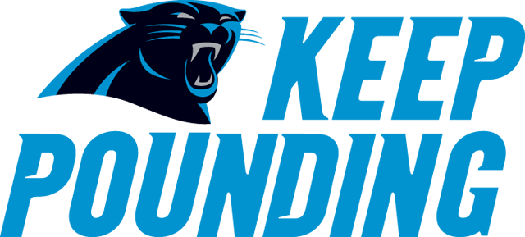

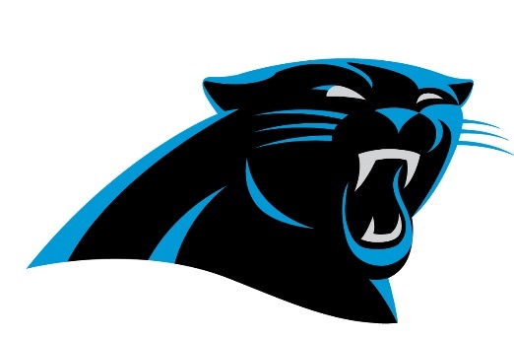
9-10 Panthers

2018 Staff Bio

Head Coach/Offense Coordinator – Kevin Manns – irishmanns@gmail.com - 901-273-6138
Kevin is a Football USA Heads Up certified coach and is in his fifth year as Head Coach with OBYFCL. Kevin serves on the board of the OBYFCL as Coaching Commissioner and is CPR/AED/First Aid Certified through the American Red Cross. He has assisted coach the OBYFCL All Star Teams for the last three seasons, all of which have resulted in undefeated seasons, and was the HC for the runner up Panthers in the 2017 Super Bowl.
Defensive Coordinator - Mike McDaniel
Mike is the team Defensive Coordinator. Mike is in his fourth year as Defensive Coordinator, and is Heads Up Certified. Mike has been CPR/First Aid certified. Mike was a part of the 2017 Panthers Super Bowl team.
Offensive Line Coach/Special Teams Coach – AJ Sellers
AJ serves on the OBYFCL board as Safety Commissioner, Heads Up Safety Coach, and is a certified first responder. AJ is entering his fourth year coaching, and is Heads Up Certified. AJ was a part of the 2017 Panthers Super Bowl team.
Asst Coach – Darry Farmer
Darry is moving up from 7-8 this year, and will be in his third year coaching. Darry has also coaches with the All Star teams and was a part of a successful 2017 season ending with a trip to the Super Bowl. Darry is CPR trained and will be assisting in multiple roles with our team this year.

The 2017 Panthers 9-10 team went undefeated in 7v7 and played in the Super Bowl losing in the final seconds by only two points. We believe we have a good core team and look forward to a successful 2018 season.
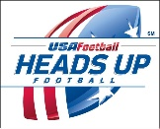

9-10 Panthers

2018 Team roster
2018 Veterian Players *Returning Player **2017 All Star Player
Kyler | Biggart
Lofton | Farmer
**Andre | Fox, Jr.
Cameron | Hudson
Tracy | Key, II
**Jacob | Manns
*Matthew | McDaniel
**Reid | Mcknett
Keston | Nutall
Mason | Odor
**Xavier | Poplar
Martez | Richmond
Matthew | Salazar
*Aaron | Sellers
Marshall | Smith Jr
Patrick | Townsend
Richard | West
Christopher | Wilburn
Elijah | Williams

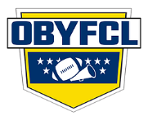 obyfcl

2018 Players Code of Conduct

Players Conduct
As a player you set the tone for the game. How you act, how you treat others, how you win and lose, all are reflections of your entire team. How you behave is a decision that you make and will be mirrored in how you play.
- The player will not criticize other players at any time.
- The player will accept the decisions of officials.
- The play will not criticize the officials, the opposing team, the coaches, fans or parents through language or gesture.
- The player will give 100% effort in all practices and games.
- The player will understand that winning a game is the result of teamwork.
- The player will treat all other players, coaches, and parents with respect and dignity.
- The player will work with his team mates each and every day to not only make himself better, but all members of the team.

obyfcl

2018 Coaches Code of Conduct

Coaches Conduct
The primary goal of coaches should be the development of boys and girls to become better players and citizens. The players must be taught sportsmanship and fair play, and these teachings should always govern their behavior while at practice and at games. Coaches shall be responsible for the conduct of all players, members of the coaching staff and spectators. This includes the time periods before, during and after league games and other events. Improper conduct, in the judgment of the game officials, on the part of the players, coaches or spectators may result in penalties, expulsion and suspension or forfeiture of the game.
- The coach will not criticize players in front of spectators.
- The coach will accept the decisions of officials.
- The coach will not criticize the officials, the opposing team, the coaches, fans or parents through language or gesture.
- The coach will strive to make every football activity serve as a training ground for life and as a basis for good mental and physical health.
- The coach will emphasize that winning a game is the result of teamwork.
- The coach shall not use abusive or profane language in front of anyone connected with the game.
- The coach will refrain from “running up” the score against an opponent.
- The coach shall not be under the influence of alcohol or illegal drugs.
- The coach will set an example in personal conduct at all times.
- The coach will follow league practice rules relative to time and frequency.
- The coach shall provide all players the minimum play time based on league policy.
- The coach will not smoke or use any form of tobacco while on the field of play during games, scrimmages or practices.
- The coach will treat each player, opposing coach, parent and commissioner with respect and dignity.
- The coach will learn the strengths and weakness of his/her players in order to place them into situations where each has a maximum opportunity to achieve success.
- The coach will protect the health and safety of his/her players by insisting that all of the activities under his/her control be conducted for their psychological and physiological welfare, rather than the interests of adults.

obyfcl

Parent Code of conduct

Parent Conduct
Parents are vital to the development of young athletes. Whether sitting in the stands or helping out as a volunteer, parents must set a positive example. Parents and adults involved in youth sports should be models of good sportsmanship and lead by example on and off the playing field.
As a parent we ask that you observe the following code of conduct;
- Give constructive criticism during a private moment, never in front of other parents, players, officials, spectators, etc. This includes conversations with your player and the staff.
- Support your coach and refrain from excessive “sideline coaching” from the stands.
- Refrain from using profanity.
- Abide by a doctor’s decision in all matters of player’s health and injuries and physical ability to play. Your player’s safety the number one most important thing.
- Accept the decisions of officials on the field as being fair and called to the best ability of the officials. Parents must stay off the field and remain under control in order to set a good example for players and other spectators. Parents must stay five yards off the field and out of the coaches’ box at all times.
- Do not criticize an opposing team, its players, fans, coaches or team by words or gestures.
- Support the coaches, players and officials and help teach the value of commitment to the teams, sportsmanship, ethical conduct and fair play.
- Inappropriate behavior is cause for immediate ejection from the stands. Repeat offenses will result in being barred from future games and league sponsored activities.
- Parents will not encourage their child or any other person to engage in unsportmanship conduct with any coach, parent, player, participants, officials or any other attendee.
- Parents should have players at practice on time and ready to play. Practices will be set and communicated ahead of time by the coaching staff.
- Parents should send players to games and practice with appropriate equipment, uniform, and plenty of liquids to keep the player properly hydrated.

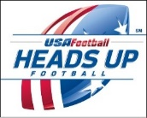

Parents can’t be afraid to talk about concussions with their children
Peter Schwartz Tue, 03/29/2018 - 10:41am
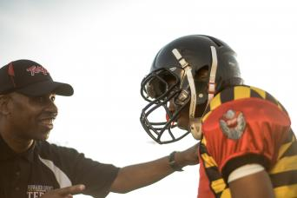
I love football. I love that my son plays football. But Arizona Cardinals head coach Bruce Arians was out of line when he said recently: “Our game is great. People that say ‘I won’t let my son play it’ are fools.”
That is unfair. Parents have the right to make up their own minds as to whether or not they will let their kids play football. But what should be said is that parents are foolish to let their kids play football and not discuss the subject of concussions.
There’s no question that there is an inherent risk in playing football or other sports for that matter.
A child could get a concussion from the constant heading of the ball in soccer. In baseball, you could get hit in the head with a pitch or an errant bat swing. In hockey, you could get a concussion by getting checked into the boards or if you’re on the receiving end of a hard open ice hit.
It’s parents’ responsibility to discuss concussions, as well as other serious injuries, with their children so that the kids have an understanding of what to do and what to say if they are hurt. There is so much that is reported and said on television about concussions but a child might just ignore it or not understand it.
SEE ALSO: Learn more about concussion awareness at USAFootball.com
Now, here’s a checklist that a parent should cover with their child before the start of the season.
- What is a concussion? The first thing a parent should do is tell the child just what a concussion is and why it’s become such a big topic of conversation. A child may get the wrong impression of a concussion from another source, so it’s best that this conversation takes place with parents.
- What are the symptoms? There are times when a coach or parent can tell if something is wrong – like when a kid is slow to get up or if the child seems a little out or sorts either on the field or on the sideline. Children should know that if coaches or parents see something, they are going to take action.
- Look it up on your own, too. These days, some kids are more computer literate than adults, so it’s a good bet that kids can find information on the internet on just about anything. Drive the point home and show your child you care about this by doing your own research. Don’t rely on one media story, something posted on social media or something you read on WebMD. Go to trusted medical site – a hospital or sports medicine facility – to learn more about concussions. Get that tablet out and do some research on something that you’re directly and physically involved in.
- It’s OK to say something. There’s nothing a kid hates worse than coming out of a game. Anyone who is competitive – like my son is – hates to lose, but he also hates not playing. Athletes can’t think concussions will just go away. It’s important that a parent relays to a child that if something seems wrong, you need to say something about it. A child needs to know that not saying anything about an injury is a bigger problem than that the risk of injury itself.

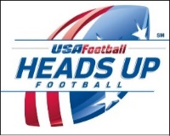

Helmet Safety Starts with a Proper Fit
- By Rose DiPaula Sat, 06/12/2010 - 11:55am
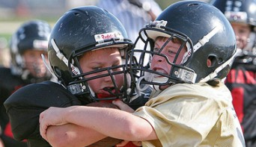
Helmet safety is one of the most crucial elements to playing football, but it is also a difficult part of equipment distribution for many players, coaches and parents. Riddell, USA Football's Official Football Helmet and Protective Equipment Partner, gives some recommendations on good helmet-fitting practices.
Thad Ide, Vice President of Research & Development at Riddell, said, "Most components of football helmets and shoulder pads serve a critical protective purpose. A proper fit ensures that all protective elements of your equipment are positioned where the product designers and engineers intended them to be to best protect the athlete."
The most important part to proper helmet fitting is listening to the players being fitted. Be sure to ask how their helmets feel, if they feel tight and if they feel safe throughout the process to make sure they each feel comfortable every step of the way.
When taking head measurements of your athletes, measure around the middle of their foreheads. To put the helmet on, show the players to put their thumbs over the bottom of the face pads, with their fingers in the inside of the helmet. Face pads should first touch the temples when pulling the helmet down over the head.
Once the helmet is on, make sure the helmet touches the middle of the forehead. Never let players participate with helmets that sit too high or too low on the head. Use both hands to push down on the top of the helmet, and double check that the helmet does not move.
The chin strap should be centered under the chin and should fit well so that the player's chin feels secure. These straps are available in many sizes and are adjustable to ensure a good fit for all players. The chin strap's purpose is to help hold the helmet in place. Make sure that the face pads fit firmly against the face. Inflatable face pads are also an option in order to add padding.
Another necessary step in helmet fitting is to check the athlete's vision, both straight-forward and peripheral. The helmet should not inhibit vision and the athlete should be able to see clearly, despite the face mask. This is difficult to determine, especially with younger players. Track visibility with your finger to make sure they can see well enough to be safe.
To take the helmet off properly, show the athletes to first unbuckle the chin strap, and then place an index finger into each ear hole on either side. Show them how to press the face pads with their thumbs. Lift the helmet off straight over the head.
Even if a helmet feels snug, there can still be room for the athlete's head to move, which can lead to injury. Listen to what the player says about the fit of the helmet and try to make sure the helmet is not too tight and is not too loose. It is extremely important to rely on feedback from the athlete in order to find the right fit

Heat and Hydration: Signs of Dehydration and Tips for Rehydrating
- By Dave Finn Mon, 07/26/2010 - 12:03pm
As the summer sun continues to bear down, the dog days of August and preseason football are just around the corner.
Many youth leagues and high schools across the country will begin preparations for the 2010 season with two-a-day practices filled with conditioning drills, play installation and fine-tuning fundamentals. The physical and mental grind will be at a high, meaning proper hydration will be paramount.
Dr. Lindsay Baker of the Gatorade Sports Science Institute addressed heat and hydration issues in a presentation to youth and high school coaches and administrators on July 22 at the 2010 NFL/USA Football Youth Football Summit in Canton, Ohio.
"I think they seemed really attentive," Baker said in an interview with USA Football after her speech. "I know it's an important and timely issue with two-a-days coming up, with the preseason practices coming up. So you know it's important because it's already really hot out there."
"I found it important that Dr. Baker talked about weighing in before and after practice," said Dan Ritter, Head Coach at Howard High School in Wilmington, Del. "We've done that before, but she clarified it in the sense that for every pound you lose, you have to drink 16 ounces of fluid, which we didn't know previously. That's definitely going to be something that will be implemented this year."
Within a culture of toughness in football, on-field performance and proper hydration go hand in hand.
"Of course the coaches are looking for a good performance from their players, and I always say that the first step for good performance is to make sure they're hydrated," said Baker, who covered hot topics from pre- and post-practice weigh-ins to proper fluids to drink during practice. "Lots of research has shown that dehydrated players perform worse than if they're hydrated. Of course [coaches] want players to play hard, go all out, maintain focus and get a lot of stuff done. Well, the first step is to make sure they're eating and drinking right and drinking enough of the right stuff. So it's a really important factor, including enough rest breaks so that they can drink early and at regular intervals. It's a necessity to keep them both safe and performing well on the field."
Just like sizes of helmets and pads, the right approach to hydration and nutrition amid the intense summer heat differs from player to player.
"Players are very unique in how they sweat, so sweating rates can vary considerably among individuals," Baker said. "You might have a player who sweats less than half a quart in an hour, or you may have guys who sweat more than two quarts on hour. A lot of it is just genetics. Another difference that can occur in the sweating response is that some players lose a lot more sodium in their sweat than others. So players have different hydration needs, and that's why the hydration plan needs to be customized."
Still, no matter how trainers and coaches monitor their players' needs and symptoms, youth athletes need to know their bodies and how they respond to the heat.
"Indications of dehydration are thirst, nausea, dizziness, headache," Baker said. "Maybe they feel hotter, maybe they feel like 'Man this exercise seems more difficult than it should.' Maybe they're having more difficulty focusing, paying attention to the coach or remembering plays. Those are some indications.
"An indication that someone may be getting more severe and maybe their temperature is getting dangerously high is when they start to have a change of personality. And this is something that the players themselves may not be aware of because the high temperatures are affecting their central nervous systems. That may be something that other players can keep track of and just monitor how their peers look, how they're acting, if anything looks out of sorts."

Player Equipment List

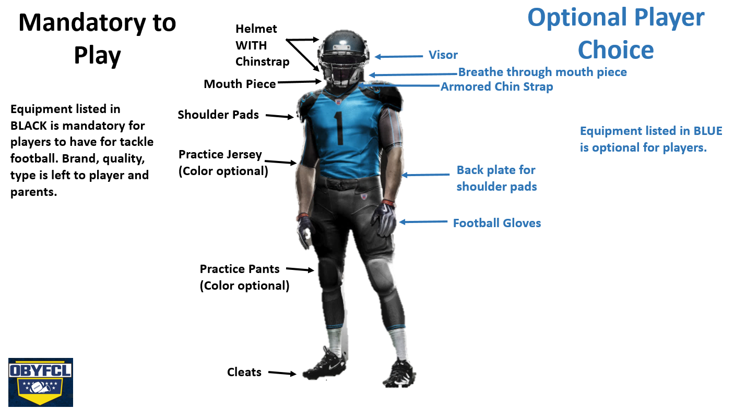

2018 Uniforms

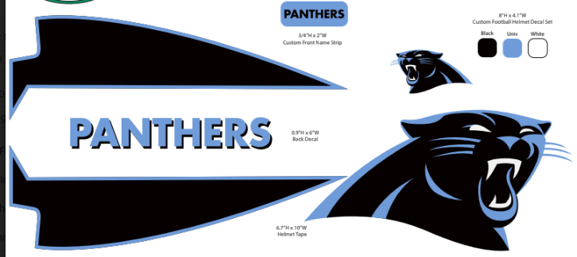

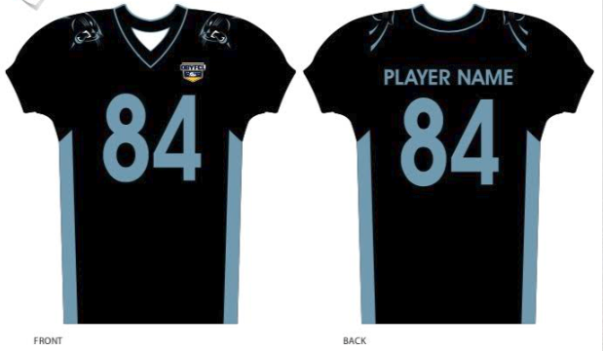
The 2018 uniforms come with BLACK pants with integrated pads, and matching BLACK socks. The Helmet logos ARE NOT a part of the uniform cost. Each team is responsible for the purchase and application of their helmet art. The 2018 Panthers will be collecting helmet art money during the first week of practice and will schedule a Sat helmet striping party before season begins. The team mom will collect the money and coordinate the event. PLEASE NOTE, ONCE WE COLLECT THE HELMET MONEY THERE WILL BE NO SECOND ORDERS. THIS MUST BE DONE ALL AT ONCE INORDER TO GET THE DISCOUNTED PRICES. Approx cost is $20/player.
Teaching tools – All players should know gaps and player position titles.
