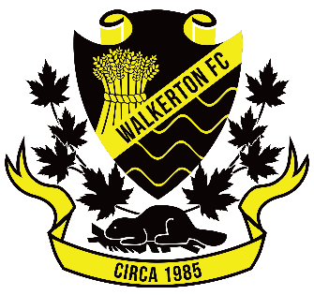

The Role of the Rep Team Representative
(1 Per Team)

Rep Team Representative shall:
- Attend all league meetings for Walkerton FC
- Liaison between Rep Team, Coaches and Executive
- Report team numbers to Lakeshore
- Communicate with the Executive with information on scheduling and updates from their respective rep division
- Work collaboratively with Walkerton FC Executive to maintain and encourage the health of the rep program

Start Date: Immediately

