Boys SSAC Playoff Brackets
Playoff Round:

Friday, January 11th, 2019
Legacy Charter (0) | Vs.@6pm | Admiral Farragut (8)  (Host)
All Saints Academy (1) | Vs. @3:30pm | Windermere Prep (5)  (Host)
TFA Leesburg (0) | Vs. @7pm | St. Edwards (8)  (Host)
Bayshore Christian (0) | Vs. @7pm | Masters Academy (5)  (Host)

Girls SSAC Playoff Brackets
Playoff Round:

Friday, January 11th, 2019
Legacy Charter (5) | Vs.@5pm | All Saints Academy (0)  (Host)
Admiral Farragut | Vs. @3:30pm | Windermere Prep  (Host)
Orangewood | Vs. @5pm | St. Edwards  (Host)
Mount Dora Christian (0) | Vs.@5pm | Masters Academy (8)  (Host)

Boys Soccer Final 4

Windermere Prep (0) vs. Admiral Farragut (5)
The Master’s Academy (0) vs. St. Edward’s School (3)

Girls Soccer Final 4

Legacy Charter (0) vs. Windermere Prep (3)
St. Edward’s School (0) vs. The Master’s Academy (4)

Boy Soccer Championship: St. Edward’s School (2) vs Admiral Farragut (1)

Girls Soccer Championship: Windermere Prep (2) vs The Master’s Academy (1)

2019 SSAC Boys Soccer Champions
St. Edward’s School
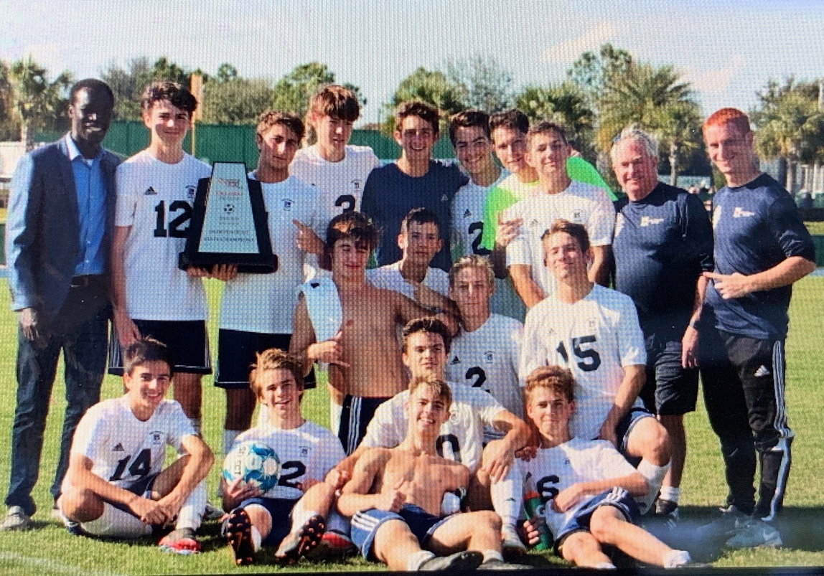

2019 SSAC Girls Soccer Champions
Windermere Prep
