Aug/Sept Diamond Sports Digest

Notice of Annual Meeting and Open Positions
By CAA Diamond Sports 08/31/2022, 9:45am CDT
Our Annual CAA Diamond Sports Board Meeting is scheduled for Sunday October 9th at 7:00pm at the American Legion in Chanhassen. All Diamond Sports (baseball & softball) parents are welcome to attend!
Do you have ideas that could help improve the CAA Baseball & Softball programs? Have you ever wondered why we do things a certain way, or what goes on behind the scenes? Do you want to give back to the organization that your children spend so much time in while they are growing up and learning their respective sports of baseball and softball? Please consider getting involved on the leadership team!
The below positions will be voted on at our annual meeting. See the links below for descriptions of these positions on our website. * Denotes board position.
*Director of Marketing - 1 candidate
*Director of Community League - Open
*Diamond Sports Webmaster - 1 candidate
K/1/2 Coordinator – Open
*Secretary/Communications – 1 candidate
*Director of Softball Travel – 1 candidate
*Player Agent Softball – 1 candidate
*VP Diamond Sports – 1 candidate
*Safety Officer – 1 candidate
*Director of Metro Baseball, 12+ - 1 candidate
*Player Agent 9-11 – 1 candidate
We are looking to add a few new positions, but the roles haven’t been finalized yet. If you're interested in these roles, please email us at caadiamondsports@gmail.com and we can tell you more about these key volunteer roles.
1) Field Ambassador/Grounds Crew Lead - Accountable for managing the general upkeep of our Baseball and Softball fields and any larger related projects.
2) Tournament Assistants - looking to add to our team that runs tournaments. This position would work with the Director of Tournaments.
Links to find more info on board positions:
Baseball: https://www.chanathleticassociation.com/baseball-leadership
Softball: https://www.chanathleticassociation.com/softball-leadership
If you have any questions or are interested in any of these positions email us at: caadiamondsports@gmail.com


2022 Baseball Season Recap
By CAA Diamond Sports 08/31/2022, 9:15am CDT
Tournament/Metro Program
During the 2022 baseball season, we had 23 teams participate at the tournament / metro level. This group encompasses players ages 9 through 15 and included 259 athletes.
There were 20 teams that played in the Metro Baseball League (MBL). These teams each played 12-14 games from late April through early July against teams from the greater metro area. Combined the CAA teams finished above .500 on the season with the 10AAA team winning their region. 16 of the 20 teams also played in the league playoffs highlighted by three 1st place finishes (10A Grey, 11A Silver & 12AA Blue) and two 2nd place finishes (10A Silver & 15AA Gold).
In addition to league play, all 23 teams participated in weekend tournaments throughout the year. CAA teams earned 9 tournament titles with numerous 2nd and 3rd place finishes. A special highlight of the regular tournament season was the 11A White team winning the Chan Challenge.
Lastly our teams showed very well at the State tournaments, highlighted by two 2nd place finishes by the 10A Silver and 14AA Gold teams in MBT and a 3rd place finish by the 9AA Gold team in Gopher State.
Congrats to all the Tournament/Metro teams for a fun and successful 2022 season!
Nick Hansgen
VP Baseball
Community Program
The CAA Storm 10/11U Community Baseball teams ended their season in July at their end of season Community Baseball competing against teams from Chaska, Carver, Shakopee, Eden Prairie and Edina. The Gold team had a great season with a 9-6-1 record and took 4th in their bracket! The Blue team also had great success and finished their season strong with a 3rd place finish in the tournament!
Chanhassen 16-18U Community team finished 2nd in the SYBL season tournament, finishing with a 9-6 record overall. In getting to the championship game, they defeated the previously undefeated top seed in the playoffs!
Congrats to all our community teams for a fun season!
Glen Schoenburg
Director of Community Baseball


2022 Softball Season Recap
By CAA Diamond Sports 08/31/2022, 8:45am CDT
The 2022 CAA Softball season was by all accounts an amazing success! Unless there are better records kept outside of our current system it would appear that there were more girls playing softball for CAA in 2022 than in any prior year. 178 girls participated in the Spring/Summer season from age Kindergarten through 12U! There were victories, parties, snacks, tournaments, losses (yes, of course there are always losses) and many life-long memories made this season. Through all of the ups and downs of a youth sports season one of the most important things these girls should take away is the fun experience of playing a sport with friends.
Teams: CAA Softball consisted of three 12U, five 10U, four 8U and three K/1/2 teams in 2022! Here are some amazing tournament finishes – congrats!!
- 10U Nationals Team won 1st place in the Bronze bracket at the NAFA Nationals tournament in July! https://www.nafasoftball.com/10unorthernnafa
- 12U Blue won 1st place in the New Ulm Windmill Classic in June!
- 12U Blue won 1st place in the Silver Bracket at the Burnsville Fireball
- 12U Gold won 3rd place in the Silver Bracket at the Burnsville Fireball
- 10U Silver won 2nd place in the Silver Bracket at the Burnsville Fireball
- 10U Blue won consolation bracket in the Bloomington Bash
- 10U Gold won 1st place in the Silver bracket at the Mission Blast Off tournament
- 12U Blue won 3rd place at the 12U B state qualifier
- 10U Gold won 1st place in the Silver bracket at the Shakopee 25th Annual Father’s Day tournament
- 10U Blue won 1st place in the 10U B State qualifier
- 10U Blue won 3rd place in Tier 3 State tournament
- 8U Gold won 3rd place at State
Volunteers: Remember CAA runs off of volunteers, there are no teams formed, no games scheduled, no tournaments registered (or run), nothing happens without volunteers. Thank you to all of you who have volunteered time to make this organization as successful as it is! We have many key volunteer positions that are filled by people who put in countless hours including Kelli Strauss, Travel Director; Katie Recker, Player Agent; Matt Birkenholz, Player and Coach Development Director; Jamie Bruemmer, Equipment Coordinator; Julie Vasatka, Uniform Coordinator; Derek Gunderson, Tournament Director; Amanda McGibbon; Volunteer Director AND SO MANY MORE!
Coaches: Thank you very much for all the time, teaching, patience, diligence and fun that you pour into these girls! You have a very big job and as volunteers an even bigger thank you for being a huge part of this organization and making the teams a success!
Tournaments: This year CAA hosted two tournaments at Lake Ann – 10U B Qualifier with 32 teams! That’s right, 32 teams played in a double elimination tournament at Lake Ann June 25-26 (a tournament that 10U Blue won!) CAA also hosted 12U State at Lake Ann with 16 teams participating. Huge thank you to Derek Gunderson for all of his time and efforts to organize and manage all aspects of these tournaments! To all of you who volunteered time to rake fields, run concessions, set up fences and many other jobs – thank you for helping to make these tournaments a success!
Fall ball (the kick-off to the 2023 season) is already underway, having formed teams from the player evaluation process and as we roll into fall, I hope everyone has another amazing season and your daughters enjoy this wonderful game of softball. From all of us here at CAA Diamond Sports, thank you for your support, your time, your energy and your positivity that continues to put smiles on these young faces.
Mark Stay
VP Softball



Machine Pitch Tournament Recap
By CAA Diamond Sports 08/31/2022, 8:30am CDT
Saturday July 9th, we hosted a Machine Pitch Tournament. The Championship & Third Place games were played on the big fields at Chanhassen High School. Denny Laufenburger, the voice of the Chanhassen Red Birds, called the game from the press box, we had ice cream, and a drawing for prizes. Thanks to all the families that came out to join the fun and to all the volunteers that organized and helped run the event! Check out our Facebook page for pictures from the event.
https://www.facebook.com/profile.php?id=100057183173094



12AA Team Sponsors
By CAA Diamond Sports 08/31/2022, 7:30am CDT
The 12AA team would like to thank our generous sponsors for their support of the team trip to the Cal Ripken Tournament in Pigeon Forge, TN! Lifelong memories were made both on and off the field! Sponsors: QC Verify, Chanhassen American Legion, Impact, Life Time, Midwest Mechanical Solutions, Tradition Bank, and United Bankers Banks.
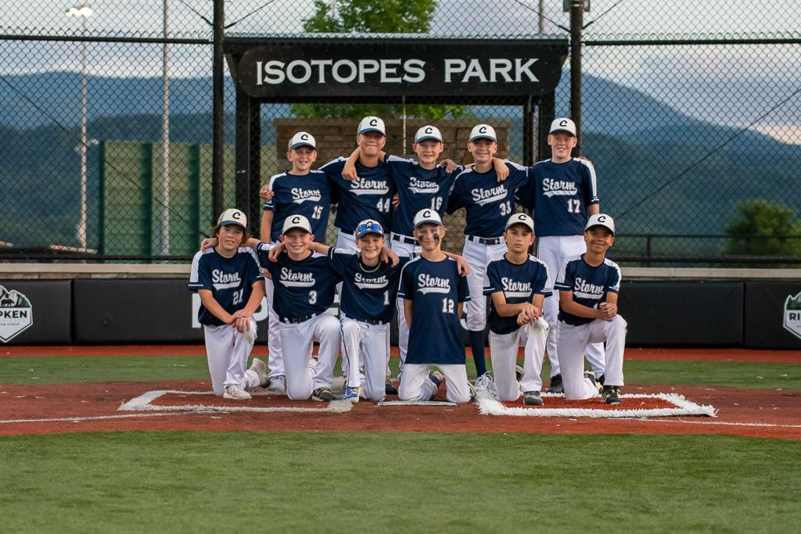

Sponsorship Update - ETS
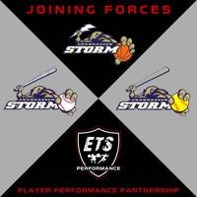
ETS is the official Performance Provider for the Chanhassen Athletic Association. ETS Performance provides individualized strength, speed, and injury prevention training for athletes of all sports.
ETS + CAA Discounted Membership Options: etsperformance.com/caa
ETS + CAA Speed | Ages 8-11
o The ETS Speed Plus Program focuses on linear and lateral speed
development, deceleration mastery, relative strength, and injury
prevention training for young athletes to establish a foundation for athletic
success and performance mastery.
ETS + CAA Performance | Ages 12+
The ETS Strength Plus Program is individualized for each athlete and focuses on sport specific strength, speed, power, deceleration, elite speed, and specific energy system development training.
Sign up a FREE Athlete Evaluation TODAY to learn more: etsperformance.com/getstarted

Sponsorship Update - Victoria Burrow
Be Sure to Support the Victoria Burrow - One of our Fantastic Sponsors that support our Chanhassen Athletic Association!
www.theburrowmn.com


