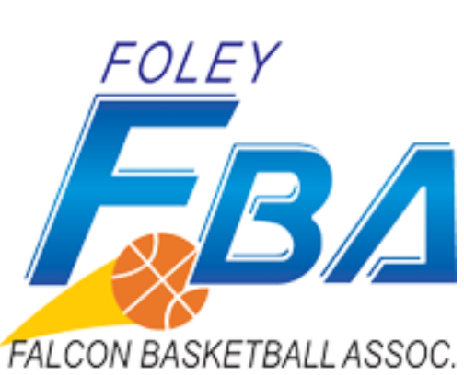 Boys and Girls Basketball Tournament Rules 2026
Game length: Length of game will be two 16 minutes running time halves. The clock will only stop for timeouts, the last 1 minutes of the first half, and the last 2 minutes of the game. The final 2 minutes will be running time when there is a 20 point difference in score. Stop time will resume when the scoring difference reaches 10 points.
- Home team is listed first or on top of the bracket and will provide game ball.
- Home team will provide someone to keep official book and visiting team will provide someone to run the scoreboard.
- Players must compete in their own grade. Exception: Players in a lower grade level may compete in an older division. All players in grades 5-8 are eligible to participate. Players may play on only one team.
- Awards: Players MUST HAVE participated on the day of the tournament to earn an award. A Maximum of 10 awards will be given out per team.
- Uniforms: All teams must have uniforms similar in color with visible numbers on the back.
- Free Throws: One plus the bonus will be shot on the 7th team foul. Two shots will be taken on the tenth team foul.
- 3 timeouts per game
- Use of the possession arrow will apply in all jump ball situations, as well as the start of the second half.
- The 3-point shot will be used.
- Substitutions: Will be allowed on dead ball situations only.
- Overtime: Will be 2 minutes, with the clock stopping on all dead ball situations. The second overtime period will be sudden death with a 4 minute running clock and stop time in the final 30 seconds. If time expires on 2nd overtime, 5 players chosen from each team will shoot alternate free throws. The team with jump ball possession will get choice to shoot 1st or 2nd. The team with the most made free throws after 5 attempts wins. If free throws made is still tied, continue alternating until winner is determined.
- Forfeit Rule: 10 minute grace period. Game will be awarded to team present and scored as 20-0 which is maximum point differential awarded in case of a tie breaker. Teams can start and finish with four players.
- Fouls: Players are allowed 5 personal fouls.
- Technical Fouls: Non-offending team will receive 2 points and the ball out of bounds at mid court. Any team committing 3 technical fouls regarding poor sportsmanship or arguing with the referees during the tournament will result in forfeiture of that team from the tournament.
- Each team must provide their own balls, first aid kits and someone to either keep official book or run the scoreboard
- Basketballs: Youth Basketball 27.5” will be used for 3rd and 4th grade, Women’s 28.5” ball will be used for girls and boys 5 & 6. Men’s 29.5” ball will be used for 7 & 8 boys.
- Pressing: Grades 5 & 6 will have no full court pressing of any kind until the last 2:00 minutes of the game and only if the score is within 15 points. On first offense, a warning will be issued and on the second offense a technical foul will be called on the offending team. All other grades may press at any time.
- Defenses: No zone defense or zone pressing allowed for 3rd 4th, 5th & 6th grade teams. All other grades may play any defense
  - Help Defense is encouraged in 3rd, 4th, 5th and 6th grade
    - On defense a team can switch on screens and take on the new offensive player as their primary defensive responsibility.
    - Helping in the lane is allowed – If an offensive player enters the lane the defensive player may help creating a double team but only in the lane.
    - Each defensive player must have a primary offensive player responsibility
      - For example, a player cannot just play defense in the lane.
    - Defensive teams will not be required to guard offensive players everywhere on the court
      - If the offensive team lines up all players outside the 3 point line the defense isn’t required to guard them there.
        - For example, lining 4 offensive players up at half court then setting up an iso with one offensive player driving the lane the defensive team would be able to have all defensive players inside the 3 point line
    - Sagging on defense is allowed.
      - If the ball is on the opposite side of the court the defending player will be allow to “sag” off their responsibility within reason. This is also referred to as “2 passes away”
On first offense, a warning will be issued and on the second offense a technical foul will be called on the offending team.
- All formal complaints must ONLY come through the coach concerning their own game. Coaches are responsible for their teams and fans.
- Coaches should check-in half hour prior to their first game at the Foley Field House
- NO FOOD OR BEVERAGE ALLOWED INSIDE THE FIELD HOUSE COURT AREA

