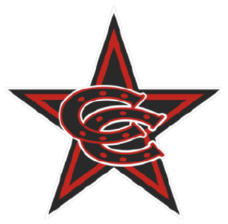

**Fall 2025 8U Select Team Roster**

|  |
| --- |
| **Coppell Cowboys**  COACH-Bryan Jones |
| 1. Alexander Licon 2. Ben Stansberry 3. Blake Hayward 4. Cooper McWilliams 5. Dallas Ciancio 6. Ethan Jones 7. Hayes Brown 8. James Southall 9. Lucas Kalamaras 10. Teddy Reed 11. Tristan Thomas |