How do I find the referees assigned to our games?
1) Go to www.arbitersports.com
2) Sign in to your Arbiter account in the upper right hand corner.


If you do not have a current Arbiter account for your club or you have any other issues with ArbiterSports, please contact MLUA Assigner, contact below:
Girls Lacrosse- Mike Lawrow, mlawrow9102@msn.com

3) Once logged into your Arbiter account you may have to “Sign In” to a specific Account. Do this by clicking on the silhouette under “Sign In” next to the appropriate account.

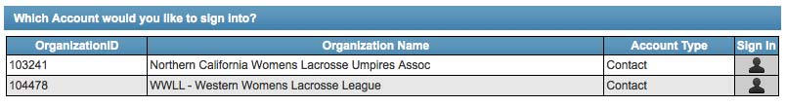
4) Once logged into the appropriate sign-in, click on “Schedule” on the horizontal tool bar.

5) Your team’s name, sport, and level will come up. Click on the blue number under the “Games” column.
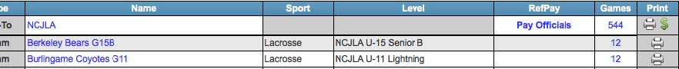
6) You will see the remaining schedule for your team’s lacrosse season. To view who is assigned to your games click on the number in the “Slots” column. If you see 2/2 in green then both slots are filled. If you only have 1 of 2 in green, then only one slot is filled. If you have 0/2 in red for that weekend only, then danger, you have no referees/umpires assigned for your games that week. Contact your assigner, listed above in #2.
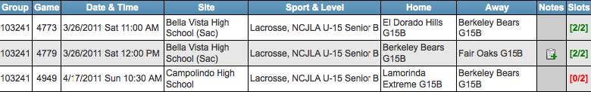
7) When you click on the “Slots” number your assigned referees/umpires will appear in the drop down. To view their contact information simply double click on their name. The official(s) confirm the game date, start time, and field location with each official. If team does not get a confirmation from the officials, use Arbiter to contact them.
