The 2025 Porter Parent Football Association (PPFA) Newsletter – Week6
The LTHS Porter Parent Football Association (PPFA) is a volunteer group dedicated to enhancing the football experience for players. Our goal is to foster a positive, memorable environment for each player, achieved through support for both the players and coaches. The PPFA funds its efforts through various fundraising initiatives, including spirit wear, player sponsorships, and volunteering.
- Twitter @LockportFootba1 - Facebook @ LTHSFootballBoosters  - Lockportfootball.com
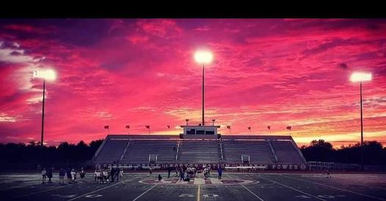Every Week
Varsity Players Pasta Dinner – Every Thursday @ Cooms Corner except this week, where we’ll serve ALL players (see below).
Week6 All Program Pasta Dinner (LTHS Cafeteria): 10/2 @ 5:00pm **Parent Volunteer and/or Dessert Donation**
** Ask-a-Porter ** - 10Q with Colton Benaitis
Game Schedule/Results
Varsity: Porters vs Naperville Central: Fri 10/3 @ 6:15pm **Homecoming** Game Preview
Porters over Naperville North on 9/26 (20-17) Game Recap
Sophomore: Porters vs Naperville Central: Sat 10/4 @ 9:00am Porters lose to Naperville North on 9/26 (35-55)
Freshman A: Porters vs Naperville Central: Sat 10/4 @ 11:15am Porters A lose to Naperville North on 9/26 (20-33)
Freshman B: Porters vs Naperville Central: Sat 10/4 @ 9:00am Porters B unknown to Naperville North on 9/26 (x-x) ?
News and Notes
PPFA Board Meeting: 10/21 (Tuesday) @ 7:00pm – LTHS (Porter Room)
Save-the-Date: 10/2 - All Program Pasta Dinner 10/31 - State Playoffs (first round)
**Lost and Found** Missing a PPFA 2025 Newsletter? Click HERE

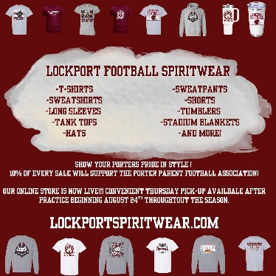
Order your 2025 Lockport Football Spirit wear HERE
Helpful Links
Spirit Wear Game Digital Tickets IHSA Football Info 8to18

