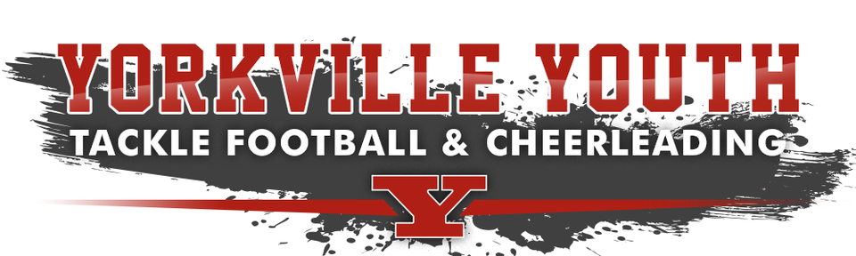
Cheerleader Code of Conduct
As a cheerleader, I realize that it is an honor and privilege that carries with it an enormous responsibility. It is not only my responsibility to display and generate enthusiasm, but also to control and direct it in a manner that makes a loud and positive statement of good sportsmanship. As an ambassador of spirit and enthusiasm, I am in the public eye. What I do and say (good or bad), will have a tremendous impact on the respect ascribed to me, other Yorkville Youth Tackle Football (YYTF) cheerleaders, the entire YYTF organization, as well its fans. YYTF strives to teach the values of hard work, teamwork, sound fundamentals, and dealing with winning and losing in a constructive way.

Therefore, I will:

1. Promote interest and enthusiasm among fans at games (both home and away) and at competitions

2. Demonstrate and encourage good sportsmanship for the opposing team, its cheerleaders, fans, and the officials by setting a good example.

3. Support and be respectful to all coaches, board members, adult volunteers, teammates, parents, opponents, and officials.

4. Refrain from any vulgar, lewd, or obscene language or gestures while cheering or watching any league sponsored game, practice, event or competition.

5. Refrain from smoking, drinking alcohol or any other illegal substance.

6. Respect the property of all league franchises and the property of the residents living in the homes surrounding all game/practice fields.

7. Be responsible, courteous, and cooperative in dealing with coaches and teammates.

8. Support my team – win or lose.

9. Respect my team by wearing the appropriate team uniform and making sure my appearance is neat and clean.

10. Attend all practices, games and competitions.

11. Refrain from posting any lewd, vulgar, obscene or derogatory comments or pictures of any variety on any internet website. This includes, but is not limited to "Facebook, Instagram, Snapchat, Tik Tok or Twitter". This applies to me, a teammate, or anyone within my franchise or anyone from another franchise. I can/will be removed from the YYTF organization, if I should fail any of these items listed above.

Parent/Guardian Code of Conduct
Yorkville Youth Tackle Football/Cheerleading (YYTF) requires managers, coaches, players, parents, family members, legal guardians, friends and board members to abide by a “Code of Conduct”. I hereby pledge to provide positive support, care and encouragement for my child participating in youth sports by following this Code of Ethics:
- I agree to encourage good sportsmanship by demonstrating positive support for all players, coaches, and officials at every game, practice or other youth sports event.
- I agree to provide transportation for my athletes to and from practices and games.
- I agree to be in attendance or will appoint a responsible adult in my absence at all practices and games.
- I understand that there is very little shelter for all athletes at the field and I will make arrangements for immediate transportation if severe weather conditions occur.
- I agree to place the emotional and physical well-being of my child ahead of any personal desire to win.
- I agree to insist that my child plays in a safe and healthy environment.
- I agree to provide support for coaches and officials working with my child to provide a positive, enjoyable experience for all.
- I agree to demand a drug, tobacco and alcohol-free sports environment for my child and agree to assist by refraining from their use at all YYTF events.
- I agree to remember that the game is for children and not for adults.
- I agree to do my very best to make youth sports fun for my child.
- I agree to have my child to treat other players, coaches, fans, and officials with respect regardless of race, sex, creed, or ability.
- I agree to help my child enjoy the youth sports experience within my personal constraints by assisting with coaching, and being a respectful fan.
- I will insist that my child’s coach agrees to the youth sports Coaches’ Code of Ethics Pledge.
- I understand that no pets are allowed on school grounds and I agree not to bring my pet(s) to practices or games.
Parent/Guardian Code of Conduct Acceptance:*
Yes, I have read, I fully understand and I agree to follow this policy
Communication:
- I will never criticize an opposing team, its players, coaches, referee’s or fans by word or gesture.
- I will never ridicule or demean an opposing team, its players, coaches, referee’s or fans.
- I will never use abusive or profane language.
Parent/Guardian Code of Conduct Acceptance:*
Yes, I have read, I fully understand and I agree to follow this policy
Professionalism:
- I will represent YYTF in a professional manner at all times.
- I will comply with the decisions of game/league officials and observe all rules, policies and procedures as established or endorsed by the YYTF League.
Parent/Guardian Code of Conduct Acceptance:*
Yes, I have read, I fully understand and I agree to follow this policy
Social Media and Public Relations:
Players, parents, coaches, volunteers, board members and others associated with YYTF are expected to follow these social media and public relation guidelines when publishing and/or commenting on social media, or in any public forum, while representing YYTF, or when it could be reasonably inferred they are acting in their capacity as a representative of YYTF.
For the purpose of these guidelines, social media means any outlet for online publication and commentary, including, but not limited to blogs, wiki’s, social networking sites such as Facebook, LinkedIn, Twitter, Flicker, Instagram, Snapchat, TikTok, YouTube and any team website or applications.
YYTF players, parents, coaches, and volunteers are free to publish or comment via social media in accordance with these guidelines. Failure to abide by these guidelines may lead to disciplinary action. Publication and commentary on social media carries similar obligations to any other kind of publication and/or commentary. Any use of social media must follow these same ethical standards that are set forth elsewhere in this code of conduct and ethics.
Players, parents, coaches, volunteers, board members and others associated with YYTF are not permitted to:
- Post any comments that could be deemed derogatory about the league, coaches, players, teams or team officials.
- Post any threats of violence or harassment
YYTF reserves the right to delete comments where possible in violation of these guidelines
Social Media Code of Conduct Acceptance:*
Yes, I have read, I fully understand and I agree to follow this policy

Any conduct found to be detrimental to YYTF will not be tolerated and should be considered a violation of the Code of Conduct. Players, Coaches, Parents, and Board members have a responsibility to assist the league in the enforcement of this Code of Conduct by informing the President, Vice President or a League Representative in signed writing of any questionable conduct. The President, Vice President or League Representative shall notify the Board of Directors, in writing, within 48 hours of receipt. In the event of a written report of an alleged Code of Conduct violation from a designated league official, the Board of Directors shall review and investigate said complaint and take appropriate action, including providing a written response to the reporting party at the conclusion of the Board of Directors investigation and review, all within a timely fashion.
Violations of the Code of Conduct will result in disciplinary action from the league, including but not limited to, censure, suspension, and revocation of league privileges or ejection from the league. The league Board of Directors shall be responsible for investigating and enforcing the league rules, including the Code of Conduct, bylaws and the constitution.
Parent/Guardian Code of Conduct Acceptance:*
Yes, I have read, I fully understand and I agree to follow this policy

