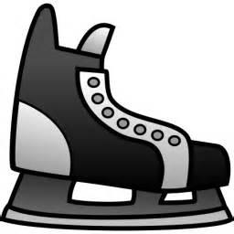Learn to Skate Classes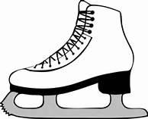
Learn basic skating skills in a safe and fun environment!

Class Dates/Time: Sundays, 12/4, 12/11, 12/18, 2:30-3:00, and Tuesday 12/20, 4:45-5:15

Cost: = $45 (includes skate rental)

Age: 4 years and up

Location: Blue Line Family Ice Center 550 Fond du Lac Ave. Fond du Lac, WI 54935

Skater’s Name _________________________________________________________

Parent’s Name _________________________________________________________

Email Address _________________________________________________________

Phone Number_________________________________________________________

Classes are limited to 20 skaters. Please register by Nov 30 to insure your skater’s spot in the class.

For questions contact Angie at FDLfigureskatingclub@gmail.com

Make checks payable to Blue Line

Send completed registration form and payment to:
Blue Line Family Ice Center
Attn: Angie D.
550 Fond du Lac Ave.
Fond du Lac, WI 54935

