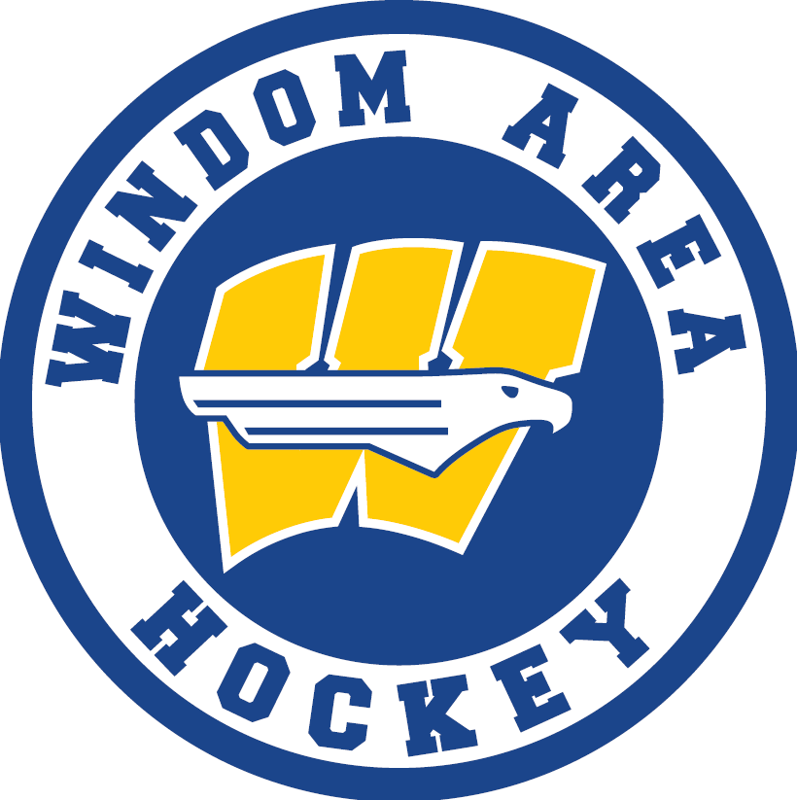
Windom Area Youth Hockey Association Player and Parent Code of Conduct

Mission
It is the mission of the Windom Area Youth Hockey Association(WAHA) to provide a safe, competitive, and fun hockey experience for all our members. Achieving this is a community endeavor that requires commitment, effort, and sacrifice from every level of our organization. Parents, players, and coaches all play important roles in us achieving our mission. As a member of the WAHA, it is expected that you make every effort to serve the organization to insure it remains the greatest place there is to develop quality young men and women.
Expectations
- Player Expectations
  - Treat parents, teammates, opponents, coaches, officials, and facilities (home and away) with the maximum amount of respect:
    - Players will show respect towards all parents.
    - Players will support and encourage their teammates to be the best young men, women, and hockey players they can be.
    - Practice/play within the rules and control your actions.
    - Players will compete with passion while showing respect to their opponents and opponent’s coaches.
    - Players will respect their volunteer coaches. Disruptive players will be asked to stop, if the disruptive behavior continues, the player will be asked to leave the ice.
    - Players will always respect the officials. Complaints or discussions with officials will be made tactfully by coaches only.
    - Players will treat every facility we use with respect. Locker rooms will be respected and left in a condition as good or better than when we entered them.
  - Commit to making practice (on and off the ice) the highest priority:
    - Players are expected to be on time for practice.
    - When a coach blows the whistle, all players are expected to cease whatever they are doing and hustle to the coach for instructions.
    - When a coach is talking, all other conversation should end, and all players should stand still or take a knee. All eyes should be on the coach who is talking.
    - Compete with your teammates but respect them. Competition and playing hard is the way to make each other better. Don’t be mad at a player for playing hard during practice.
    - Players are expected to work hard and always strive to improve.
    - Practice with a purpose. Be relentless and never take a practice off. The little things make big things happen.
    - Have fun.
  - Game day expectations:
    - Arrive an hour prior to game time for stretching, warm-ups, game planning and discussion.
    - All pre-game activities are TEAM activities. No individual activities.
    - Dress appropriately. Represent the association well.
    - Keep uniforms clean and neat. No WAHA jerseys should ever touch the floor.
    - White or black skate laces and white or black stick tape only.
    - Only WAHA approved decals on helmets.
    - No cell phones use in the locker rooms.
    - Compete relentlessly but maintain sportsmanship.
    - Have fun.
- Parent Expectations
  - Always represent the association with pride and class.
    - Maintain appropriate behavior as spectators.
    - Respect parents, players, coaches, and officials from both WAHA and opponents.
  - Commit to getting your child to all practices and games.
  - Minimize time in the locker rooms.
    - We understand younger players need help with equipment but minimize time in the locker rooms as much as possible.
  - Encourage your child to participate in off-ice drills and practice.
  - Encourage healthy habits such as exercise, healthy eating, and adequate sleep.
  - Volunteer – Our association cannot operate without the dedication of our parents and supporters.
    - Dibs are necessary to provide great arena experiences for all members of our association.
    - Take pride in working dibs. They make so much possible for our kids.
    - Support fundraising. Fundraising is essential to keep costs down and make hockey a reality for as many kids as possible.
    - Volunteer as a coach, referee, or parent rep. The more help we have the better the experience for everyone.

