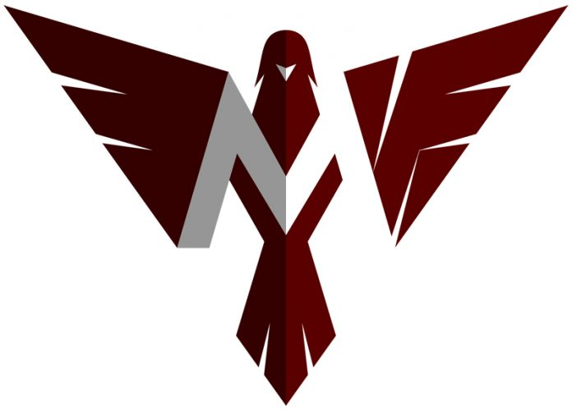
Menomonee Falls Phoenix Invite
Wednesday, May 10, 2023
Menomonee Falls High School
W142 N8101 Merrimac Drive
Menomonee Falls, Wisconsin 53051

Teams Competing: Brookfield East, Menomonee Falls, Milwaukee Vincent, Homestead, Milwaukee Riverside, and West Bend West

Time Schedule:
Coaches meeting at 3:15 p.m. near the finish line.
Pole Vault at 3:30 p.m.
Field Events at 3:45 p.m.
Running events at 4:15 p.m.

** There is no predetermined time schedule **

Entries: You are allowed three (3) entries per event and one (1) team per relay.
WIAA rules for number of events per athlete.

All entries will be made online at www.milesplit.com. Entry deadline is May 8 at 12:00 noon.

Scratches and replacements will be made at the coaches meeting. Please try and limit your changes. We’ll also need coaches to help out with exchange zones in the 400 and 800 relays.

Scoring:
Top eight places (10-8-6-5-4-3-2-1)
Medal awards to the top three (3) in each event
Trophy awarded to the top team

*Awards will be available in the press box at the conclusion of the meet*

Spikes: Eight lane track and no spikes longer than ¼ inch and no pin or Christmas tree spikes, please.

Miscellaneous: Tent set-up is preferred on the south end of the stadium, near the concession stand and garage areas.

Concessions will be available.

Meet Information:
Prelims in the 100HH and 100 dash, with top eight (8) advancing to the finals. The 200
meter dash will be finals only.

Opening Heights:
High Jump and Pole Vault: Starting heights will be 2 heights below the 8th seed.
Horizontal Jumps: 4 jumps, no finals. These events will run simultaneously and pits will
be open for 90 minutes.
Shot Put and Discus: 4 throws, no finals. Discus first, followed by shot put.

Meet Schedule: Running events start at 4:15 p.m.
100-meter HH trials
100-meter dash trials
Finals
3200-meter relay
100-meter HH finals
100-meter dash finals
1600-meter run
800-meter relay
400-meter dash
400-meter relay
300-meter low hurdles
800-meter run
200-meter dash
3200-meter run
1600-meter relay

Contact: If you have questions, contact Jenny Prochazka, Menomonee Falls Head Coach (414)467-1043 or pro5461@yahoo.com

