To Update a time/date of a game after a rainout, click on the game and click on the wheel in the upper right corner and click “Edit Game Details”
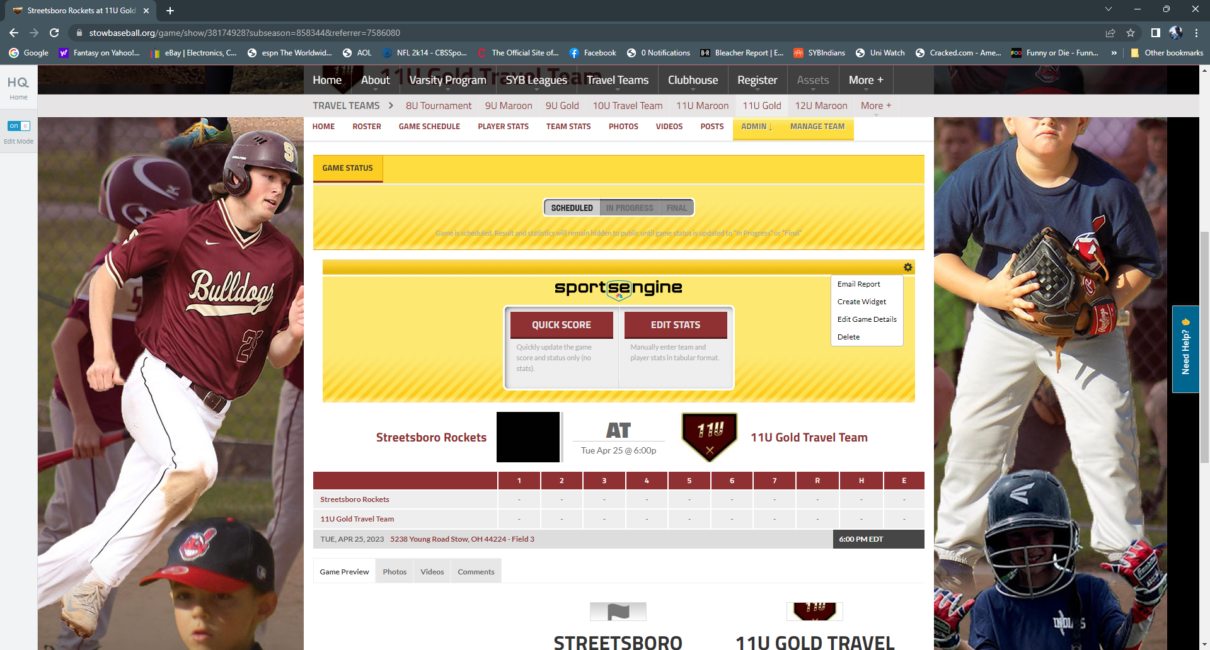
The following screen should come up where you can enter new date, time and location. Please do not change anything else.
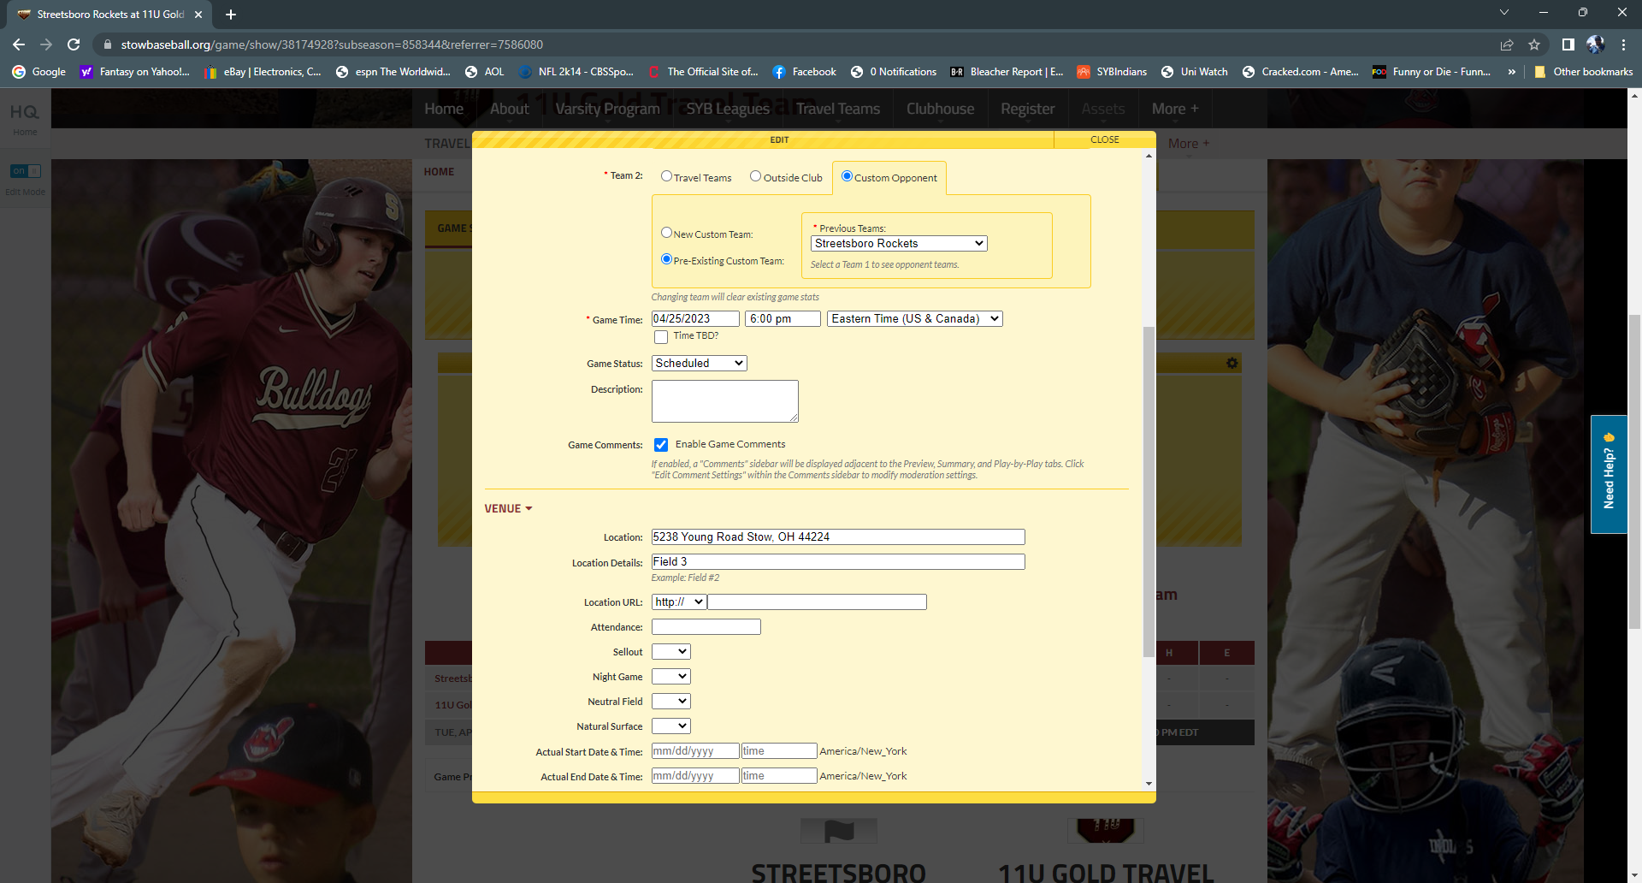

If a game has been rained out, you can do the following from the app on a phone only (But will have to be undone if you reschedule the game for a later date)
Click on the pencil in the lower left corner:
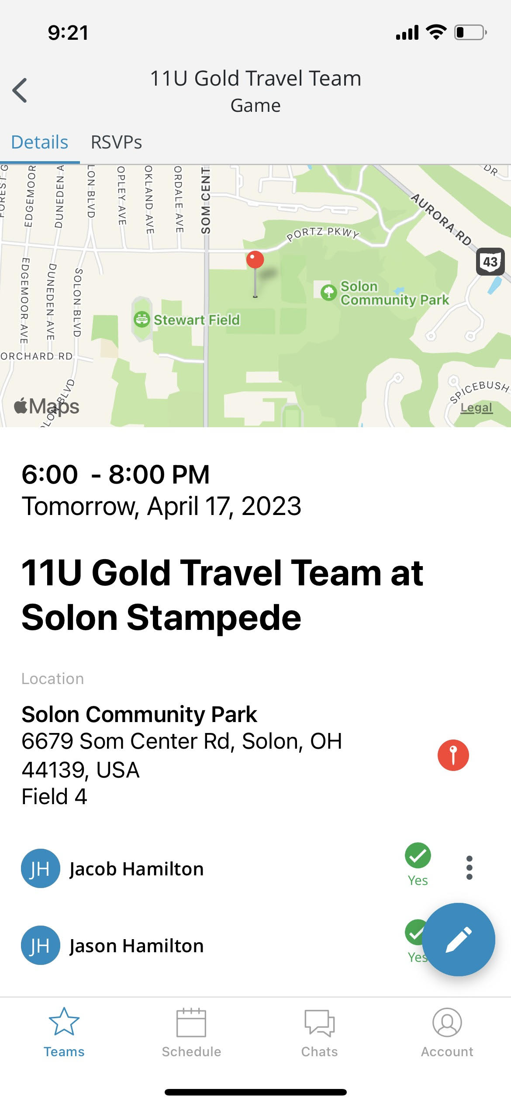

Click on ‘Edit’
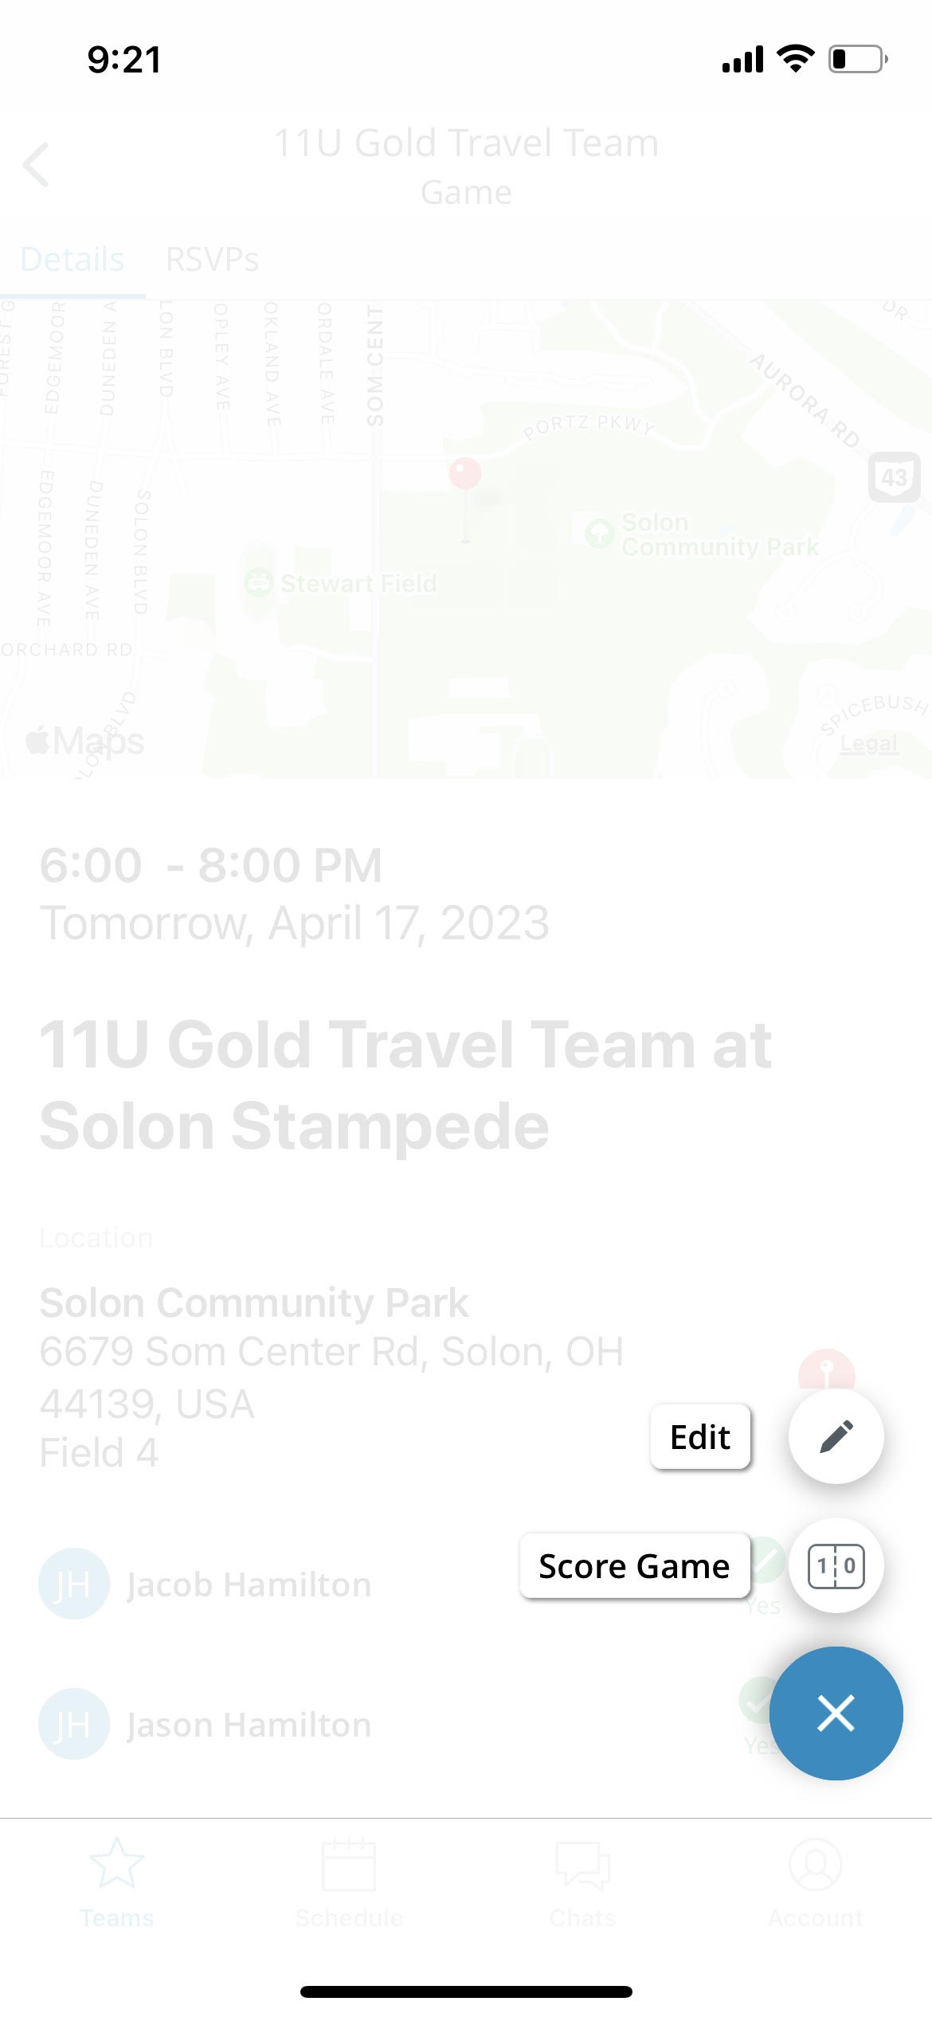

Click on Status
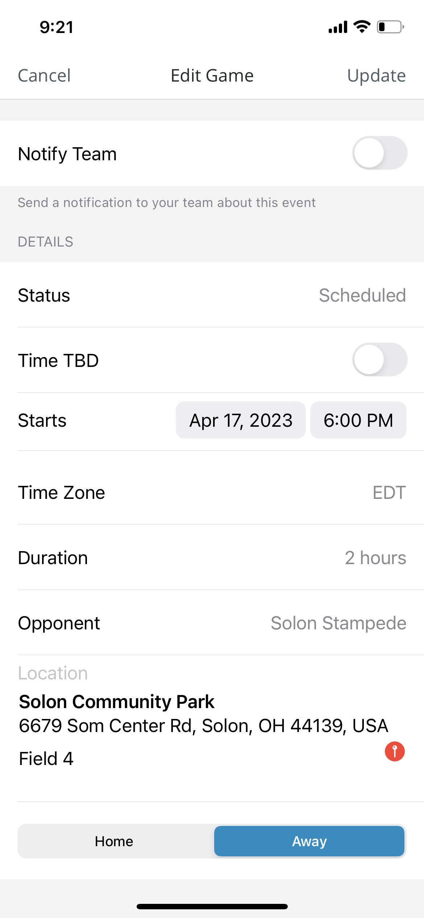

Click on ‘Postponed’ or whatever would be correct
