Rogers Youth Hockey
Monthly Board Meeting
March 21, 2022

Present: Mike Johnston, Jamie Davis, Dan Gilbert, Josey, Sara Weis

Agenda Item | Updates / Comments / Notes
Call to Order | Meeting called to order at 6:30 p.m.
Gambling Account | 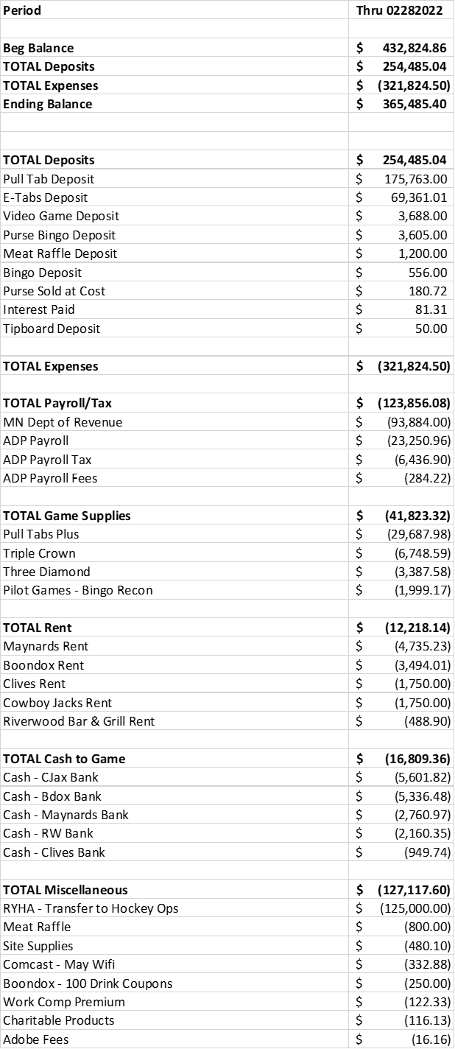
Gambling Director | - D. Gilbert reviewed and approved electronic payments on Feb 2022 bank statement.  - Cash Account for Feb 2022 reviewed.  - Reviewed of Schedule A – “Lawful Gambling Receipts” for each location – Boondox, Clives, Cowboy Jacks and Maynards for Feb 2022.  - Site review.  - Game at Maynards was considered defective when seller noticed two different serial numbers. Paid out $438 to a player, these expenses are generally reimbursed.  - Motion by M. Johnston/Second by D. Gilbert to approve monthly operation expenses of $75k. Motion approved.  - Motion by M. Johnston/Second by D. Gilbert to approve transfer of $150k to Hockey Ops account. Motion approved.  - Motion by M. Johnston/Second by D. Gilbert to move 4/18 meeting to 4/25 due to the fiscal year ending on 5/1.  - Motion to adjourn by M.Johnston /Second by D. Gilbert.
 | Adjourned 7:00 p.m.

