How to update AVAILABILITY on a desktop/browser!
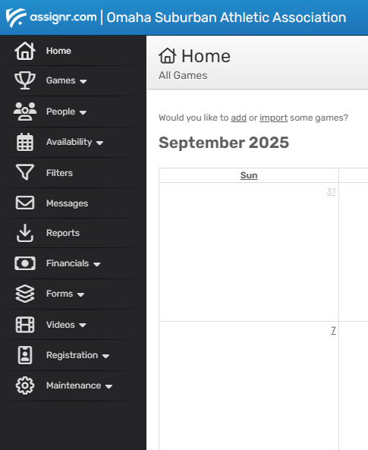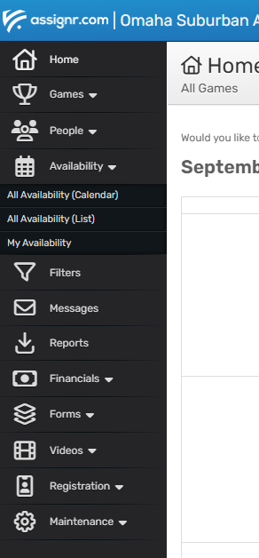
Select ‘Availability’ on the left hand side
Select ‘My Availability’ under that
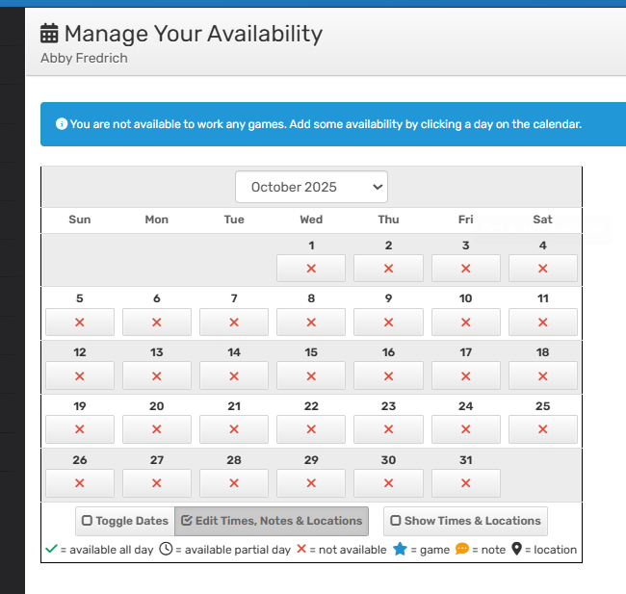
And update availability that way, leaving a note if needed.
Clock on the read X each date (4th and 11th are regular season, 18th is end of season tournament)
Select October 2025 in the drop down, if not already open

