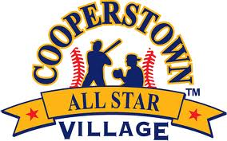

Cooperstown All-Star Village
Skills Competition
FINALISTS
Week 10

Fastest Person in Camp Finalists

Player Name: Nick Maurro
Team Name: South Shore Chiefs, NY
Time: 12.30

Player Name: Tucker Murry
Team Name: Newport Rays, CA
Time: 13.35

Player Name: Jaxon Lowe
Team Name: Thunder Academy, Co.
Time: 12.27 (WINNER)

Fastest Double Play Finalists

Team Name: So Cal Yard Goats (WINNER)
Time: 2.78

Team Name: Vestal LL
Time: N/A

Team Name: Pequannock Patriots
Time: 5.58

Home Run Derby Finalists

Player Name: Jack Picardo (WINNER)
Team Name: Pequannock Patriots
Number of Home Runs:22

Player Name: Richie Mojica
Team Name: Charros
Number of Home Runs:4

Player Name: Mike Buonagara
Team Name: Diamond Baseball
Number of Home Runs:12

Team Relay Finalists

Team Name: Thousand Oaks Bulldogs
Time: 35.54

Team Name: Thunder Academy Wiliamson
Time: 27.66

Team Name: Fairless Hills Steel
Time: 22.34 (WINNER)

