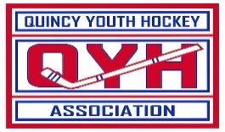

**QUINCY YOUTH HOCKEY**

**2024 Scholarship Application**

**“Book Award”**

Awards are available to family members of past/present members of Quincy Youth Hockey Association. To be considered, someone in your immediate family (sibling/parent) must have played hockey in QYH. Additional factors include length of time in QYH and service activity in the community.

NAME: __

ADDRESS: __

CELL PHONE: _________

EMAIL: _________

Dates of membership/involvement with QYH: _______________________________

Teams and/or Coaches: ___

Community Service History: ____________________________________________________

Continuing in the field of (list current school, employment, deployment in service or other): _____________________________

**Please read and sign the following statement:**

I certify that I am not under a full scholarship with the school/program that I am enrolled. I would like to be considered for a QYHA Scholarship.

Signature of Applicant:

All applicants must be members in good standing. Please return applications to:

QYHA @ 60 Murphy Memorial Drive OR via EMAIL to [treasurer@qyha.net](mailto:treasurer@qyha.net)

**Applications must be submitted by November 15th, 2024**