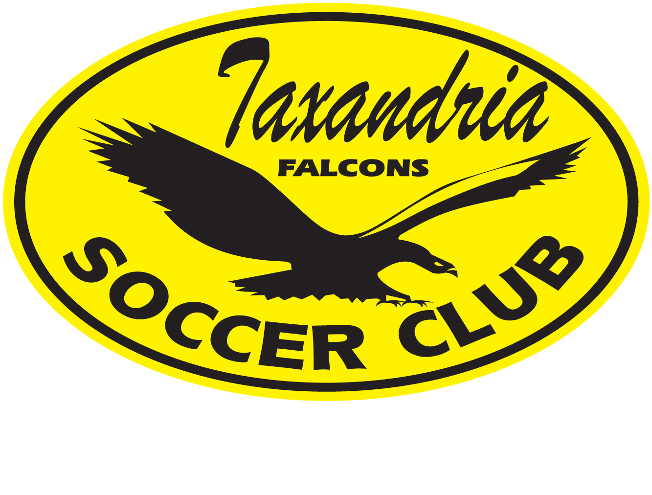
TAXANDRIA FALCONS SOCCER CLUB

ANTI-BULLYING POLICY

Effective: May, 2024

Introduction:
Bullying is a serious issue that can have lasting impacts on children and youth. Taxandria Soccer Club (hereinafter “Taxandria” and/or “The Club”) is committed to creating a safe and inclusive environment for all players, coaches, and parents, both on and off the field. This policy outlines Taxandria's approach to preventing bullying and resolving any incidents that may occur within the club.

Definition of Bullying:
Bullying is defined as unwanted, aggressive behavior among children and youth that involves a real or perceived power imbalance. This behavior is repeated or has the potential to be repeated over time and may include actions such as harassment, violence, intolerance, and intimidation.

DSC Code of Conduct:
All players, coaches, and parents associated with Taxandria are expected to adhere to the club's Code of Conduct, which outlines the positive behaviors expected of everyone involved. Taxandria’s Anti-Bullying Policy is an integral part of this Code of Conduct, and all players are expected to follow it.

Coach Education:
Taxandria will provide training to all coaches to increase awareness about bullying and its impacts. Coaches will be expected to be knowledgeable about bullying and to actively promote prevention measures among their players. Coaches will also be responsible for identifying and addressing any incidents of bullying that may arise within their teams.

Conflict and Resolution Protocol:

If a bullying incident is reported, DSC will follow a conflict and resolution protocol to address the situation. The steps of the protocol are as follows:

- Reporting: Any bullying incidents should be reported to the coach, manager, coordinator, or a member of the Board of Directors.
- Contacting the Executive: The coach or adult receiving the report should contact the executive of Taxandria immediately to inform them of the incident.
- Parent Involvement: Parents of the involved parties will be asked to attend a meeting to discuss the problem and provide additional information.
- Police Consultation: If necessary and appropriate, Taxandria may consult with the police to address the situation.
- Investigation and Intervention: The bullying behavior or threats of bullying will be promptly investigated, and appropriate action will be taken to stop the bullying behavior.
- Support and Education: Efforts will be made to help the bully (or bullies) change their behavior through support and education.
- Disciplinary Action: If mediation and intervention fail, Taxandria may initiate disciplinary action, as deemed appropriate.

Recommended Actions for Resolution:

If Taxandria coaches determine that it is appropriate for the parties involved to resolve the situation, the following steps should be followed:

- Reconciliation: The parties involved should be brought together, and a genuine apology may be sought as a resolution.
- Gathering Details: If reconciliation is not appropriate or fails, the coach(es) of the team should meet with the parent and child alleging bullying to gather details of the allegation, and minutes should be taken for clarity.
- Meeting with Alleged Bully: The coach(es) should then meet with the alleged bully and their parent(s) to present the incident raised and gather their view of the allegation. Minutes should be taken.
- Gathering Additional Information: The coach(es) should also talk to any other individuals who may have been involved to gather additional information, and minutes should be taken.
- Warning and Notice: If bullying is determined to have taken place, the athletes should be warned and put on notice of further action. Consideration should be given to whether a reconciliation meeting between parties is appropriate at this time.
- Communication: All other coaches involved with both athletes should be made aware of the concerns and outcome of the process, including the warning issued.

Compliance with Legislation:

Taxandria's Anti-Bullying Policy is in line with Bill 14 of the Anti-Bullying Act, 2012 from the Legislative Assembly of Ontario, and Taxandria.

If you have any questions or concerns regarding this policy, please contact our board at taxandriasoccer@gmail.com.

