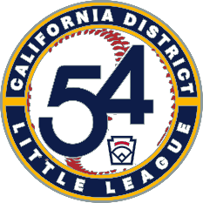
TOURNAMENT OF CHAMPIONS - 2025

BASEBALL
- Minors
- Little League (Majors)
- Intermediate
- Juniors
SOFTBALL
- Little League (Majors)

