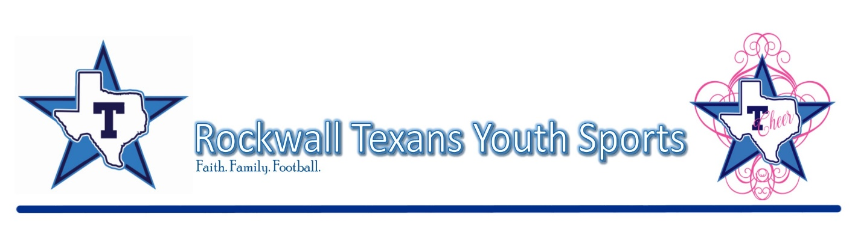
Release and Waiver of Liability and Indemnity Agreement

In consideration of being permitted to participate in any way in the Rockwall Texans Youth Sports Program indicated below and/or being permitted to enter for any purpose any restricted area (here in defined as any area where in admittance to the general public is prohibited), the parent(s) and/or legal guardian(s) of the minor participant named below agree:

1. The parent(s) and/or legal guardian(s) will instruct the minor participant that prior to participating in the below football/cheerleading activity or event, he or she should inspect the facilities and equipment to be used, and if he or she believes anything is unsafe, the participant should immediately advise the officials of such condition and refuse to participate. I understand and agree that, if at any time, I feel anything to be UNSAFE, I will immediately take all precautions to avoid the unsafe area and REFUSE TO PARTICIPATE further.

2. I/WE fully understand and acknowledge that:
(a) There are risks and dangers associated with participation in football/cheerleading events and activities which could result in bodily injury partial and/or total disability, paralysis and death, as well as various illnesses, such as Covid 19, flu, etc, that can be unintentionally transmitted by way of contact sports.
(b) The social and economic losses and/or damages, which could result from these risks and dangers described above, could be
severe.
(c) These risks and dangers may be caused by the action, inaction or negligence of the participant or the action, inaction or
negligence of others, including, but not limited to, the Releasees named below.
(d) There may be other risks not known to us or are not reasonably foreseeable at his time.

3. I/WE accept and assume such risks and responsibility for the losses and/or damages following such injury, disability, paralysis or
death, however caused and whether caused in whole or in part by the negligence of the Releasees named below.

4. I/WE HEREBY RELEASE, WAIVE, DISCHARGE AND COVENANT NOT TO SUE any Rockwall Texans Youth Sports Organizational Staff Member, Team Member, or Texans utilized facility such as Cain Middle School or Heath High School as used by the participant, including its owners, managers, promoters, lessees of premises used to conduct the football/cheerleading event or program, premises and event inspectors, underwriters, consultants and others who give recommendations, directions, or instructions to engage in risk evaluation or loss control activities regarding the football/cheerleading facility or events held at such facility and each of them, their directors, officers, agents, employees, all for the purposes herein referred to as “Releasee”...FROM ALL LIABILITY TO THE UNDERSIGNED, my/our personal representatives, assigns, executors, heirs and next to kin FOR ANY AND ALL CLAIMS, DEMANDS, LOSSES OR DAMAGES AND ANY CLAIMS OR DEMANDS THEREFORE ON ACCOUNT OF ANY INJURY, INCLUDING BUT NOT LIMITED TO THE DEATH OF THE PARTICIPANT OR DAMAGE TO PROPERTY, ARISING OUT OF OR RELATING TO THE EVENT(S) CAUSED OR ALLEGED TO BE CAUSED IN WHOLE OR IN PART BY THE NEGLIGENCE OF THE RELEASEE OR OTHERWISE.

5. I/WE HEREBY acknowledge that THE ACTIVITIES OF THE EVENT(S) ARE VERY DANGEROUS and involve the risk of serious injury and/or death and/or property damage. Each of THE UNDERSIGNED also expressly acknowledges that INJURIES RECEIVED MAY BE COMPOUNDED OR INCREASED BY NEGLIGENT RESCUE OPERATIONS OR PROCEDURES OF THE RELEASEES.

6. EACH OF THE UNDERSIGNED further expressly agrees that the foregoing release, waiver, and indemnity agreement is intended to be as broad and inclusive as is permitted by the law of the Province or State in which the event is conducted and that if any portion is held invalid, it is agreed that the balance shall, notwithstanding continue in full legal force and effect.

7. On behalf of the participant and individually, the undersigned partner(s) and/or legal guardian(s) for the minor participant executes
this Waiver and Release. If, despite this release, the participant makes a claim against any of the Releasees, the parent(s) and/or legal guardian(s) will reimburse the Releasee for any money which they have paid to the participant, or on his behalf, and hold them harmless.

I HAVE READ THIS RELEASE AND WAIVER OF LIABILITY, ASSUMPTION OF RISK AND INDEMNITY AGREEMENT, FULLY
UNDERSTAND ITS TERMS, UNDERSTAND THAT I HAVE GIVEN UP SUBSTANTIAL RIGHTS BY SIGNING IT, AND HAVE SIGNED IT FREELY AND VOLUNTARILY WITHOUT ANY INDUCEMENT, ASSURANCE, OR GUARANTEE BEING MADE TO ME AND INTEND MY SIGNATURE TO BE COMPLETE AND UNCONDITIONAL RELEASE OF ALL LIABILITY TO THE GREATEST EXTENT ALLOWED BY LAW.

_______________________________________ _______________________________________
Parent or Guardian Signature (if minor) Parent or Guardian Signature (if minor)

___________________________________________________________________________
Printed Name of Participant

___________________________________________________________________________________________________
Address of Participant

Received by:

______________________________________________________________________________________________________
Registrar Signature Printed Name Member # Region on File Date

